   □    □ 

   □   □  is the continuative/transitional use of the postpositive conjunction DE, meaning “Then; Now.” With this we have the nominative masculine singular aorist active participle of the verb EIDON, which means “to see: seeing.”
The aorist tense is a constative/historical aorist, which views the action in its entirety as a fact.
The active voice indicates that Jesus produced the action.
The participle is a temporal participle that precedes the action of the main verb and can be translated “after seeing.”
Next we have the nominative subject from the masculine singular article and proper noun IĒSOUS, which means “Jesus.” This is followed by the accusative direct object from the masculine singular noun OCHLOS, meaning “the crowd.” Then we have the preposition PERI plus the accusative of place from third person masculine singular personal use of the intensive pronoun AUTOS, meaning “around, about, or near Him.”

“Now after seeing the crowd around Him, Jesus”

  □   is the third person singular aorist active indicative from the verb KELEUW, which means “to command; to give orders; to give instructions or directions.”
The aorist tense is a constative/historical aorist, which views the action in its entirety as a fact.
The active voice indicates that Jesus produced the action.
The indicative mood is declarative for a simple statement of fact.
Next we have the aorist active infinitive from the verb APERCHOMAI, which means “to go away; to depart.”
The aorist tense is a constative/historical aorist, which views the action in its entirety as a fact.
The active voice indicates that Jesus and the disciples produced the action.
The indicative mood is declarative for a simple statement of fact.
Finally, we have the preposition EIS plus the accusative of place from the neuter singular article and adverb of place PERAN, which means “to the opposite shore.”

“gave instructions to go away to the opposite shore.”

Mt 8:18 corrected translation
“Now after seeing the crowd around Him, Jesus gave instructions to go away to the opposite shore.”

Explanation:

1. “Now after seeing the crowd around Him, Jesus”
a. Matthew transitions to another event in the public ministry of Jesus. This did not occur the same evening that Jesus healed the people of Capernaum. It may have been weeks later according to Mk 1:35-39 tells us that the next day and for weeks thereafter Jesus and the disciples went on an evangelism tour of Galilee. “And early in the morning [this is the next morning after the healings in Capernaum], while quite dark, after rising, He left and went away to an isolated place, and was praying there. And then Simon and those with him searched for Him; and they found Him, and said to Him, ‘Everyone is looking for You.’ And He said to them, ‘Let us go elsewhere to the neighboring market-towns, in order that I might preach there also; for I came for this purpose.’ And He went into their synagogues in all Galilee, preaching and casting out the demons.” There were over thirty towns in Galilee, so that even at two cities/towns/villages a day, it would have taken about two weeks to complete this speaking tour. Luke reports the same thing in Lk 4:42-44, “Now when day came, after going away, He went to a secluded place and the crowds kept searching for Him. And they came to Him and tried to prevent Him, in order that He not go away from them. However, He said to them, ‘I must also proclaim the kingdom of God to the other cities, because I was sent for this purpose.’ And so He kept on preaching in the synagogues of Judea.” Notice that Mark says that Jesus went throughout all Galilee and Luke says He went to the synagogues of Judea. This is not a contradiction. Jesus did both.
b. Because of this public speaking tour, large crowds have gathered around Jesus from all over Galilee. We are not told the size of the crowd or the time of day or if this was after a sermon by Jesus. All we know for certain is that Jesus sees the large crowd surrounding Him and feels the need to separate Himself from these people at this moment.

2. “Jesus gave instructions to go away to the opposite shore.”
a. Therefore, the Lord gives instructions to His professional fishermen to embark in one of Peter’s boats and depart to the opposite shore of lake Galilee. The assumptions are that this takes place during the day, that Jesus has probably finished speaking to this large crowd, that Jesus and His disciples are on the shore of the lake in Capernaum, and that the opposite shore is the southern end of the lake.
b. The verb KELEUW means to command; to give orders; to give instructions or directions. In this situation there is no need for Jesus to command the disciples. That translation is too strong. It is more likely that He simply gave instructions and the disciples carried them out.
c. See the map below for the orientation of Capernaum to the opposite shore.
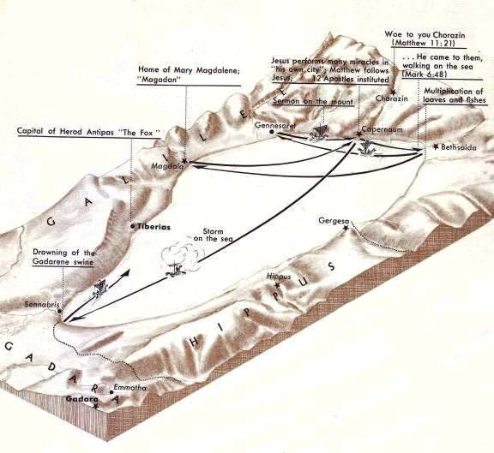

3. Commentators’ comments.
a. “The impact of the evening of miracles launched Jesus on a grand preaching tour of Galilee.”
b. “In order to introduce the miracles of the calming of the storm and the healing of the Gadarene demoniacs (on the east side of the lake), Matthew mentions Jesus’ decision to leave Capernaum, apparently to escape from the growing crowds. This decision inevitably results in a separation of his true followers, who will accompany him, from less committed supporters, and thus Matthew introduces in verses 19–22 two case-studies illustrating the demands of committed discipleship. The same incidents are related at a later point in Luke’s narrative (Lk 9:57–60, with a further similar example added in verses 61–62).”
c. “Jesus commands an unspecified group of individuals, most likely the Twelve, to get boats ready to cross to the east side of the Sea of Galilee. Before He can leave, two other people express their desire to follow Jesus across the lake.” Luke describes Jesus’ encounter with this scribe thus Lk 9:57, “As they were going along the road, someone said to Him, ‘I will follow You wherever You go.’” This doesn’t sound like this man came to Jesus as He was about to depart in a boat to the other side of the lake.
d. “The healings brought crowds about Jesus. Jesus may well have wanted some peace and quietness [or just to continue His ministry elsewhere], and therefore instructed His immediate followers to cross the lake. Nothing is said about how they were to make the journey; the writer apparently assumes that a boat was available, but he says nothing about it. We do not know whose it was or how it came to be put to Jesus’ use. Matthew says nothing at all about the reason for the crossing.”

BDAG, p. 796.
Mills, M. S. (1999). The Life of Christ: A Study Guide to the Gospel Record (Mt 4:23–Lk 4:44). Dallas, TX: 3E Ministries.
France, R. T. (1985). Matthew: an introduction and commentary (Vol. 1, p. 163). Downers Grove, IL: InterVarsity Press.
Blomberg, C. (1992). Matthew (Vol. 22, p. 146). Nashville: Broadman & Holman Publishers.
Morris, L. (1992). The Gospel According to Matthew (p. 200). Grand Rapids, MI; Leicester, England: W.B. Eerdmans; Inter-Varsity Press.

