   □  

   □  is the temporal adverb TOTE, meaning “Then,” followed by the third person singular present active indicative from the verb PARALAMBANW, which means “to take: took.”
The present tense is a historical present, which describes the past action as though occurring right now for the sake of vividness or liveliness in the narrative. It is translated by the English past tense.
The active voice indicates that the devil produced the action.
The indicative mood is declarative for a simple statement of fact.
Next we have the accusative direct object from the third person masculine singular personal use of the intensive pronoun AUTOS, meaning “Him” and referring to Jesus. This is followed by the nominative subject from the masculine singular article and adjective DIABOLOS, which means “the devil.” This is followed by the preposition EIS plus the accusative of place from the feminine singular article and adjective HAGIOS plus the noun POLIS, meaning “into the holy city.”

“Then the devil took Him into the holy city”

  is the additive/continuative use of the conjunction KAI, meaning “and,” followed by the third person singular aorist active indicative from the verb HISTĒMI, which means “to stand.”
The culminative aorist regards the action in its entirety as a fact with emphasis on its completion. This is brought out in translation by use of the English auxiliary verb “had.”
The active voice indicates that the devil produced the action.
The indicative mood is declarative for a simple statement of fact.
Next we have the accusative direct object from the third person masculine singular personal use of the intensive pronoun AUTOS, meaning “Him” and referring to Jesus. Then we have the preposition EPI plus the accusative of place from the neuter singular article and noun PTERUGION, which means “on the tip or extremity of anything: end, edge.” Finally, we have the possessive genitive or genitive of identity from the neuter singular article and adjective HIEROS, meaning “of the temple.”

“and had Him stand on the edge of the temple,”

Mt 4:5 corrected translation
“Then the devil took Him into the holy city and had Him stand on the edge of the temple,”

Explanation:

1. “Then the devil took Him into the holy city”
a. Matthew moves the story along to the next testing/temptation. Comparing this passage with Luke we see that this in Matthew’s second test, but Luke’s third test. This is not a contradiction, but a difference in emphasis. One is chronological and the other is theological. It is simply a matter of different emphasis. Matthew is building up to the offer of the kingdoms of the world. Luke is building up to the importance of the humanity of Christ not rejecting the will of the Father. “What was the actual order of the testings of Jesus? We cannot be sure. We know which one was first, but do not know the order of the other two. Matthew had less reason to rearrange the testings than did Luke, so suspect that Matthew’s order is the original order, but that is impossible to prove conclusively. Both the Gospel writers give what they promise, a truthful interpretation of the life of Jesus that brings out the true meaning of the different events. Each of the authors sees a different aspect of this true meaning. Matthew focuses on Jesus as the fulfillment of the Old Testament and thus Jesus as the true Son that Israel failed to be. Luke focuses on Jesus moving toward Jerusalem as the Son of God invading Satan’s kingdom and bringing God’s salvation in history to those whom Satan has bound. Each orders the testings of Jesus and mentions details to bring out their picture. Both pictures are true, but neither is complete in itself. If we lacked either picture we would be poorer. This is why it is important to read each Gospel for itself and to get the distinctive message each author is proclaiming.”
b. The devil is now given control of the action. In the first test the Spirit was leading Jesus around in the desert for forty days and nights. Now we see the devil taking Jesus into the city of Jerusalem. The title ‘holy city’ is a title only used for Jerusalem in Scripture. It is the holy city because it is the city of God, where the Shekinah glory resided in God’s tabernacle and temple in the holy of holies between the two cherubim above the ark of the covenant.
c. Were the devil and Jesus visible to people as this event took place? Probably not. Did it occur in daytime or at night? We are not told. Had it been in daytime and Jesus was visible, then thousands would have witnessed someone standing on top of the Temple at the end of the wall. Not only would people wonder how the Man got up there, but they would also imagine Him to be suicidal.
d. This testing/temptation was probably just as private as the previous testing in the desert.

2. “and had Him stand on the edge of the temple,”
a. How Jesus and Satan got to the top of the temple we are not told. Did Jesus fly? Did Satan carry Him up? Did elect angels assist in this process? We are not told, because none of these things are relevant or important. And where Scripture is silent, it is often prudent for us to be just as silent.
b. The important fact is that Satan directs the action and has Jesus stand at the very top of one of the walls of the temple right on the very edge of the Temple. The Temple in Jerusalem was sixty feet high. Taken from the ESV Study Bible and the Crossway ESV Atlas, here’s the best current scholarly understanding of what the Temple would have looked like:
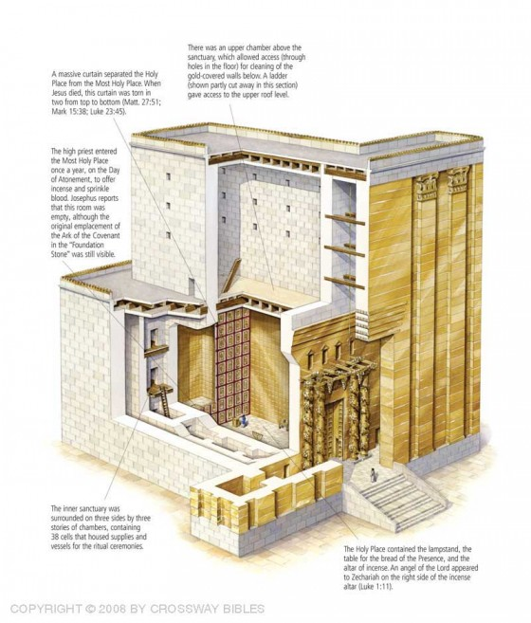
c. Obviously Satan puts Jesus in a death-defying position, where He could slip and fall to his death. Satan is not permitted to kill Christ, but he is hoping that Jesus will either deliberately or accidentally end His life, and thus, not be able to go to the Cross and keep the Father’s promise of eternal salvation to all who trust in Him.

3. Commentator’s comments:
a. “The second test by Satan appealed to personal display or popularity. This test built on the first, for if He is the Son of God and the Messiah, nothing could harm Him. Whether this was actual or simply a vision cannot be determined dogmatically.”
b. “Whether the devil took Him literally or in a vision is not clear. The pinnacle (literally ‘small wing’) of the temple would be some projecting part of the temple buildings; the main temple building was some 180 feet high.”
c. Here’s another description: “The ‘pinnacle’ of the temple was the highest place among the ‘royal colonnade’ gallery built by Herod. The cloisters (porches) were among the finest architectural features of the entire Temple. They were a spectacular sight to behold, overlooking the Kedron valley. The historian Josephus gives an interesting description: ‘This cloister deserves to be mentioned better than any other under the sun; for, while the valley was very deep, and its bottom could not be seen if you looked from above into the depth, this farther vastly high elevation of the cloister stood upon that height, insomuch that if any one looked down from the top of the battlements, or down both those altitudes, he would be giddy, while his sight could not reach to such an immense depth.’ -Antiquities, Book 15, Chap.11:5 . Some believe the distance to have been seven hundred feet.”
d. “‘The highest point’ is the wing or portico, not ‘pinnacle’ (NASB). Portico refers to the flat-topped corner of Solomon’s porch on the southeast corner of the temple complex overlooking the Kidron Valley.”
e. “Jesus had rejected the first temptation because he trusted God to supply his need; now he is tempted through that very assurance. Matthew reverts to the devil as his name for the evil one and says that he now takes Jesus along into the holy city (i.e., Jerusalem; this term occurs again in 27:53 and 4 times in Revelation only in the New Testament). Neither Matthew nor Luke makes it clear whether this is a physical removal of Jesus from the wilderness or whether it means a vivid suggestion to the mind such that he saw Himself in the position mentioned. But in any case we should remember that the essence of temptation is inward: it does not depend on the physical location of the person tempted. The devil stood him on the wing of the temple. The word translated wing seems to have been used for the extremity of anything; it is used of the fins of a fish, the tail flaps of a lobster, and the tip of a rudder. It seems that here it means the peak, the point of a roof. But there is a problem in that we do not know what roof. The definite article shows that it was a well-known place, but we can scarcely do more than say that it was obviously something at a great height, so that a leap from it would be spectacular.”
f. “This ‘wing of the temple’ was most likely the one from which James was thrown down, Acts 12:2. This was part of the outer wall that encircled the entire Temple area. The most acceptable location is the royal porch on the south wall, a deep ravine lying between it and the opposite suburbs; others think of the east wall along Solomon’s Porch where the drop is 600 feet.”

Arndt, Danker, Bauer & Gingrich, (2000). A Greek-English Lexicon of the New Testament and other early Christian literature (3rd ed., p. 895). Chicago: University of Chicago Press.
Kaiser, W. C., Jr., Davids, P. H., Bruce, F. F., & Brauch, M. T. (1996). Hard Sayings of the Bible (pp. 456–457). Downers Grove, IL: InterVarsity.
Barbieri, L. A., Jr. (1985). Matthew. The Bible Knowledge Commentary: An Exposition of the Scriptures (Vol. 2, p. 26). Wheaton, IL: Victor Books.
France, R. T. (1985). Matthew: an introduction and commentary (Vol. 1, p. 104). Downers Grove, IL: InterVarsity Press.
Bible History Online, Scripture Backdrops: the Pinnacle of the Temple.
Blomberg, C. (1992). Matthew (Vol. 22, p. 84). Nashville: Broadman & Holman Publishers.
Morris, L. (1992). The Gospel according to Matthew (pp. 75–76). Grand Rapids, MI; Leicester, England: W.B. Eerdmans; Inter-Varsity Press.
Lenski, p. 148.

