 □        □  

 □  is the continuative use of the conjunction KAI, meaning “And,” followed by the third person plural aorist active indicative from the verb AKOLOUTHEW, which means “to follow.”
The aorist tense is a constative/historical aorist, which views the action in its entirety as a fact.
The active voice indicates that the large crowds produced the action.
The indicative mood is declarative for a simple statement of fact.
Then we have the dative (in)direct object from the third person masculine singular personal use of the intensive pronoun AUTOS, meaning “Him” and referring to Jesus. Next we have the nominative subject from the masculine plural noun OCHLOS with the adjective POLUS, meaning “great or large crowds.”

“And large crowds followed Him”

       □   is the preposition APO plus the ablative of origin from the feminine singular article and nouns GALILAIA, DEKAPOLIS, IEROSOLUMA, and IOUDAIA, meaning “from Galilee, Decapolis, Jerusalem, and Judea.” Each noun is followed by the conjunction KAI, which functions like our comma, and can be translated either way. Finally, we have the preposition PERAN plus the adverbial genitive of place from the masculine singular article and proper noun IORDANĒS, meaning “beyond the Jordan,” which is the territory on the east side of the Jordan River.

“from Galilee and Decapolis and Jerusalem and Judea and beyond the Jordan.”

Mt 4:25 corrected translation
“And large crowds were following Him from Galilee and Decapolis and Jerusalem and Judea and beyond the Jordan.”

Explanation:

1. “And large crowds were following Him”
a. Matthew concludes this short synopsis of the beginning of our Lord’s public ministry with the results of His preaching, teaching, and healing. He was the most popular man in Galilee as evidenced by the large, great, huge, enormous, etc. crowds that followed Him.
b. Examples of these crowds are the feeding of the 5000 and 4000, which doesn’t reveal the real story. Luke points out that this was only a count of the men. When you add the wives and an average of at least two children, the crowds are more like 20,000 and 16,000.
c. Did people take off work to do this? You bet they did. This was the expected Messiah, and who needs to worry about a measly job now, when you can make ten-fold more in the millennial kingdom. Men were eager to leave their jobs for the better paying jobs that would exist as soon as the Messiah inaugurated His kingdom. And wasn’t Jesus saying that the kingdom was near? People followed Him to get healed. Some followed Him to see the next miracle. Some followed Him because He spoke like no other man had ever spoken. He told the truth all the time and never tried to persuade anyone with ‘fake news’. Some also followed out of jealousy and hatred, but most of that would come after this initial period.
d. The verb ‘to follow’ is not used in the technical sense of being a follower of Jesus, but is used in the locative sense of physically going where He went. Imagine Jesus coming to your town and there are thousands of people following Him. Your town is about to overwhelmed with people, and you are probably going to join the crowd just to see what is going on.

2. “from Galilee and Decapolis and Jerusalem and Judea and beyond the Jordan.”
a. Matthew then lists where these people came from to see and hear Jesus. Naturally they came from all over Galilee, where Jesus was doing all this work. But they also came from Decapolis—the district of the ten cities to the east of Galilee. They also came from Jerusalem and the entire district of Judea (which means the cities, towns, and villages surrounding Jerusalem. The territory ‘beyond the Jordan’ is the east side of the Jordan River valley, extending from the Dead Sea norther to Lake Galilee. This area is also known as Perea.
b. See the map for the location of these districts/territories:
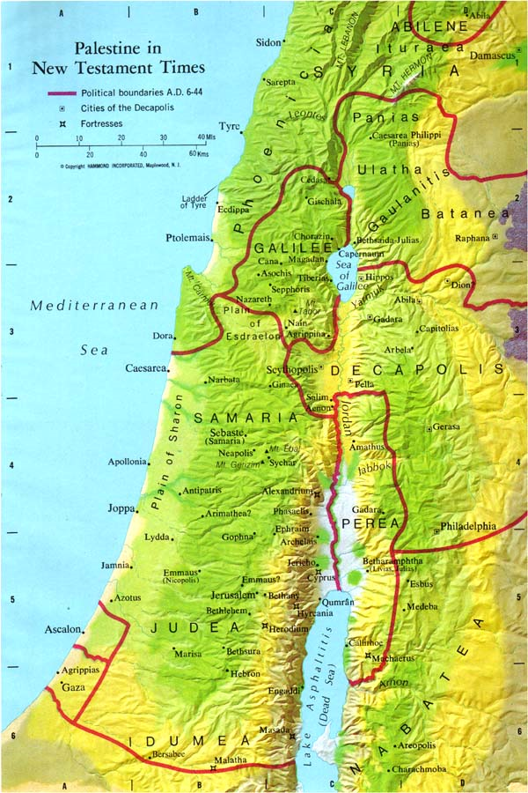

3. Commentators’ comments.
a. “Jesus’ following was drawn not only from Galilee, the area of his actual activity, but also from Judea to the south, and to the east from both Decapolis (a largely Gentile confederacy) and Perea (beyond the Jordan), which together covered the Old Testament Gilead; thus the whole ancient ‘holy land’ (with the exception of Samaria, which Matthew nowhere mentions except to exclude it) responded to the coming of the Messiah.”
b. “A report of these miracles goes out to all of the nearby territories both inside and outside of Israel, except for Samaria.” As a result of this news traveling all over Israel, Jews came from everywhere (except Samaria) to see Jesus and hear His message.
c. “Clearly the healings made a deep impression; for great crowds followed Jesus. This, of course, does not mean that they followed him as disciples, but simply that, as curiosity seekers, they did not want to miss the latest sensation. In Matthew the crowds are not opposed to Jesus as the Jewish leaders are, but they are not adherents as the disciples are. Matthew lists the places from which these crowds came. We would have expected Galilee, for that was the area in which Jesus was moving, but the others in the list show that some of the people came a good distance. Decapolis means ‘ten cities’; these were all east of the Jordan except Scythopolis. Jerusalem was quite a distance away, as was Judea, which here denotes the region in the south of Palestine. Trans-Jordan [beyond the Jordan] means much of the country to the east of the Jordan, so this adds to the impression Matthew is conveying that people were attracted to Jesus from very great distances. Jesus was more than a petty healer in a tiny province.”

France, R. T. (1985). Matthew: an introduction and commentary (Vol. 1, pp. 110–111). Downers Grove, IL: InterVarsity Press.
Blomberg, C. (1992). Matthew (Vol. 22, p. 92). Nashville: Broadman & Holman Publishers.
Morris, L. (1992). The Gospel according to Matthew (p. 91). Grand Rapids, MI; Leicester, England: W.B. Eerdmans; Inter-Varsity Press.

