 □ □ 

 □  is the continuative use of the conjunction KAI, meaning “And,” followed by the temporal conjunction HOTE, meaning “when” plus the third person plural aorist active indicative from the verb EMPAIZW, which means “to ridicule.”
The aorist tense is a culminative aorist, which views the action in its entirety with emphasis on the end of the action. It is translated by the addition of the auxiliary verb “had.”
The active voice indicates that the soldiers produced the action.
The indicative mood is declarative for a simple statement of fact.
Next we have the dative direct object from the third person masculine singular personal use of the intensive pronoun AUTOS, meaning “Him.”

“And when they had ridiculed Him,”

 is the third person singular aorist active indicative from the verb EKDUW, which means “to strip; to take off (clothing); to undress.”
The aorist tense is a constative/historical aorist, which views the entire past action as a fact.
The active voice indicates that the soldiers produced the action.
The indicative mood is declarative for a simple statement of fact.
Next we have the double accusative of personal and impersonal objects from the third person masculine singular personal use of the intensive pronoun AUTOS, meaning “Him” plus the accusative impersonal object from the feminine singular article and noun CHLAMUS, meaning “(of) the cloak/robe.” The word ‘scarlet’ does not exist in the Greek manuscript.

“they stripped Him (of) the robe”

 □  is the additive use of the conjunction KAI, meaning “and,” followed by the third person plural aorist active indicative from the verb ENDUW, which means “to dress; to put on.”
The aorist tense is a constative/historical aorist, which views the entire past action as a fact.
The active voice indicates that the soldiers produced the action.
The indicative mood is declarative for a simple statement of fact.
Next we have the accusative direct object from the third person masculine singular personal use of the intensive pronoun AUTOS, meaning “Him.” This is followed by the double accusative of the thing from the neuter plural article and noun HIMATION with the possessive genitive from the third person masculine singular personal use of the intensive pronoun AUTOS, meaning “His garments/clothes.”

“and put His garments on Him,”

  is the continuative use of the conjunction KAI, meaning “and,” followed by the third person plural aorist active indicative from the verb APAGW, which means “to lead away.”
The aorist tense is a constative/historical aorist, which views the entire past action as a fact.
The active voice indicates that the soldiers produced the action.
The indicative mood is declarative for a simple statement of fact.
With this we have the accusative direct object from the third person masculine singular personal use of the intensive pronoun AUTOS, meaning “Him.” This object serves both the verb and the following infinitive. Then we have the preposition EIS plus the accusative of purpose from the neuter singular articular aorist active infinitive of the verb STAUROW, which means “to crucify.”
The aorist tense is a constative/historical aorist, which views the entire past action as a fact.
The active voice indicates that the soldiers produced the action.
The infinitive is an infinitive of purpose.

“and led Him away to crucify Him.”

Mt 27:31 corrected translation
“And when they had ridiculed Him, they stripped Him (of) the robe and put His garments on Him, and led Him away to crucify Him.”

Mk 15:20, “And when they had ridiculed Him, they took the purple garment off Him and put His own garments on Him. And then they led Him out, in order that they might crucify Him.”

Explanation:

1. “And when they had ridiculed Him,”
a. Matthew continues by describing the conclusion of the mocking and ridicule of Jesus. The soldiers have had enough of their fun for the morning. They got tired of hitting, making fun of, spitting on, kneeling to, and verbally abusing this pitiful looking, disfigured man.
b. The soldiers had done all they could to try and make Jesus feel as worthless as a human being could feel; yet got no reaction or retaliation of any kind from Him. He said nothing and did nothing. The soldiers were fed up with their physical, mental, and verbal abuse of the prisoner. They have better things to do. Pilate too, had finished showing Jesus to the crowd, who continued to call for His crucifixion.

2. “they stripped Him (of) the robe”
a. With the abuse, mockery, and ridicule at an end, the soldiers had to once again prepare Jesus for crucifixion. This required them to strip the worn out, bloody robe off of Jesus. The verb used here denotes a violent act rather than a gentle, tender removal of the garment. They didn’t care how much the cloth stuck to the coagulated blood on Jesus’ back. They just ripped the garment off Him.
b. This is not suggesting that Jesus was stripped naked. He would have retained His loincloth throughout this process of humiliation.

3. “and put His garments on Him,”
a. In addition to taking off the robe/cloak, the soldiers had to put Jesus’ clothes back on Him.
b. Not stated directly, but most certainly implied is that Jesus was too weak and helpless to put His own clothing back on. The soldiers had to do it for Him. The active voice of the verb clearly indicates that the soldiers, not Jesus, were the ones producing the action of the verb.
c. Our Lord at least had the dignity of being led to His place of execution without having to be naked. It was the least the soldiers could do for Him and there was little else they did for Him until He was already on the Cross suffering.

4. “and led Him away to crucify Him.”
a. Finally, with the prisoner prepared, the Roman soldiers, not the Temple Guards, led Jesus away to be crucified. This was the final purpose of that morning’s events. And the Roman Gentiles were in charge of carrying out the mission. The Jewish leadership watched with approval.
b. The procession included more than just Jesus. At the head of the procession would be the Roman centurion (who we will meet later in the story at the foot of the Cross). He is followed by Jesus and two thieves, each of the three prisoners, being escorted by a Roman soldier.
c. The map below shows the location of the Praetorium (lower left) and Golgotha (Gordon’s Calvary in the upper left). The straight line distance is 4500 ft. Accounting for turns and twists in the route, it would have been about a mile from Pilate’s Gabbatha (Jn 19:13) to Golgotha.
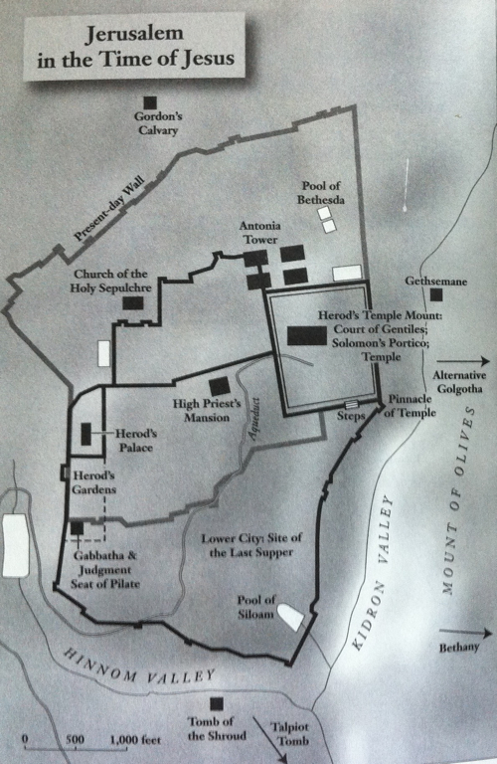

5. Commentators’ comments.
a. “Jesus was led outside the city to the place of execution (Heb. 13:12–13). It was required that the prisoner carry his own cross (or at least the crossbeam), and that he wear a placard around his neck announcing his crime. That placard was then hung over his head on the cross for all to see.”
b. “He silently bore the unjust treatment, submitting to the will of His Father (1 Pet 2:23). With their sport completed, the soldiers again dressed Jesus in His own clothes and led Him away to be crucified.”
c. “When the Jews took the purple robe off Jesus, they removed the sign of Roman recognition of His kingship and reduced Him to a private citizen. The remarkable physical stamina of Jesus must be wondered at—after a brutal flogging, the emotional strain of six court cases, of defection by all His followers and the nation, no sleep for 24 hours—after all this He still started out lugging His own cross.”
d. “The scarlet garment is then removed, his own cloak returned, and he is taken away to the site of the crucifixion. It was normal for criminals to be led to the cross naked. The return of Jesus’ clothes perhaps reflects a Roman concession to the Jews because of the special shame they attached to appearing naked in public.”
e. “The fun was over and the serious business was about to begin. They led Jesus off to crucify him. There would not have been as many involved in the actual crucifixion as in the mocking (normally four soldiers crucified a man), but it would have included some of the same men.”

See Brooks & Winbery, Syntax of NT Greek, p. 51, where this verse is cited as the example and gives this exact translation.
Wiersbe, W. W. (1996). The Bible Exposition Commentary (Vol. 1, p. 102). Wheaton, IL: Victor Books.
Barbieri, L. A., Jr. (1985). Matthew. The Bible Knowledge Commentary: An Exposition of the Scriptures (Vol. 2, p. 88). Wheaton, IL: Victor Books.
Mills, M. S. (1999). The Life of Christ: A Study Guide to the Gospel Record (Mt 27:31–Jn 19:17). Dallas, TX: 3E Ministries.
Blomberg, C. (1992). Matthew (Vol. 22, p. 415). Nashville: Broadman & Holman Publishers.
Morris, L. (1992). The Gospel According to Matthew (p. 712). Grand Rapids, MI; Leicester, England: W.B. Eerdmans; Inter-Varsity Press.

