😐 □     □

😐 □   is the continuative use of the conjunction KAI, meaning “And,” followed by the nominative masculine singular aorist active participle of the verb EXERCHOMAI, which means “to go out; to come out.”
The aorist tense is a constative/historical aorist, which views the entire past action as a fact.
The active voice indicates that Jesus produced the action.
The participle is a temporal participle, which precedes the action of the main verb. It can be translated “after coming out.”
Next we have the nominative subject from the masculine singular proper noun IĒSOUS, meaning “Jesus.” This is followed by the preposition APO plus the ablative of origin from the neuter singular article and adjective HIEROS, meaning “from the temple.” Then we have the third person singular imperfect deponent middle/passive indicative from the verb POREUOMAI, which means “to go, to journey, to travel, to proceed, to leave.”
The imperfect tense is an ingressive imperfect, which describes the beginning of a past action without reference to its conclusion. This can be translated by use of the English auxiliary verb “he proceeded to leave.”
The deponent middle/passive voice is middle/passive in form but active in meaning with the subject (Jesus) producing the action.
The indicative mood is declarative for a simple statement of fact or reality.

“And after coming out from the temple, Jesus proceeded to leave,”

   □ is the additive use of the conjunction KAI, meaning “and,” followed by the third person plural aorist active indicative from the verb PROSERCHOMAI, which means “to come to; to
come.”
The aorist tense is a constative/historical aorist, which views the entire past action as a fact.
The active voice indicates that the disciples produced the action.
The indicative mood is declarative for a simple statement of fact or reality.
Next we have the nominative subject from the masculine plural article and noun MATHĒTĒS with the possessive genitive from the third person masculine singular personal use of the intensive pronoun AUTOS, meaning “His disciples.” With this we have the aorist active infinitive of the verb EPIDEIKNUMI, which means “to show; to point out.”
The aorist tense is a constative/historical aorist, which views the entire past action as a fact.
The active voice indicates that the disciples produced the action.
The infinitive is an infinitive of purpose.
Next we have the dative indirect object from the third person masculine singular personal use of the intensive pronoun AUTOS, meaning “to Him.” This is followed by the accusative direct object from the feminine plural article and noun OIKODOMĒ, which means “the buildings.” Finally, we have the possessive genitive from the neuter singular article and adjective HIEROS, meaning “of the temple” or “the temple buildings.”

“and His disciples came to Him to point out the temple buildings.”

Mt 24:1 corrected translation
“And after coming out from the temple, Jesus proceeded to leave, and His disciples came to Him to point out the temple buildings.”

Explanation:

1. “And after coming out from the temple, Jesus proceeded to leave,”
a. Jesus was finished with the scribes and Pharisees and the leaders of Israel. He had had enough and was now leaving the city. This is described in a twostep process. First, Jesus departs from the area of the temple, that is, from the temple grounds. He would have proceeded from the court of the Jewish men, through the court for the Jewish women, and then through the court of the Gentiles and through the outer wall of the temple grounds.
b. The second step in this process was then to proceed to leave the city of Jerusalem itself. He and the disciples would have left through the east gate of the city, which was the exit directly opposite the Mount of Olives on the other side of the Kidron Valley. (The Mount of Olives is on the right side of the map below.)

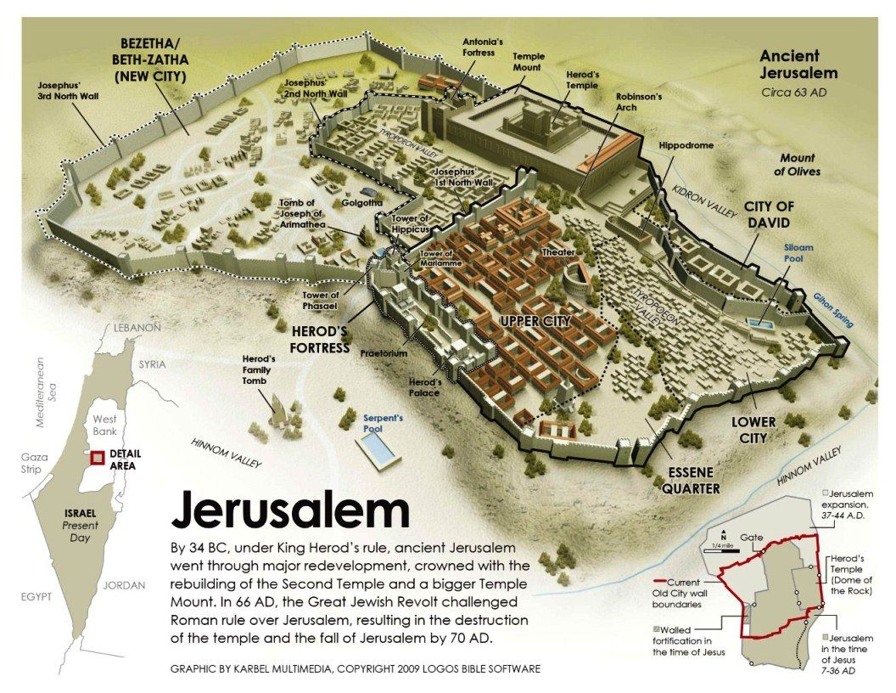

2. “and His disciples came to Him to point out the temple buildings.”
a. The Lord typically walked in front of His disciples and they followed behind Him. So the phrase ‘His disciples came to Him’ probably refers to them catching up to Him as He walked ahead of them. They were awestruck by the temple buildings and were pointing various things out to each other. In their fascination with the architecture, they point out various things to Jesus. They are impressed by the buildings and think the Lord will be also.
b. Mark and Luke tell us part of the content of what the disciples said:
(1) Mk 13:1, “And while He was going out of the temple, one of His disciples said to Him, ‘Teacher, behold what wonderful stones and what wonderful buildings!’”
(2) Lk 21:5, “And while some were saying about the temple that it was decorated with beautiful stones and votive offerings,…”
c. The disciples were marveling at the work of man, when they should have been thinking about the work of God that Jesus had just performed in warning the leaders of Israel.
d. Not mentioned here but implied by statements used against Jesus at His trials, there were other people listening to what Jesus is about to say in answer to His disciples. The Lord’s ever present critics were listening carefully to what He is about to say regarding the temple and its buildings and will use what He says to accuse Him of blasphemy (the Jewish charge against Him) and sedition (the Gentile charge against Him).

3. Commentators’ comments.
a. “The disciples pointed out the buildings of the temple area to Jesus as if to impress Him with their magnificence. What could possibly happen to such impressive buildings, especially to the temple of God?”
b. “The disciples pointed in wonder to the solidity and massiveness of the magnificent temple that Herod had built for the Jewish nation. Could Jesus really mean that all this solid magnificence would be destroyed? To them, it must have appeared impossible that anyone could destroy so solid and massive a structure, or even if someone could, then surely it would be unthinkable for anyone to be so unfeeling, so base, as to destroy something so beautiful, the only temple of the only true God.”
c. “As they leave the temple, Jesus’ followers continue to marvel at its grandeur. Jesus immediately redirects their attention to its transience.”
d. “All three Synoptists tell us that this important discourse [the Olivet Discourse] was triggered by a comment made to Jesus about the stones with which the temple was built. The temple was an important and beautiful building, and plainly the Jews were very proud of it. But Jesus was more interested in the service of God than the beauty of the place of worship, and He immediately prophesied the destruction of the magnificent edifice. Matthew makes a break between this narrative and the preceding by telling us that Jesus had gone out of the temple. There appears to be symbolism in this: Jesus now leaves the temple for the last time; He abandons it. Matthew omits the story of the widow’s mite (Mark 12:41–44), an omission that has the effect of showing that what Matthew now says is the sequel to the lament over Jerusalem at the end of chapter 23. It is not clear why his disciples drew attention to the great stones in the building (Mark says that one of them did this, and Luke has the indefinite ‘some’). Perhaps it was not so much an attempt to show Him something that they thought He had not seen before, as a remark about the wonder of the temple’s construction, more especially, how would such a solidly built city be destroyed?. There were some very large stones in the temple Herod built; Josephus says in one place that they measured twenty-five cubits in length [37.5 ft.], eight in height [12 ft.], and twelve in width, and in another he gives the dimensions as forty-five by five by six. In any case, the temple was a beautiful building with its white marble and its gold overlays. There is a rabbinic comment: ‘He who has not seen the Temple of Herod has never seen a beautiful building’.”

BDAG, p. 370.
Barbieri, L. A., Jr. (1985). Matthew. In The Bible Knowledge Commentary: An Exposition of the Scriptures (Vol. 2, p. 76). Wheaton, IL: Victor Books.
Mills, M. S. (1999). The Life of Christ: A Study Guide to the Gospel Record (Mt 24:1–Lk 21:6). Dallas, TX: 3E Ministries.
Blomberg, C. (1992). Matthew (Vol. 22, p. 352). Nashville: Broadman & Holman Publishers.
Morris, L. (1992). The Gospel According to Matthew (pp. 594–595). Grand Rapids, MI; Leicester, England: W.B. Eerdmans; Inter-Varsity Press.

