   

 is the adversative use of the postpositive conjunction DE, meaning “However” plus the nominative masculine singular aorist active participle of the verb AKOUW, which means “to hear.”
The aorist tense is a constative/historical aorist, which views the action in its entirety as a fact.
The active voice indicates that Herod produced the action.
The participle is a temporal participle that precedes the action of the main verb and can be translated “after hearing.”
Next we have the nominative subject from the masculine singular article and noun BASILEUS plus the proper noun HĒRWIDĒS, meaning “King Herod.” There is no direct object in the Greek, but English grammar requires one. Thus the addition of the word “[this].” Then we have the third person singular aorist passive indicative from the verb TARASSW, which means “to be shaken; to be troubled, frightened, terrified Mt 2:3; 14:26; Mk 6:50; Lk 1:12; 24:38.”
The aorist tense is a constative/historical aorist, which views the action in its entirety as a fact.
The passive voice indicates that Herod received the action.
The indicative mood is declarative for a simple statement of fact.

“However, King Herod, after hearing [this], was troubled”

    is the additive use of the conjunction KAI, meaning “and,” followed by the nominative subject from the feminine singular adjective PAS with the proper noun HIEROSOLUMA, meaning “all Jerusalem.” Finally, we have the preposition META plus the genitive of association from the third person masculine singular personal use of the intensive pronoun AUTOS, meaning “with Him.”

“and all Jerusalem with him,”

Mt 2:3 corrected translation
“However, King Herod, after hearing [this], was troubled and all Jerusalem with him,”

Explanation:

1. “However, King Herod, after hearing [this], was troubled”
a. Matthew continues the story with a contrast between the attitude of the magi, who wanted to worship the new king, and the attitude of King Herod and all Jerusalem, who are troubled, frightened, and terrified by the revelation of the magi. The Greek verb TARASSW, means to be shaken, to be troubled, frightened, terrified, showing the different degrees of mental state based upon the given circumstances in which a person finds themselves. Herod was shaken mentally, when he first heard the news. And the more he thought about it, the more troubled he became. Eventually he feared losing his throne, and finally he was terrified at the prospect of what the future held.
b. We see in the life of Herod how his mind worked in this type of situation. Every time someone in his family was suspected of any disloyalty they were murdered. “It was necessary for Herod to gain loyalty from his subjects and to eliminate those hostile to his role. He contended with four adversaries: the populace and the Pharisees, the aristocracy, the Hasmonean family, and Cleopatra of Egypt.
Since the Pharisees held sway over the majority of the people, there was a reluctance to have Herod rule because he was an Idumean, a half-Jew, and a friend of the Romans. Herod punished with severity those Pharisees and elements of the population that opposed him.
The second adversary was the aristocracy. Herod executed forty-five of the Sadducean aristocracy; many if not all of them were members of the Sanhedrin. He confiscated their property to pay the demands placed upon him by Antony.
The third adversary was the Hasmonean family. Herod’s mother-in-law Alexandra, the mother of Mariamne, was the cause of the trouble. One Hasmonean was Hyrcanus, the former high priest, who had a good relationship with Herod. Upon Hyrcanus’s return from the Parthian captivity, however, he was not able to resume his office as high priest because of his physical mutilation. Therefore, since Herod was an Idumean and could not assume the rule of high priest, Herod selected Ananel (Hananeel) of the Babylonian Diaspora. He was an insignificant priest from the Zadokite family thought to be of the Aaronic line, and who had held the high priesthood before the Hasmoneans. Herod thought this to be a legitimate way of bypassing the Hasmonean priestly line. Herod’s mother-in-law Alexandra felt insulted; for she wanted her sixteen-year-old son Aristobulus, Mariamne’s brother, to be high priest since he was the only legitimate heir for that position from the Hasmonean line. Alexandra put pressure on Herod by appealing to her friend Cleopatra, who then convinced Antony of Herod’s wrong conduct; consequently under Antony’s urging Herod removed Ananel (an unlawful removal since the high priest’s office was lifelong) and installed Aristobulus as high priest when he was only seventeen years of age, circa late 36 or early 35 b.c. Although this action brought some relief to the tension between Herod and Alexandra, it was short-lived, because Herod thought of the Hasmonean family as his enemies. This distrust was so overbearing that Alexandra and her son Aristobulus tried to escape to Egypt in two coffins but were caught in the act when the plan was betrayed to Herod. Although he overlooked the offense because of his fear of Cleopatra’s reprisals, his suspicion of Alexandra only intensified. At the following Feast of Tabernacles (35 b.c.) Aristobulus officiated as high priest and the populace showed great affection for him; his popularity caused Herod to view him as a dangerous rival who had to be removed. Immediately after the festivities, Alexandra invited Herod to be her guest in Jericho. Herod exhibited friendliness toward Aristobulus and on a hot day suggested that they go swimming to cool off. Some of Herod’s servants and friends were swimming and playing in the water with Aristobulus. As if in sport Herod’s friends held Aristobulus’s head too long under water and he drowned. Herod simulated the most profound grief and provided a lavish funeral and a very fine tomb. Although the populace accepted the official version of an accidental death, Alexandra knew the facts and devoted herself to revenge. She convinced Antony through Cleopatra of Herod’s misdeeds and Antony summoned Herod to appear before him at Laodicea (on the coast of Syria). Realizing that he could be sentenced to death, Herod put his wife Mariamne under the surveillance of his uncle Joseph, who was also the husband of Herod’s sister Salome, and ordered her death if Herod were sentenced to die. Herod convinced Antony by means of gifts and eloquence that he was not guilty. When he returned Salome accused her husband Joseph of having intercourse with Mariamne. Mariamne denied this and Herod believed her. She revealed, however, that Joseph had informed her of Herod’s order to kill her if Antony sentenced him to death. In a fit of rage Herod was now convinced that Salome’s charge of adultery was accurate, and without a trial Joseph was executed. Since he felt that many of these problems were caused by Alexandra, Herod put her in chains and under guard.
The final adversary was Cleopatra. She was greedy, and wanted to eliminate Herod and Malchus of Arabia and possess their land. Antony would not permit this. In 32 b.c. civil war broke out between Octavius and Antony. Herod wanted to help Antony but was prevented by Cleopatra, who wanted Herod to make war on the Arabian king because he was late in paying his tribute to Cleopatra. Ultimately she wanted Herod and the Arabian to weaken and exhaust each other so she could take over both of their territories. In 31 b.c., shortly after the war between these two vassal rulers had come to a standstill, there was a terrible earthquake in Palestine that killed thirty thousand people. The Arabs seized the opportunity to attack, but Herod was able to muster an army, completely rout the Arabs, and demand their surrender. Soon afterward, on September 2, 31 b.c., Octavius defeated Antony in the Battle of Actium. This was a blow to Herod, who now had to skillfully convince Octavius that he was the legitimate ruler of Palestine. Fortune was on his side. In Cyzicus there were gladiators of Antony who were training for the games that were to be a part of the victory celebration of Antony over Octavius. When they heard of Antony’s defeat they attempted to go to Egypt to help him, but were prevented from passing through Syria by the governor of Syria, and Herod. With this demonstration of loyalty, Herod now could go to Octavius. Before he departed to meet him, however, he did two things. First, he accused Hyrcanus, the only remaining rival to the throne, of plotting with the king of the Nabateans and had him executed. Second, fearing that possibly his mother-in-law, Alexandra, might cause some problems, Herod put her and his wife Mariamne in Alexandreion under the surveillance of his steward Joseph (not his brother-in-law) and a trusted friend. He ordered their death if he were killed, and the preservation of the kingdom for his sons and his brother. Herod met Octavius at Rhodes (spring, 30 b.c.) and handled the situation skillfully. Although he admitted his loyalty to Antony, he demonstrated that he actually did not fight Octavius during the civil war because of his skirmish with the Arabs. Octavius was convinced of his loyalty, and confirmed his royal rank. Leaving Asia Minor, Octavius went along the Phoenician coast to invade Egypt. With great pomp Herod met him in Ptolemais, giving him eight hundred talents, duly appreciated by Octavius. After Octavius defeated Antony in Egypt, Herod went to Egypt to congratulate him. Octavius returned Jericho (which had been taken by Cleopatra) to Herod, and added Gadara, Hippos, Samaria, Gaza, Anthedon, Joppa, and Strato’s Tower (which later became Caesarea). Although Herod was politically successful, his domestic affairs fell into disarray. While Herod was in Rhodes, Mariamne discovered from the guard that she was to be killed in the event that he did not return. This caused great upheaval in Herod’s life. With the encouragement of his sister Salome, and their mother, both of whom hated Mariamne, Herod finally executed Mariamne at the end of 29 b.c. Herod never fully accepted her death. He became ill, and because there was some doubt that he would recover, Alexandra attempted to seize control of two fortified places in Jerusalem in order to secure the throne. Hearing of this plot, Herod had her executed in 28 b.c. Finally, the governor of Idumea (husband of Herod’s sister Salome), who earlier conspired with Cleopatra against Herod but was forgiven because of Salome’s entreaty, once again came under suspicion for alleged pro-Hasmonean sympathies. Salome now wanted to get rid of her husband, and supplied information about his plans for a revolt. She charged that her husband was preserving the influential sons of Babas who remained loyal to Antigonus and always spoke ill of Herod. Herod was incensed and executed Costobarus and his followers (25 b.c.). All the male relatives of Hyrcanus had now been removed, and no living contenders for Herod’s throne remained. This marks the end of the first period of Herod’s rule.” And that only takes us down to 25 B.C., the first twelve years of his reign.

2. “and all Jerusalem with him,”
a. Herod wasn’t the only person that was troubled and frightened by the news of the new King. All the people of Jerusalem were also troubled along with Herod. The question is, ‘Were they troubled for the same reason as Herod, or afraid of what Herod might do based on his past history of dealing with those who challenged his rule?’ Would Herod take out his fear on the people of Jerusalem?
b. Knowing Herod’s history, it is no wonder that the population of Jerusalem were ‘troubled, frightened, terrified. Herod could snap at any moment and start killing anyone he suspected of hoping for the advent of the new King. The priesthood could be wiped out. The Sadducees could be wiped out. The Pharisees could be accused of treason. No one was safe in this situation.

3. Commentators’ comments.
a. “Herod was a cruel and crafty man who permitted no one, not even his own family, to interfere with his rule or prevent the satisfying of his evil desires. A ruthless murderer, he had his own wife and her two brothers slain because he suspected them of treason. He was married at least nine times in order to fulfill his lusts and strengthen his political ties.”
b. “Herod was not the rightful king from the line of David. In fact he was not even a descendant of Jacob, but was descended from Esau and thus was an Edomite. This fact caused most of the Jews to hate him and never truly to accept him as king.”
c. “Herod was in his late sixties at the magi’s visit. He had an absolute paranoia about someone usurping his throne, and was ruthless in quelling anything that he saw as a threat to his reign. Deaths at his hands ran into thousands; he even executed two of his own sons by strangling (probably about three years before the magi’s visit) as he suspected them of plotting to take his throne, and had earlier executed another son and wife for plotting against him. Traditionally, there was a close political affinity between the Persians and Jews, so the paranoid Herod would have been suspicious of a visit from the magi, traditionally king-makers, proclaiming the birth of a new king, especially as the Parthian Empire (which included the Persians and magi) was outside the Roman Empire. The Parthians had invaded Palestine around 36 bc and swept the Romans and Herod out of the country, and Herod had only been able to regain his throne after three years. This visit by the Magi could easily have contributed to Jerusalem’s agitation.” The people could have feared another invasion by the Parthians.
d. “Herod’s concern is understandable: as an Edomite and a Roman appointee, he was vulnerable to the claims of a king of the true Davidic dynasty. His later years were plagued by the fear of rivals.”
e. “If Herod were a true devotee of the Judaism of Scripture, he should have rejoiced greatly, but he does not. Instead, he views the new child as a mortal threat. ‘Disturbed’ is too weak a translation of his reaction; ‘in turmoil’ or even ‘terrified’ would be more accurate. ‘All Jerusalem’ probably refers primarily to the religious leaders of Israel who dominated the city, many of whom were also personally installed by Herod.”
f. “Herod was troubled; he was an Edomite, not a Jew, and he had been made king by the Romans. The news that the Magi were bringing sounded suspiciously like the emergence of a genuine descendant of the royal line of David as a claimant to the throne (Herod was more interested in saving his throne than in saving his soul!). And if Herod was troubled, the whole city was troubled with him. When Herod the Great trembled the whole city shook.”
g. “The city readily guessed the true reason of Herod’s agitation and on its part feared the violent measures the bloody old despot might take in putting down any movement that might arise in favor of the Messiah King. The contrast is highly dramatic and significant: the Gentile magi come from distant lands to worship the newborn King. Herod and the Jewish capital are upset at the thought of such a King.”

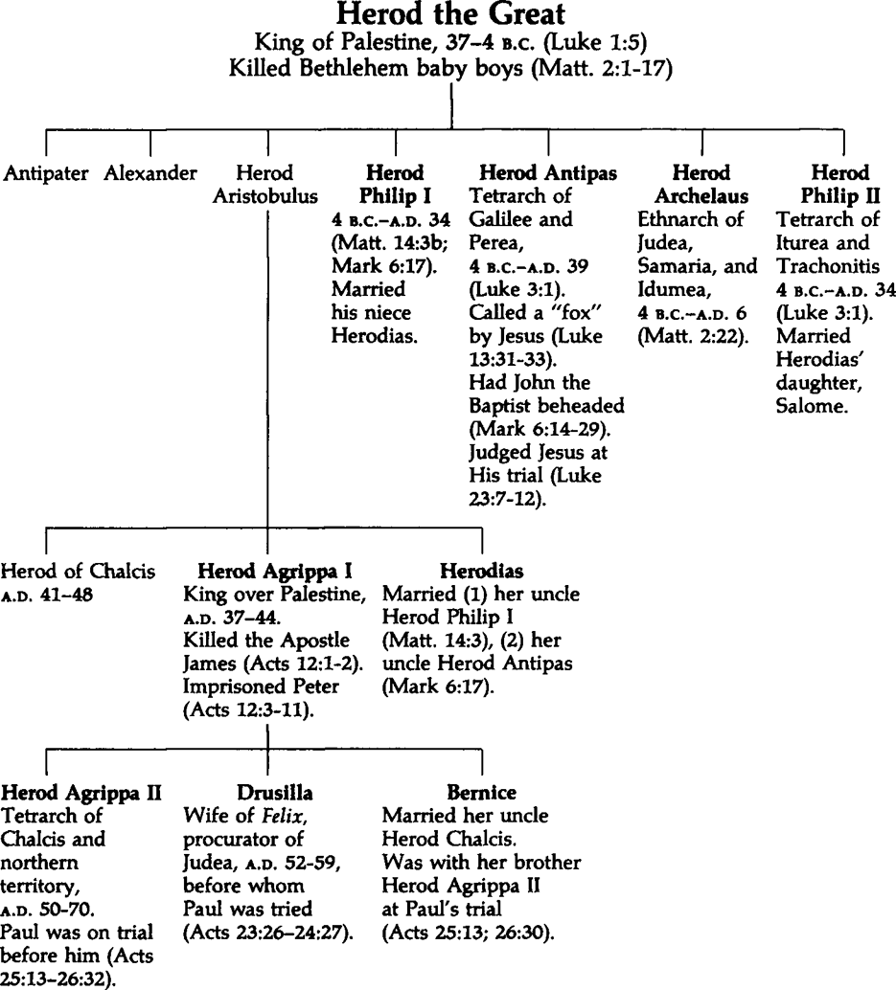

Arndt, Danker, Bauer & Gingrich, (2000). A Greek-English Lexicon of the New Testament and other early Christian literature (3rd ed., p. 990). Chicago: University of Chicago Press.
Hoehner, H. W. (1979–1988). Herod. In G. W. Bromiley (Ed.), The International Standard Bible Encyclopedia, Revised (Vol. 2, p. 690ff). Wm. B. Eerdmans.
Wiersbe, W. W. (1996). The Bible Exposition Commentary (Vol. 1, p. 14). Wheaton, IL: Victor Books.
Barbieri, L. A., Jr. (1985). Matthew. The Bible Knowledge Commentary: An Exposition of the Scriptures (Vol. 2, pp. 21–22). Wheaton, IL: Victor Books.
Mills, M. S. (1999). The Life of Christ: A Study Guide to the Gospel Record (Mt 2:1–12). Dallas, TX: 3E Ministries.
France, R. T. (1985). Matthew: an introduction and commentary (Vol. 1, p. 88). Downers Grove, IL: InterVarsity Press.
Blomberg, C. (1992). Matthew (Vol. 22, p. 63). Nashville: Broadman & Holman Publishers.
Morris, L. (1992). The Gospel according to Matthew (p. 37). Grand Rapids, MI; Leicester, England: W.B. Eerdmans; Inter-Varsity Press.
Lenski, p. 61.

