□     

□  is the continuative use of the postpositive conjunction DE, meaning “Then” with the nominative masculine singular subject from the article HO, used as a personal pronoun, meaning “he” and referring to Joseph. Next we have the nominative masculine singular aorist passive participle of the verb EGEIRW, which means “to rise, to arise, to get up, to awake.”
The aorist tense is a constative/historical aorist, which views the action in its entirety as a fact.
The passive voice indicates that Joseph will receive the action.
The participle is a temporal participle that precedes the action of the main verb and can be translated “after getting up.”
This is followed by the third person singular aorist active indicative from the verb PARALAMBANW, which means “to take: took.”
The aorist tense is a constative/historical aorist, which views the action in its entirety as a fact.
The active voice indicates that Joseph produced the action.
The indicative mood is declarative for a simple statement of fact.
Then we have the accusative direct object from the neuter singular article and noun PAIDION plus the additive use of the conjunction KAI plus the accusative direct object from the feminine singular article and noun MĒTĒR with the possessive genitive from the third person masculine singular personal use of the intensive pronoun AUTOS, meaning “the Child and His mother.”

“Then, after getting up, he took the Child and His mother”

     is the continuative use of the conjunction KAI, meaning “and,” followed by the third person singular aorist active indicative from the verb EISERCHOMAI, which means “to go into; to enter.”
The aorist tense is a constative/historical aorist, which views the action in its entirety as a fact.
The active voice indicates that Joseph produced the action.
The indicative mood is declarative for a simple statement of fact.
Finally, we have the preposition EIS plus the accusative of place from the feminine singular noun GĒ plus the genitive of identity from the masculine singular proper noun ISRAĒL, meaning “into the land of Israel.”

“and entered into the land of Israel.”

Mt 2:21 corrected translation
“Then, after getting up, he took the Child and His mother and entered into the land of Israel.”

Explanation:

1. “Then, after getting up, he took the Child and His mother”
a. Matthew continues the story of the travels of Jesus as a young child by telling us what Joseph did after the angel appeared to him in a dream and told him to take the family back to Israel.
b. Joseph did exactly as he was told—immediate, willing, obedience. He woke up in the morning, not in the middle of the night, got the family up, had breakfast, explained what the angel had said, packed up the family, said goodbye to friends and neighbors and headed north to Israel. His immediate destination will be Bethlehem.
c. Again we notice the priority of the Child over the mother, the Child being mentioned first.
d. We are never told exactly where Joseph settled in Egypt. But the most logical place would have been Alexandria, because of the large Jewish population there and the ability to ‘hide’ among the thousands of Jews there. The distance is roughly 350 miles, which could have been traveled in 3-4 weeks.

2. “and entered into the land of Israel.”
a. Traveling from the south, the family would have first entered Israel at Gaza or Beersheba. (See the map.) The final destination is yet to be determined or revealed.
b. Commentators love to compare this ‘Exodus’ of Jesus from Egypt to Israel with the Exodus of Moses and the people of Israel.

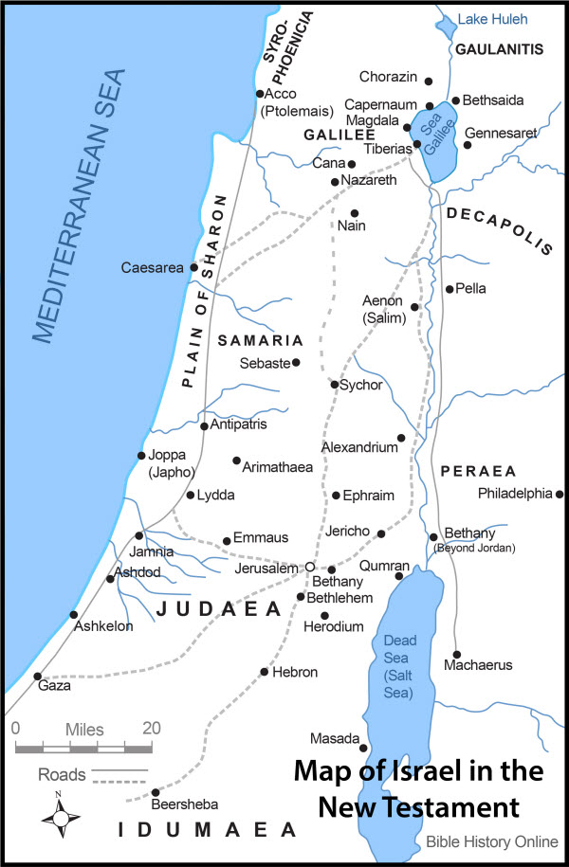

3. Commentators’ comments.
a. “Joseph obediently followed the Lord’s instruction and was planning to return to the land of Israel, perhaps to Bethlehem.”
b. “The wording of the narrative echoes the angel’s command and highlights Joseph’s careful obedience.”
c. “For the fourth time we have a reference to Joseph rising and taking the young child and his mother (verses 13, 14, and 20). Joseph was obedient.”

Barbieri, L. A., Jr. (1985). Matthew. The Bible Knowledge Commentary: An Exposition of the Scriptures (Vol. 2, p. 23). Wheaton, IL: Victor Books.
Blomberg, C. (1992). Matthew (Vol. 22, p. 69). Nashville: Broadman & Holman Publishers.
Morris, L. (1992). The Gospel according to Matthew (p. 48). Grand Rapids, MI; Leicester, England: W.B. Eerdmans; Inter-Varsity Press.

