   □    □ □

   □   is the transitional use of the postpositive conjunction DE, meaning “Now; Then” plus the nominative masculine singular aorist active participle of the verb ERCHOMAI, which means “to come.”
The aorist tense is a constative/historical aorist, which describes the past action as a fact.
The active voice indicates that Jesus produced the action.
The participle is temporal with the action of the participle preceding the action of the main verb. This can be translated “after coming.”
Next we have the nominative subject from the masculine singular article and proper noun IĒSOUS, meaning “Jesus.” This is followed by the preposition EIS plus the accusative of place from the neuter plural article and noun MEROS plus the descriptive genitive (genitive of identity) or adverbial genitive of place from the feminine singular proper noun KAISAREIA and the possessive genitive (‘belonging to Philip’) or genitive of identity from the feminine singular article and proper noun PHILIPPOS, meaning “into the district of Caesarea of Philip.”

“Now Jesus, after coming into the district of Caesarea of Philip,”

 is the third person singular imperfect active indicative of the verb ERWTAW, which means “to ask: was asking.”
The imperfect tense is a descriptive imperfect, which describes what was actually taking place in the past. It describes the past action as having been in progress.
The active voice indicates that Jesus was producing the action.
The indicative mood is declarative for a simple statement of fact.
Then we have the accusative direct object from the masculine plural article and noun MATHĒTĒS with the possessive genitive from the third person masculine singular personal use of the intensive pronoun AUTOS, meaning “His disciples.” With this we have the nominative masculine singular present active participle of the verb LEGW, which mean “to say: saying.”
The present tense is a descriptive present of what was occurring at that moment.
The active voice indicates that Jesus produced the action.
The participle is circumstantial.

“was asking His disciples, saying,”

  □ □  is the accusative direct object from the masculine singular interrogative pronoun TIS, meaning “Who?” Next we have the third person plural present active indicative of the verb LEGW, which means “to say.”
The present tense is a descriptive present of what is now occurring.
The active voice indicates that men produce the action.
The indicative mood is an interrogative indicative, which is used in questions that can be answered by providing factual information.
This is followed by the nominative subject from the masculine plural article and noun ANTHRWPOS, meaning “men.” Next we have the present active infinitive of the verb EIMI, which means “to be: is.”
The present tense is an aoristic present, which describes the state of being as a fact.
The active voice indicates that Jesus produces the state of being someone.
The infinitive functions like a finite verb in the accusative-infinitive construction, which we have here.
With the infinitive we have the accusative ‘subject of the infinitive’ from the masculine singular article and noun HUIOS plus the genitive of relationship from the masculine singular article and noun ANTHRWPOS, which means “the Son of Man.”

“‘Who do men say the Son of Man is?’”

Mt 16:13 corrected translation
“Now Jesus, after coming into the district of Caesarea of Philip, was asking His disciples, saying, ‘Who do men say the Son of Man is?’”

Mk 8:27, “And then Jesus and His disciples went out to the villages of Caesarea of Philip; and on the way He kept asking His disciples, saying to them, ‘Who do men say that I am?’”

Explanation:

1. “Now Jesus, after coming into the district of Caesarea of Philip,”
a. From Bethsaida in Galilee Jesus and the disciples go into the district of Caesarea, ruled by Herod Antipas’ brother Philip. Some translations say “Caesarea Philippi,” but the Greek says “Caesarea of Philip,” using the proper noun PHILIPPOS rather than the word PHILIPPOI, which is the same word used for the city of Philippi in Macedonia. The idea conveyed by the Greek is that this is “Philip’s Caesarea” (possessive genitive).
b. “Herod Philip the tetrarch was the son of Herod the Great and Cleopatra of Jerusalem. He was tetrarch [a one-fourth ruler; he ruled one-fourth of the land ruled by Herod the Great after Herod’s death] of Gaulanitis, Trachonitis, Auranitis, Batanea and Panias (according to Josephus, if the indications he gives in various passages may thus be brought together), and according to Lk 3:1, also Iturea (all small districts northeast of Palestine). He rebuilt Panias as Caesarea (Philippi) and Bethsaida as Julias. Josephus praises his personality and administration. He was married to Salome, the daughter of Herodias. He died 33/34 a.d.”
c. Why did Jesus go into Herod Philip’s territory? To avoid being hunted down and arrested by Herod Antipas, who thought Jesus was the resurrection of John the Baptist, whom Herod had beheaded. Jesus will go to Jerusalem at Passover to be the Lamb of God who takes away the sin of the world. He will not give Herod Antipas the chance to arrest and behead Him, which was one of Satan’s schemes to keep Jesus from being judged for our sins on the Cross.
d. See the map below for the location of Philip’s territory.
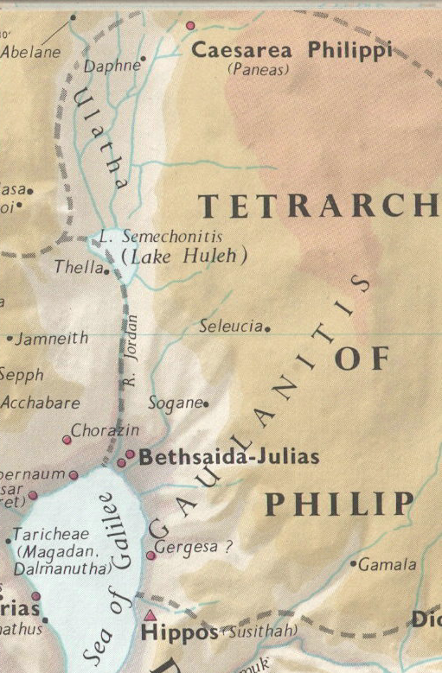

2. “was asking His disciples, saying,”
a. Having gone into safe territory, where Jesus can continue teaching His disciples and preparing them for His death, the Lord turns His attention to what the disciples believe and understand about His person.
b. In order to understand His death, burial, resurrection and ascension, the disciples must be crystal clear about who Jesus is. They must understand that He is no mere man like them, but someone far more than just a man. A mere man cannot go to the Cross and bear the sins of the world and be judged for them. A mere man cannot go into the grave for three days and nights and be resurrected. (Men were resuscitated—came back to life and subsequently died again—but no one had ever rose from the dead, never to be able to die again.) No one had yet ever ascended into heaven. (Enoch walked with God, but it doesn’t say he walked into heaven. Like the rest of the Old Testament believers, Jesus probably walked with Enoch into the Paradise of Hades.)
c. So in order to get the disciples thinking, Jesus does what He typically does—He begins asking questions.

3. “‘Who do men say the Son of Man is?’”
a. The first question Jesus asks on this teaching occasion is “Who do men say that He, Jesus, is?”
b. As we have seen previously in this gospel, Jesus used the title ‘Son of Man’ as a substitute for the first person personal pronoun EGW, meaning “I.” So in reality this question is “Who do men say I am?”
c. Jesus wants to know what the disciples have heard people discussing Jesus say about who He is. Is He God, the Messiah, a former Jewish prophet come back to life, the Prophet foretold by Moses, a good Rabbi, a nice man, a nut job, etc. There are all kinds of possible answers the disciples have heard from the crowds or the religious leaders of Israel.
d. After hearing all the answers by His closest followers, the Lord can then ask them a more leading and personal question. Rightly establishing exactly who He is will be critical for surviving and handling the coming crisis of Jesus’ death. The disciples must establish the firm fact in their thinking of whom Jesus really is, or they will not be able to endure the psychological and spiritual pressure of His death.
e. Therefore, Jesus is setting them up for future spiritual success by focusing their understanding on Who and What He is now.

4. Commentators’ comments.
a. “Jesus took His disciples to Gentile territory, in the region of Caesarea Philippi. They were about 120 miles from Jerusalem in the northern part of Palestine. The region was strongly identified with various religions: It had been a center for Baal worship; the Greek god Pan had shrines there; and Herod the Great had built a temple there to honor Augustus Caesar.”
b. “Jesus and the disciples removed themselves from the region around the Sea of Galilee and went north about 30 miles to Caesarea Philippi, that is, Caesarea in the tetrarchy of Herod Philip, Antipas’ brother.”
c. “Caesarea Philippi lies thirty miles north of Bethsaida. Jesus was taking His disciples towards a specific destination, the Mount of Transfiguration. To prepare them for this event, He asked a leading question about His person, a question designed to make them squarely face making up their mind as to just exactly who He is.” The problem with this statement is that Jesus told the three disciples not to discuss His transfiguration with ‘anyone’, which includes the other disciples, until after His resurrection (Mt 17:9). So the other disciples weren’t being prepared for the transfiguration. They had no idea it had happened.
d. “In Jesus’ question Matthew has the Son of man where Mark and Luke have simply ‘I’; this substitution confirms the view that ‘the Son of man’ was understood to be Jesus’ special way of referring to Himself, but not a title with a ready-made content, thus leaving open the question ‘Who is this Son of man?’ (Jn 12:34).”
e. “Jesus and His followers head upstream along the Jordan River to its headwaters near Caesarea Philippi, approximately twenty-five miles north of the Sea of Galilee. Formerly known as Paneas, a center of worship for the Greek god Pan, the city recently had been renamed by Philip the tetrarch in honor of himself and Augustus Caesar. Matthew does not tell us why Jesus and the disciples went here, but it is easy to imagine them once again foreshadowing the more extensive Gentile ministry that lies ahead. [And to stay out of the clutches of Herod Antipas.] Matthew, however, focuses solely on the dialogue Jesus initiates with the Twelve. He questions their perception of the crowds’ views of His identity, not for His own information but to correct the misconceptions that have arisen.”
f. “At this point Matthew puts His emphasis on the Master. He came to the district of Caesarea Philippi. This city was situated about twenty-five miles north of the sea of Galilee at the foot of Mount Hermon, which was largely pagan territory. One of the sources of the Jordan issues from a cave near this city, and there was an ancient shrine in the cave. When the Greeks came they dedicated the shrine to ‘Pan and the Nymphs’; they called the cave ‘Paneion’ and the area ‘Paneas.’ In 20 b.c. Augustus gave the district to Herod the Great and built a temple of white marble in honor of the emperor at Paneas. When Herod died in 4 b.c. the area became part of the tetrarchy of Philip, and this man rebuilt the city. He called it Caesarea in honor of the emperor Augustus and added ‘Philippi’ (which distinguished it from Caesarea on the Mediterranean coast and, of course, honored Philip himself). Jesus asked the disciples a question about what people thought of Him. There is no indication of why He did this, and nothing in the narrative leads up to it. But He asked them who men (that is, people in general) said the Son of man was. This, of course, was Jesus’ favorite self-designation, and it is clear that He was asking a question about how He Himself was regarded by people outside His circle, not inquiring about how they interpreted Dan 7:13. This is clear from Mark and Luke, neither of whom has ‘the Son of man,’ but simply ‘who I am’.”
g. “What Jesus desires is to have the disciples state the wrong opinions of men in order to set over against them their own right conviction. These foolish opinions He does not care even to discuss; and the disciples themselves will brush them aside.”

Arndt, W., Danker, F. W., Bauer, W., & Gingrich, F. W. (2000). A Greek-English Lexicon of the New Testament and other early Christian literature (3rd ed., pp. 1057–1058). Chicago: University of Chicago Press.
Wiersbe, W. W. (1996). The Bible Exposition Commentary (Vol. 1, p. 57). Wheaton, IL: Victor Books.
Barbieri, L. A., Jr. (1985). Matthew, in The Bible Knowledge Commentary: An Exposition of the Scriptures (Vol. 2, p. 57). Wheaton, IL: Victor Books.
Mills, M. S. (1999). The Life of Christ: A Study Guide to the Gospel Record (Mt 16:13–Lk 9:21). Dallas, TX: 3E Ministries.
France, R. T. (1985). Matthew: an introduction and commentary (Vol. 1, p. 255). Downers Grove, IL: InterVarsity Press.
Blomberg, C. (1992). Matthew (Vol. 22, p. 250). Nashville: Broadman & Holman Publishers.
Morris, L. (1992). The Gospel According to Matthew (p. 419). Grand Rapids, MI; Leicester, England: W.B. Eerdmans; Inter-Varsity Press.
Lenski, p. 619.

