😐  □     □ □

😐   is the continuative/transitional use of the conjunction KAI, meaning “And so; And then.” This is followed by the nominative masculine singular aorist active participle of the verb EXERCHOMAI, which means “to go out; to go from; to go away.”
The aorist tense is a constative/historical aorist, which describes the past action as a fact.
The active voice indicates that Jesus produced the action.
The participle is temporal with the action of the participle being coterminous with the action of the main verb. This is translated like a circumstantial participle.
Then we have the adverb of place EKEITHEN, meaning “from there.”

“And then, going away from there,”

□     □ □  is the nominative subject from the masculine singular article and proper noun IĒSOUS, meaning “Jesus,” followed by the third person singular aorist active indicative of the verb ANACHWREW, which means “to go away; to withdraw; to retire.”
The aorist tense is a constative/historical aorist, which describes the past action as a fact.
The active voice indicates that Jesus produced the action.
The indicative mood is declarative for a simple statement of fact.
Next we have the preposition EIS plus the accusative of place/direction from the neuter plural article and noun MEROS, meaning “into the districts.” With this we have the possessive genitive or genitive of identity from the feminine singular proper nouns TUROS and SIDWN with an additive use of the conjunction KAI, meaning “of Tyre and Sidon.”

“Jesus withdrew into the districts of Tyre and Sidon.”

Mt 15:21 corrected translation
“And then, going away from there, Jesus withdrew into the districts of Tyre and Sidon.”

Mk 7:24, “Then, after getting up, He went away from there to the region of Tyre. And after entering into a house, He wanted no one to know; and yet He was not able to escape notice.”

Explanation:

1. “And then, going away from there,”
a. Matthew continues the narrative of the life of Jesus by telling us that Jesus ‘went away from there’. The last place Matthew mentions as Jesus’ location was the land or district of Gennesaret, Mt 14:34, “And after crossing over, they came onto land at Gennesaret.”
b. Mark has Jesus located in the same place, Mk 6:53, “And after crossing over, they came on the land at Gennesaret, and were moored.”
c. So based on the only evidence we have in the gospels, Jesus went from Gennesaret to the districts of Tyre and Sidon as mentioned in the next statement.

2. “Jesus withdrew into the districts of Tyre and Sidon.”
a. To withdraw suggests movement away from a dangerous situation. The dangerous situation is not the people of Gennesaret, but the person of Herod Antipas and his intent to find and kill Jesus, whom he believes to be the resurrected John the Baptist.
b. Jesus makes the prudent decision to relocate temporarily into the districts or region of Tyre and Sidon. The gospels do not indicate that the Lord actually went into these cities, but to the supporting villages and areas around these cities.
(1) “Sidon was named after the firstborn son of Canaan (Gen 10:15) and probably settled by his descendants. The northern border of ancient Canaan extended to Sidon (Gen 10:19). Later, Jacob spoke of it as the boundary of Zebulun (Gen 49:13) and Joshua included it as part of the land promised to Israel (Josh 13:6). Sidon was included in the inheritance of Asher, on its northern boundary (Josh 19:28), but it was not taken by that tribe in conquest (Judg 1:31, 3:3).
(2) Tyre is twenty miles south of Sidon on the Mediterranean coast. Both cities were Canaanite cities. Tyre first appeared as part of Asher’s western boundary (Josh 19:29). Tyre does not appear again in the Bible until Hiram, king of Tyre, sends cedar, carpenters, and masons to build David’s house (2 Sam 5:11).”
c. Jesus is the first missionary to the Gentiles, taking the gospel message into the Gentile territory of Tyre and Sidon.
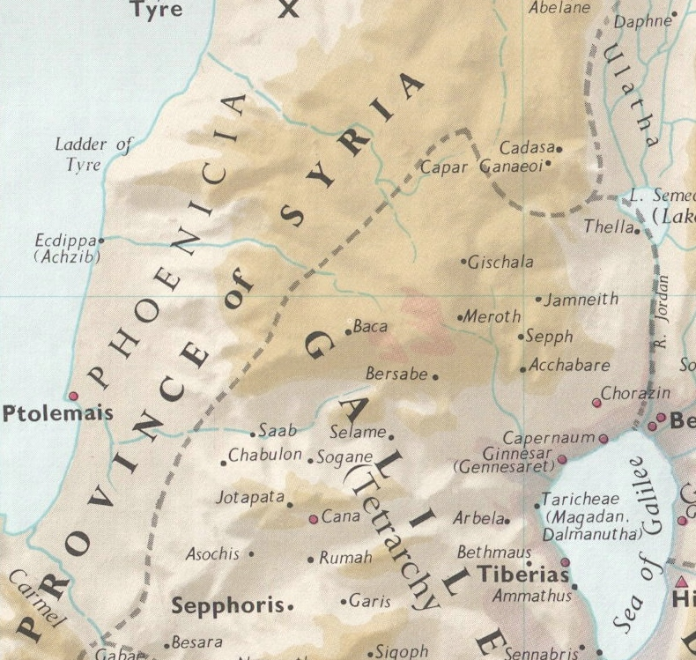

3. Commentators’ comments.
a. “Not only did Jesus teach that no foods were unclean, but He practiced His teaching by going into Gentile territory. He left Israel and withdrew again, this time into the area of Tyre and Sidon. The Gentiles were ‘unclean’ as far as the Jews were concerned.”
b. “To get away from the questionings of the religious leaders, Jesus withdrew from Israel and went north into the region of Tyre and Sidon, the Gentile coastal region of Phoenicia. Tyre was 35 miles from Galilee and Sidon was 60.”
c. “Tyre and Sidon are two Phoenician cities which lay on the Mediterranean coastline to the north of Galilee, Tyre being thirty-five miles from Capernaum, and Sidon a further twenty-five miles north of Tyre. In Jesus’ time this area was part of Syria (thus explaining the description of the woman as a Syro-Phoenician), and was very much under the Greek influence.”
d. “This brief visit to Gentile territory was not for the purpose of evangelism, but rather in the nature of a ‘retreat’ after the pressures of controversy and popularity.” I disagree that the purpose was not for evangelism, since everything Jesus did was for the purpose that not any should perish.
e. “Jesus has obviously withdrawn from Israel ideologically in verses 1–20; now He again withdraws geographically. This time he does not cross to the eastern shore of the Sea of Galilee but heads northward to Tyre and Sidon, port cities in what today would be parts of Lebanon and Syria. With the coming of Jesus, these cities receive another opportunity to repent.”
f. “Perhaps the thought is that Jesus left Galilee, that he went out of His own country. After the encounter with the scribes and Pharisees, Jesus deemed it prudent to move into the adjoining territory for a time. He went into the regions of Tyre and Sidon, the area to the north of Galilee. These were Phoenician cities on the Mediterranean coast, but they controlled territory inland. Matthew does not indicate with any precision just where Jesus went in this territory (nor does Mark). Sidon was about twenty-five miles north of Tyre, and that city was much the same distance from Jesus’ Galilean haunts, so this represents a considerable journey on foot. The round trip could have taken months. Mark tells us, as Matthew does not, that Jesus went into a house and did not want anyone to know where He was, but He could not be hidden.”
g. “Jesus continues His course of withdrawing from the populous centers into retired places, thus avoiding His enemies. This is not flight but well-considered prudence.”

BDAG, p. 75.
BDAG, p. 633.
Associates for Biblical Research website.
Wiersbe, W. W. (1996). The Bible Exposition Commentary (Vol. 1, p. 54). Wheaton, IL: Victor Books.
Barbieri, L. A., Jr. (1985). Matthew, in The Bible Knowledge Commentary: An Exposition of the Scriptures (Vol. 2, p. 55). Wheaton, IL: Victor Books.
Mills, M. S. (1999). The Life of Christ: A Study Guide to the Gospel Record (Mt 15:21–Mk 7:30). Dallas, TX: 3E Ministries.
France, R. T. (1985). Matthew: an introduction and commentary (Vol. 1, p. 249). Downers Grove, IL: InterVarsity Press.
Blomberg, C. (1992). Matthew (Vol. 22, pp. 242–243). Nashville: Broadman & Holman Publishers.
Morris, L. (1992). The Gospel According to Matthew (p. 401). Grand Rapids, MI; Leicester, England: W.B. Eerdmans; Inter-Varsity Press.
Lenski, p. 593.

