□ □□

 is the continuative use of the conjunction KAI, meaning “Then,” followed by the third person plural present active indicative from the verb PHERW, which means “to bring: they brought.”
The present tense is a historical present, which views the past action as occurring now for the sake of vividness and liveliness in the narrative. It is translated by the past tense.
The active voice indicates that the Roman soldiers produced the action.
The indicative mood is declarative for a simple statement of fact and reality.
Then we have the accusative direct object from the third person masculine singular personal use of the intensive pronoun AUTOS, meaning “Him” and referring to Jesus. This is followed by the preposition EPI plus the accusative of place from the masculine singular article and proper noun GOLGOTHA with the noun TOPOS, meaning “to the Golgotha place” or “to the place [called] Golgotha.”

“Then they brought Him to the place [called] Golgotha,”

□□ □□  is the nominative subject from the neuter singular relative pronoun HOS, meaning “which” plus the present periphrastic construction which combines the third person singular present active indicative from the verb EIMI, meaning “to be: is” plus the nominative neuter singular present passive participle of the verb METHERMĒNEUW, which means “to be translated.”
The present tense of both verbs is a static or aoristic present, which describes the present state of being as a fact.
The passive voice of the participle indicates that Golgotha receives the action of being translated as something.
The indicative mood is declarative for a simple statement of fact and reality.
Then we have the genitive of identity from the neuter singular proper noun KRANION, meaning “of a Skull” plus the nominative of appellation from the masculine singular noun TOPOS, meaning “Place.”

“which is translated, ‘Place of a Skull’.”

Mk 15:22 corrected translation
“Then they brought Him to the place [called] Golgotha, which is translated, ‘Place of a Skull’.”

Explanation:

1. “Then they brought Him to the place [called] Golgotha,”
a. Mark continues the story of the crucifixion of Jesus by telling us what happened after Simon was conscripted into service and forced to carry the crossbeam of the cross for Jesus. The subject “they” refers to the squad of Roman soldiers, who are in charge of this detail under the command of a centurion (a company commander). They brought (or led) Jesus to the place outside the city gates called Golgotha (the Aramaic is = GULGOTHA; the Hebrew is the same accept for the  ending).
b. This place is located north of the city only a quarter mile from Herod’s palace, where Pilate was probably staying at the time.

2. “which is translated, ‘Place of a Skull’.”
a. The Hebrew and Aramaic both mean Skull Place, a rock formation that looks like a skull from a distance.
b. Mark translates the meaning of the Aramaic/Hebrew word for the sake of his Gentile audience in Rome.
c. Jesus had a triumphal physical entry into Jerusalem at the beginning of this week. At the end of this week He had a triumphal spiritual exit from the city.

3. Commentators’ comments.
a. “Golgotha is a place of a skull-shaped mount, not a place of skulls. Latin Vulgate Calvariae locus, hence our ‘Calvary’. Calvary or Golgotha is not the traditional place of the Holy Sepulcher in Jerusalem, but a place outside of the city, probably what is now called Gordon’s Calvary [the British General Charles Gordon suggested this site in 1884], a hill north of the city wall which from the Mount of Olives looks like a skull, the rock-hewn tombs resembling eyes.”
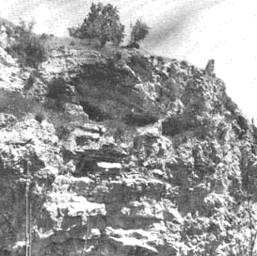
Gordon’s Calvary, one of the traditional sites of Golgotha.
b. “Golgotha is a Hebrew word that means ‘skull,’ though nowhere does the text explain why the place bore that name. Visitors to the Holy Land today are shown ‘Gordon’s Calvary,’ which does have the appearance of a skull, but guides also point out another possible site in the Church of the Holy Sepulcher. We do not know the exact place where our Lord was crucified, nor is it important that we know.”
c. “The soldiers took Jesus to the place outside but near the city wall (cf. John 19:20) called Golgotha, a Greek transliteration of an Aramaic word meaning The Place of the Skull. The word ‘Calvary’ comes from the Latin Vulgate rendering Calvaria, a variation of calva, ‘a skull.’ Golgotha was a rounded, rocky knoll (not a hill or mountain) vaguely resembling the shape of a human skull. Its exact location is uncertain. It was either at the present Church of the Holy Sepulcher, the traditional site dating from the fourth century, or ‘Gordon’s Calvary,’ a more recent suggestion. The traditional site is more probable.”
d. “That Mark has to translate again points to a Gentile audience. That the Holy Sepulcher is now within the third wall of ‘old Jerusalem’ does not contradict the above suggestion [that the site of the Holy Sepulcher is the site of Jesus’ crucifixion], since that wall was built by Herod Agrippa I after Jesus’ time. The locale of the Church of the Holy Sepulcher was outside the city wall in Jesus’ day.”
e. “The Church of the Holy Sepulchre has the support of traditions going back to the 4th century. The historian Eusebius (a.d. 263–339) stated that on the site stood a temple to Aphrodite. The church itself was erected on the same spot during the reign of Constantine and dedicated in a.d. 335. The tradition known to Eusebius may well be correct, but we cannot trace it back any further. The real question to be faced is whether the true site was forgotten when Jerusalem fell to the Roman armies in a.d. 70 and again in 135; the latter capture resulted in a drastic rebuilding of the city that may well have obliterated the true site. The traditional site has also been opposed in the past on the grounds that it may have lain within the city walls of Our Lord’s time; but the latest excavations in Jerusalem have shown that the city wall must almost certainly have run to the south of the site of the church.”
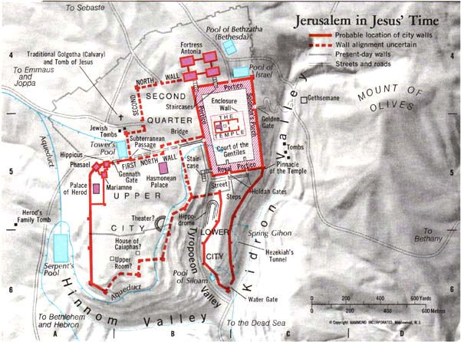

e. “If the Praetorium was in Herod’s palace, the route to the traditional site of the crucifixion was not a very long one, not much more than three hundred meters [less than a quarter mile]. A place name does not in itself require ‘translation’, but the sinister implications of the name clearly entered into Christian understanding of the crucifixion story, and Mark does not want his readers to miss that nuance.”

Robertson, A. T. (1933). Word Pictures in the New Testament (Mt 27:33). Nashville, TN: Broadman Press.
Bromiley, G. W. (Ed.). (1979–1988). In The International Standard Bible Encyclopedia, Revised. Wm. B. Eerdmans. Volume 2, page 524.
Wiersbe, W. W. (1996). The Bible Exposition Commentary (Vol. 1, p. 164). Wheaton, IL: Victor Books.
Grassmick, J. D. (1985). Mark. In J. F. Walvoord & R. B. Zuck (Eds.), The Bible Knowledge Commentary: An Exposition of the Scriptures (Vol. 2, pp. 187–188). Wheaton, IL: Victor Books.
Witherington, B., III. (2001). The Gospel of Mark: a socio-rhetorical commentary (p. 394). Grand Rapids, MI: Wm. B. Eerdmans Publishing Co.
Bromiley, G. W. (Ed.). (1979–1988). In The International Standard Bible Encyclopedia, Revised. Wm. B. Eerdmans.
France, p. 642.

