 →□ □  □ □      □

→ is the adversative use of the postpositive conjunction DE, meaning “However” plus the temporal conjunction HOTAN, meaning “when.” This is followed by the second person plural aorist active subjunctive from the verb EIDON, which means “to see.”
The aorist tense is a constative/futuristic aorist, which views the entire future action as a fact.
The active voice indicates that believers will produce the action.
The subjunctive mood is used in indefinite temporal clauses with conjunctions such as HOTAN and indicates indefiniteness as to the time of occurrence of the action.
Then we have the accusative direct object from the neuter singular article and noun BDELUGMA, which means “the disgusting, loathsome, foul, false, defiling, abomination, something that is abhorred because it defiles a sacred place and causes it to be left desolate Mt 24:15; Mk 13:14.” With this we have the genitive of identity (or perhaps the genitive of production) from the feminine singular article and noun ERĒMWSIS, which means “of devastation, destruction, depopulation Lk 21:20; Mt 24:15; Mk 13:14.”

“However, when you see the abomination of devastation”

□ □   is the appositional accusative direct object from the masculine singular perfect active participle of the verb HISTĒMI, which means “to stand: standing.”
The perfect tense is an intensive perfect, which describes a present situation as a result of a past, completed action.
The active voice indicates that the abomination of devastation produces the action.
The participle is circumstantial.
Then we have the conjunction of place HOTOU, meaning “where” plus the negative OU, meaning “not” plus the third person singular present active indicative from the verb DEI, meaning “it is necessary; it must.” This is followed by the explanatory nominative from the masculine singular articular present active participle of the verb ANAGINWSKW, which means “the reader.” The participle is substantival, functioning as a noun. With this we have the third person singular present active imperative from the verb NOEW, which means “to understand, consider carefully; take note of.”
The present tense is a customary and static present for an action that it reasonably expected to always take place at the moment this is spoken or read.
The active voice indicates that the reader is expected to produce the action.
The imperative mood is an imperative of command, and in the third person requires the auxiliary word “must” in English translation to bring out the idea of command.

“standing where it must not (the reader must understand),”

□ □      □  is the temporal adverb TOTE, meaning “then,” followed by the nominative masculine plural article HOI, used as a relative pronoun with an embedded demonstrative pronoun, meaning “those who.” With this we have the ellipsis of the verb EIMI, meaning “to be: [are].” This is followed by the preposition EN plus the locative in place from the feminine singular article and proper noun IOUDAIA, meaning “in Judea.” Then we have the third person plural present active imperative of the verb PHEUGW, which means “to flee.”
The present tense is a descriptive present, which describes what must occur at that moment.
The active voice indicates that all the people in Judea must produce the action.
The imperative mood is a command. The third person imperative should be translated with the auxiliary verb “must.”
Finally, we have the preposition EIS plus the accusative of place from the neuter plural article and noun OROS, meaning “to the mountains.”

“then those who [are] in Judea must flee to the mountains.”

Mk 13:14 corrected translation
“However, when you see the abomination of devastation standing where it must not (the reader must understand), then those who [are] in Judea must flee to the mountains.”

Explanation:

Mt 24:15-16, “Therefore when you see the abomination of desolation which was spoken of through Daniel the prophet, standing in the holy place (let the reader understand), then those who are in Judea must flee to the mountains.”

1. “However, when you see the abomination of devastation”
a. In contrast to the unbeliever’s attitude of hatred and persecution toward the believer in the Tribulation, the Lord now tells the believers what they must do in the midst of this persecution.
b. The abomination of devastation is the statue of the man of lawlessness, the Antichrist, which the False Prophet (dictator of Israel) permits to have erected in the Holy of Holies as an object of worship midway through the seven years of the Tribulation. This is described in Dan 11:31, “Forces from him will arise, desecrate the sanctuary fortress, and do away with the regular sacrifice. And they will set up the abomination of desolation.” Dan 12:11, “From the time that the regular sacrifice is abolished and the abomination of desolation is set up, there will be 1,290 days [the final 3½ years of the Tribulation].”
c. “The expression ‘abomination of desolation’ is taken from Dan 12:11, where it denotes the desecration of the temple by an image or altar of Zeus. It thus refers to Antichrist, as shown by the masculine construction and a comparison with 2 Thes 2:3f.”
d. “The nature of the sanctuary is to be used by those who come to worship God there. The abomination does not destroy the sanctuary; the abomination makes the sanctuary desolate by causing pious worshippers to avoid it because of the abomination, and by thus depriving it of any meaning or purpose.”

2. “standing where it must not (the reader must understand),”
a. The statue stands in the Holy of Holies in the Temple in Jerusalem, where the ark of the covenant used to stand. This location was considered holy by God, and now is being deliberately desecrated by Satan through his Antichrist (the dictator of the Revived Roman Empire). Because of the peace treaty the dictator of Israel (the false prophet) has with the dictator of the Revived Roman Empire (the Antichrist), this statue of the Antichrist is permitted to be set up in the Holy of Holies and worshipped throughout the world.
b. The reader (and hearer) must understand what is going on here. This act signals the beginning of the last half of the Tribulation and the final war of extermination against the Jews. This is the warning sign for Jewish and Gentile believers in Israel that war is upon them God always warns believers when it is time to leave and get out of the way of His judgment of a people and place. This illustration was likewise a warning for the believers in Judea to flee the coming of the destruction of the Temple in Jerusalem. It is very possible that the gospel of Mark was written in part to warn Jewish Christians in Jerusalem to get out of town in 66 A.D.
c. “‘Let him that reads’ means let him who reads and comments on these words in the assembly take care to understand them.”

3. “then those who [are] in Judea must flee to the mountains.”
a. The subject “those” refers to believers and any unbelievers who are smart enough to listen to believers and follow them. Specifically this refers to believers in Judea, whose principal city is Jerusalem. They are warned to flee the city and surrounding towns and villages. The reason for fleeing is the advent of war against the city and its surrounding towns. This was true in 66 A.D. and will be true for the last half of the Tribulation. “The injunction of Jesus in Mk 13:14 to flee Jerusalem and go into the mountains was carried out with the flight to the city of Pella in 66 a.d.”
b. These believers are told to flee to the mountains. There are no mountains to the west of Jerusalem. There is only desert to the south of Jerusalem. The invading army is coming from the north. Therefore, the only direction to which to flee is east—to the mountains of Edom, Ammon, and Moab.
c. “The mountains were full of caves and represented the safest place to flee; both David and the second-century b.c. Jewish revolutionaries, the Maccabees, had earlier practiced guerrilla warfare from them, and Jewish refugees hid there in the war of a.d. 132–135. It is reported that the Jerusalem Christians, warned by prophecies before Jerusalem’s fall, fled to a place called Pella, hewn from foothills far to the north.”

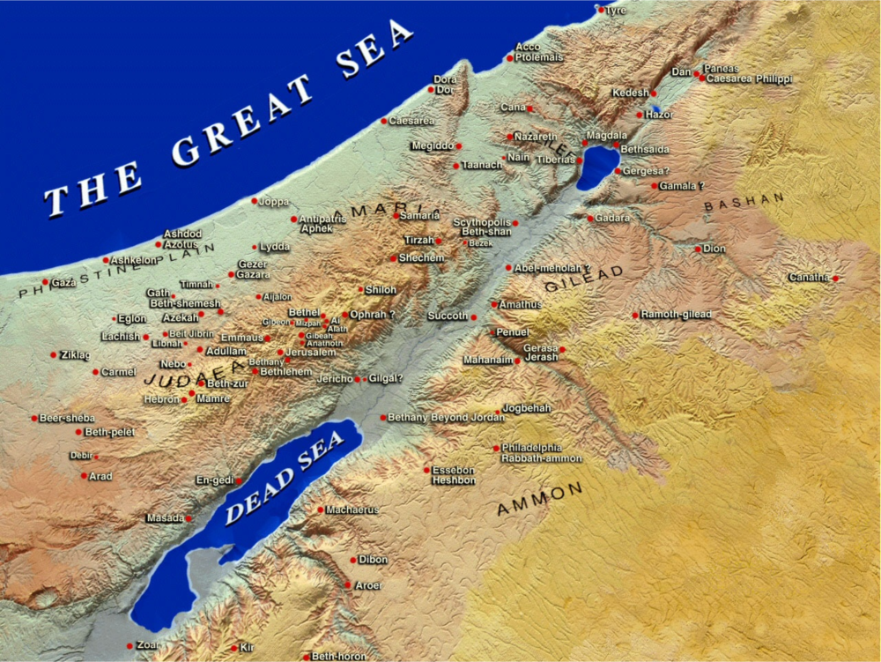

4. Commentators’ comments.
a. “‘Abomination of desolation’ is the very phrase applied in 1 Macc 1:54 to the altar to Zeus erected by Antiochus Epiphanes where the altar to Jehovah was. Mark personifies the abomination as personal (masculine), while Lk 21:20 defines it by reference to the armies (of Rome, as it turned out).”
b. “The phrase ‘abomination of desolation’ comes from the Book of Daniel and refers to the idolatrous pollution of the Jewish temple by the Gentiles. To the Jews, all idolatry is an abomination (Dt 29:17; 2 Kg 16:3). The Jewish temple was defiled in 167 b.c.by the Syrian king Antiochus IV (also called ‘Epiphanes,’ meaning ‘illustrious’), when he poured swine’s blood on the altar. This event was predicted in Dan 11:31. The temple was also defiled by the Romans in a.d.70 when they captured and destroyed the city of Jerusalem. However, these events were but anticipations of the final ‘abomination of desolation’ prophesied in Dan 9:27 and 12:11. In order to understand Dan 9:24–27, we must remember that the Jewish calendar is built on a series of sevens. Daniel saw seventy weeks, or periods of seven years, divinely determined for the Jews and for their Holy City, Jerusalem. This period of 490 years began with the decree of Artaxerxes in 445 b.c. permitting the Jews to return to their land and rebuild Jerusalem (Ezra 1:1–4). Why must the city be restored? Because 483 years later, Messiah would come to the city and give His life for sinners. Now we must do some simple calculating. Most historians agree that Jesus was born in 5 b.c.; for Herod the Great was still living at the time, and he died in March, 4 b.c. If our Lord died at about the age of 33, that would take us to a.d. 27 or 28, and this would be 483 years after 445 b.c. when the decree was given! We have accounted for 483 of Daniel’s 490 years, but what about the remaining 7 years? Dan 9:27 assigns them to the Tribulation period. ‘The time of Jacob’s trouble’ will last seven years. But what signals the beginning of this awful seven-year period? The signing of a covenant between the nation of Israel and ‘the prince that shall come’ (Dan 9:26). This ‘prince’ is the coming world dictator that we usually call ‘the Antichrist’. In the Book of Revelation, he is called ‘the Beast’ (Rev 13–14). He will agree to protect Israel from her many enemies for seven years, and will even allow the Jews to rebuild their temple and restore their ancient liturgy and sacrifices. The Jews rejected their true Messiah but will accept a false messiah (Jn 5:43). However, after three and a half years, Antichrist will break this covenant, invade the temple, set up his own image, and force the world to worship Satan (2 Thes 2:1–12; Rev 13). This is Daniel’s ‘abomination of desolation’, and it will usher in the last half of the Tribulation period, a time known as ‘the Great Tribulation’ (Mt 24:21). Note in Mark 13:14 that Mark’s parenthesis is for readers at a future time, not hearers when Jesus gave this message. This message will have special meaning to them as they see these events taking place. Jesus gave a special warning to the Jewish believers in Jerusalem and Judea: ‘Get out as fast as you can!’ This same warning applied when Rome attacked Jerusalem in a.d. 70. (See Lk 21:20–24, and remember that Dan 9:26 predicted the invasion.) What happened in a.d. 70 foreshadowed what will happen in the middle of the Tribulation.”
c. “The sign that ‘these things’ were about to be fulfilled was the appearance of ‘the abomination of desolation’, standing where it does not belong, a reference to the temple sanctuary. More precise identification may have been politically dangerous for his readers. Mark’s exhortation, ‘Let the reader understand,’ was a decoding signal urging them to recognize the significance of Jesus’ words in light of their Old Testament context (Dan 9:25–27). The word ‘abomination’ denoted pagan idolatry and its detestable practices (Dt 29:16–18; 2 Kg 16:3–4; 23:12–14; Ezek 8:9–18). The phrase ‘the abomination of desolation’ referred to the presence of an idolatrous person or object so detestable that it caused the temple to be abandoned and left desolate. Historically, the first fulfillment of Daniel’s prophetic use of the expression (Dan 11:31–32) was the desecration of the temple in 167 b.c. by the Syrian ruler Antiochus Epiphanes. He erected an altar to the pagan Greek god Zeus over the altar of burnt offering and sacrificed a pig on it. Jesus’ use of ‘the abomination of desolation’ referred to another fulfillment—the temple’s desecration and destruction in a.d. 70. When His disciples, those present and future, see this desecration take place, it is a signal for people in Judea to escape to the mountains beyond the Jordan River in Perea. Josephus recorded the occupation and appalling profaning of the temple in a.d. 67–68 by Jewish Zealots, who also installed a usurper, Phanni, as high priest. Jewish Christians fled to Pella, a town located in the Transjordanian mountains. The events of 167 b.c. and a.d. 70 foreshadow a final fulfillment of Jesus’ words just prior to His Second Advent. Mark used the masculine participle ‘standing’ to modify the neuter noun ‘abomination’. This suggests that ‘the abomination’ is a future person ‘standing where he does not belong’. This person is the end-time Antichrist. He will make a covenant with the Jewish people at the beginning of the seven-year period preceding Christ’s second coming (Dan 9:27). The temple will be rebuilt and worship reestablished (Rev 11:1). In the middle of this period (after 3½ years) the Antichrist will break his covenant, stop temple sacrifices, desecrate the temple (Dan 9:27), and proclaim himself to be God (Mt 24:15; 2 Thes 2:3–4; Rev 11:2). This launches the terrible end-time events of the Great Tribulation (Rev 6; 8–9; 16). Those who refuse to be identified with the Antichrist will suffer severe persecution and be forced to flee for refuge (Rev 12:6, 13–17). Many—both Jews and Gentiles—will be saved during this period (Rev 7) but many will also be martyred (Rev 6:9–11).”
d. “The phrase in question likely means an abomination which results in desolation, that is, in abandonment of the temple by God. Less probably, one could translate it an appalling sacrilege. Though the gender of the word ‘abomination’ is neuter, the word ‘standing’ is a masculine perfect participle, which definitely suggests someone rather than something. Thus in Mark’s text we are not talking about a heathen altar, but rather about someone who causes the temple to be desecrated and so abandoned. This is in fact what happened to the temple. Josephus tells us how the Zealots took over from November 67 or the spring of 68, at which time they allowed criminals to roam the temple, including in the Holy of Holies, and even to murder others in the temple. ‘Let the reader understand’ seems to mean ‘take note, you already know what this refers to.’ If Mark was writing in late 68, this note would be most germane. This may provide one significant clue to the dating of this Gospel.”

Arndt, W., Danker, F. W., & Bauer, W. (2000). A Greek-English Lexicon of the New Testament and other early Christian literature (3rd ed.) (p. 172). Chicago: University of Chicago Press.
Arndt, W., Danker, F. W., & Bauer, W. (2000). A Greek-English Lexicon of the New Testament and other early Christian literature (3rd ed.) (p. 392). Chicago: University of Chicago Press.
Volume 1: Theological Dictionary of the New Testament. 1964- (G. Kittel, G. W. Bromiley & G. Friedrich, Ed.) (electronic ed.) (p. 600). Grand Rapids, MI: Eerdmans.
Volume 2: Theological Dictionary of the New Testament. 1964- (G. Kittel, G. W. Bromiley & G. Friedrich, Ed.) (electronic ed.) (p. 660). Grand Rapids, MI: Eerdmans.
Bullinger, E. W. (1898). Figures of Speech Used in the Bible (p. 851). London; New York: Eyre & Spottiswoode; E. & J. B. Young & Co.
Volume 5: Theological Dictionary of the New Testament. 1964- (G. Kittel, G. W. Bromiley & G. Friedrich, Ed.) (electronic ed.) (p. 483–484). Grand Rapids, MI: Eerdmans.
Keener, C. S. (1993). The IVP Bible Background Commentary: New Testament (Mk 13:14). Downers Grove, IL: InterVarsity Press.
Robertson, A. (1933). Word Pictures in the New Testament (Mk 13:14). Nashville, TN: Broadman Press.
Wiersbe, W. W. (1996). The Bible Exposition Commentary (Mk 13:14). Wheaton, IL: Victor Books.
Grassmick, J. D. (1985). Mark. In J. F. Walvoord & R. B. Zuck (Eds.), The Bible Knowledge Commentary: An Exposition of the Scriptures (Mk 13:14). Wheaton, IL: Victor Books.
Witherington, B., III. (2001). The Gospel of Mark: A socio-rhetorical commentary (p. 345). Grand Rapids, MI: Wm. B. Eerdmans Publishing Co.

