   □ 

   □  is the continuative use of the conjunction KAI, meaning “And” plus the third person singular aorist active indicative from the verb ERCHOMAI, which means “to go: He went.”
The aorist tense is a constative/historical aorist, which views the past action in its entirety.
The active voice indicates that Jesus produced the action.
The indicative mood is declarative of a simple statement of fact.
Then we have the preposition EIS plus the accusative of place from the feminine plural article and noun SUNAGWGĒ with the possessive genitive from the third person masculine plural personal use of the intensive pronoun AUTOS, meaning “into their synagogues.” This is followed by the preposition EIS plus the accusative of place from the feminine singular adjective HOLOS plus the article and proper noun GALILAIA, meaning “in all Galilee.”

“And He went into their synagogues in all Galilee,”

 is the nominative masculine singular present active participle from the verb KĒRUSSW, which means “to proclaim publicly, to announce, or to preach.”
The present tense is a descriptive and iterative present, describing what was occurring at various intervals at that time.
The active voice indicates that Jesus was producing the action.
The participle is circumstantial.
Then we have the additive use of the conjunction KAI, meaning “and” plus the accusative direct object from the neuter plural article and noun DAIMONION, which means “the demons.” Finally, we have the nominative masculine singular present active participle from the verb EKBALLW, which means “to throw or cast out.”
The present tense is a descriptive and iterative present, describing what was occurring at that various intervals at that time.
The active voice indicates that Jesus was producing the action.
The participle is circumstantial.

“And He went into their synagogues in all Galilee, preaching and casting out the demons.”

Mk 1:39 corrected translation
“And He went into their synagogues in all Galilee, preaching and casting out the demons.”

Explanation:

1. “And He went into their synagogues in all Galilee,”
a. After inviting the four disciples to go with Him, Jesus departs from Capernaum and immediately begins a ‘speaking tour’ in all the synagogues in the district of Galilee. A synagogue was authorized to be built in any city, town, or village where twelve Jewish men lived. Since the Pharisees forbade people from walking long distances on the Sabbath, there were synagogues everywhere. Josephus says that Galilee was heavily populated with even small towns having 15,000 residents. Therefore, there were no shortage of synagogues for Jesus to speak at and large crowds wherever He spoke.
b. There are approximately seven ‘cities’ and about thirty ‘towns’ discovered by archeologists in the district of Galilee (see the map below). There were many more ‘market-towns’ and large villages, which are not depicted on the map. Even if Jesus could only teach on the three days of the week the Jews met in their synagogues for teaching, this speaking tour would have taken about three-four months. Jesus would speak in one town. The next day He would walk to the next town. Then speak in that town. This pattern was repeated until He had spoken “in all the synagogues of Galilee.”
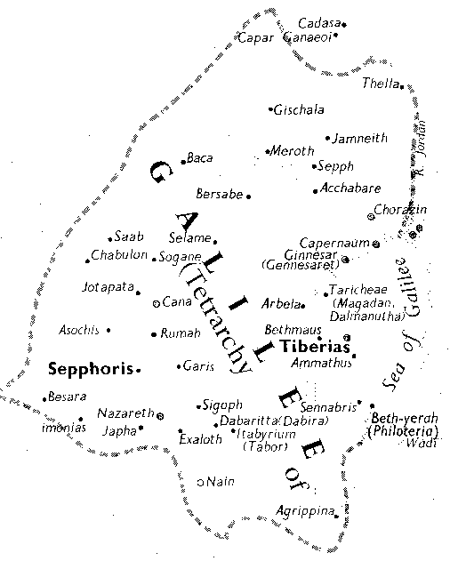
The straight line distance from Cana to Tiberias is fifteen miles or about a day’s walk.

2. “preaching and casting out the demons.”
a. Mark then focuses on the two things Jesus did on this preaching tour—He proclaimed the message of God the Father—the coming of the Kingdom and the spiritual life required to be in that kingdom (see the Sermon on the Mount, Mt 5-7)—and He cast out demons. “Jesus ‘proclaims’ (Mt 4:17) the gospel of the kingdom (Mt 4:23). Similarly, the Synoptic Gospels portray Jesus’ mission in terms of his ‘proclaiming’ the kingdom (Mk 1:14, 38–39, 45).” The casting out of demons was a demonstration of God’s establishing His kingdom over Satan. In the millennial kingdom of the Lord Jesus Christ there will be no demon activity. All demons will be incarcerated in the Abyss (Satan’s prison) or in the lake of fire. By casting out demons during His first advent, the Lord was giving Satan and the fallen angels a preview of coming attractions.
b. The casting out of demons occurred throughout Galilee, which means that at the end of this preaching tour the Jews not only knew that the kingdom of God was at hand, but they were cured of all their illnesses and were no longer bothered by demon activity of any kind. Life had never been this good for these people. People were healed and weren’t getting sick. Demons weren’t bothering anyone or causing problems for people. People were hearing the word of God taught accurately and with authority. The spiritual life that God expected of people was being clearly presented, explained, and demonstrated. Most importantly, people were hearing and understanding what God required of them in order to have eternal life.
c. Jesus was curing the Jews both spiritually and physically. Notice what took priority—their spiritual well-being.
d. Satan could not prevent the truth from being told, nor could He prevent the Lord from banishing demon activity.
e. The parallel passage in Mt 4:23-25, “Jesus was going throughout all Galilee, teaching in their synagogues and proclaiming the gospel of the kingdom, and healing every kind of disease and every kind of sickness among the people. The news about Him spread throughout all Syria; and they brought to Him all who were ill, those suffering with various diseases and pains, demoniacs, epileptics, paralytics; and He healed them. Large crowds followed Him from Galilee and the Decapolis and Jerusalem and Judea and [from] beyond the Jordan.”

3. Commentators’ comments.
a. This is “the first tour of Galilee by Jesus. We are told little about this great preaching tour.”
b. “Verse 39 summarizes His tour throughout Galilee, which probably lasted several weeks (compare Mt 4:23-25). His main activity was preaching in the local synagogues, and His driving out demons dramatically confirmed His message.”
c. “In the early part of His ministry He was invited to speak in synagogues as a visiting teacher (Mk 1:21, 39; Mt 9:35; Lk 4:16–27), but later synagogue teaching is not mentioned (because his radical teaching was unacceptable?), and Jesus is found teaching the crowds in the open air, and devoting an increasing proportion of time to the instruction of his closest disciples.”
d. “Mark records but two of the Lord’s three tours of Galilee, the first with the four fishermen (Mk 1:35-45), and the third at the conclusion of the Galilean ministry (Mk 6:1-30). The second tour occurred shortly after the choice of the Twelve (Lk 8:1-3). The third was different from the preceding two in that the disciples were sent out two by two (Mk 6:7), after which Christ went from town to town preaching and teaching by himself (Mt 11:1).”

BDAG, p. 289, meaning 1.b.
Thompson, J. W. (2000). Preaching, Proclamation. In D. N. Freedman, A. C. Myers & A. B. Beck (Eds.), Eerdmans Dictionary of the Bible (D. N. Freedman, A. C. Myers & A. B. Beck, Ed.) (p. 1079). Grand Rapids, MI: W.B. Eerdmans.
Robertson, A. (1997). Word Pictures in the New Testament (Mk 1:39). Oak Harbor: Logos Research Systems.
Walvoord, J. F., Zuck, R. B., & Dallas Theological Seminary. (1983-). The Bible Knowledge Commentary: An exposition of the scriptures (Mk 1:38–39). Wheaton, IL: Victor Books.
Wood, D. R. W., & Marshall, I. H. (1996). New Bible Dictionary (3rd ed.) (p. 566). Leicester, England; Downers Grove, Ill.: InterVarsity Press.
Pfeiffer, C. F., & Harrison, E. F. (1962). The Wycliffe Bible Commentary: New Testament (Mk 6:1). Chicago: Moody Press.

