   □  □  □ □   □         

   is the transitional use of the postpositive conjunction DE, meaning “Now.” With this we have the third person singular aorist deponent middle indicative from the verb GINOMAI, which means “to happen, occur, or to come to pass.”
The aorist tense is a constative/historical aorist, which views the action in its entirety as a fact.
The deponent middle voice is middle in form but active in meaning with the subject (the situation being described) producing the action.
The indicative mood is declarative for a simple statement of fact.
Next we have the preposition EN plus the locative of time from the feminine singular cardinal adjective HEIS with the ablative of whole from the feminine plural article, used as a demonstrative pronoun plus the noun HĒMERA, meaning “on one of these days.”

“Now it happened on one of those days”

 □  □  □ □  is the conjunction KAI, “commonly used in the speech of everyday life, where more discriminating usage would call for other particles [in this case HOTI]; and translated that.” Then we have the nominative subject from the third person masculine singular personal use of the intensive pronoun AUTOS, meaning “He” and referring to Jesus. This is followed by the third person singular aorist active indicative from the verb EMBAINW, which means “to step into; to embark.” We say simply that “He got into” a boat.
The aorist tense is a constative/historical aorist, which views the action in its entirety as a fact.
The active voice indicates that Jesus and His disciples produced the action.
The indicative mood is declarative for a simple statement of fact.
Then we have the preposition EIS plus the accusative of place from the neuter singular noun PLOION, meaning “into a boat.” Next we have the additive use of the conjunction KAI, meaning “and” plus the nominative subject from the masculine plural article and noun MATHĒTĒS with the possessive genitive from the third person masculine singular personal use of the intensive pronoun AUTOS, meaning “His disciples.”

“that He and His disciples got into a boat,”

  □    is the continuative use of the conjunction KAI, meaning “and,” followed by the third person singular aorist active indicative from the verb EIPON, which means “to say: He said.”
The aorist tense is a constative/historical aorist, which views the action in its entirety as a fact.
The active voice indicates that Jesus produced the action.
The indicative mood is declarative for a simple statement of fact.
Then we have the preposition PROS plus the accusative of place from the third person masculine plural personal use of the intensive pronoun AUTOS, meaning “to them” and referring to the disciples. This is followed by the first person plural aorist active subjunctive from the verb DIERCHOMAI, which means “to go through; to go over; to cross over.”
The aorist tense is a constative aorist, which views the action in its entirety as a fact.
The active voice indicates that Jesus and the disciples are to produce the action.
The subjunctive mood is a hortatory subjunctive in which the speaker invites the hearers to join him in a course of action. It is translated “Let us cross over.”
Next we have the preposition EIS plus the accusative of place from the neuter singular article and adverb of place PERAN, meaning “to the other side.” With this we have the adverbial genitive of place or possessive genitive from the feminine singular article and noun LIMNĒ, meaning “of the lake.”

“and He said to them, ‘Let us cross over to the other side of the lake.’”

 is the consequential use of the conjunction KAI, meaning “And so” plus the third person plural aorist passive indicative from the verb ANAGW, which “is used as a nautical technical term put out to sea Acts 28:11; 13:13; 16:11; 18:21; 27:4, 12, 21; 20:3, 13; to set sail Lk 8:22; Acts 21:1f; 27:2; 28:10.”
The aorist tense is a constative/historical aorist, which views the action in its entirety as a fact.
The passive voice is used in a deponent sense, indicating that Jesus and the disciples produced the action.
The indicative mood is declarative for a simple statement of fact.

“And so they set sail.”

Lk 8:22 corrected translation
“Now it happened on one of those days that He and His disciples got into a boat, and He said to them, ‘Let us cross over to the other side of the lake.’ And so they set sail.”

Mk 4:35, “On that day, when evening came, He said to them, ‘Let us go over to the other side’.”
Mt 8:23, “When He got into the boat, His disciples followed Him.”

Explanation:

1. “Now it happened on one of those days that He and His disciples got into a boat,”
a. Luke transitions to a new story in the life of Jesus. Luke gives us an approximate time reference that this event occurred at about the same time as the other events previously mentioned, that is, after the missionary tour from city to city and village to village, mentioned in Lk 8:1 and after the incident of His mother and brothers not being able to meet with Him.
b. Whatever day this happened to be is unknown, but it was not on a Sabbath, since the disciples would be required to do too much ‘work’ to sail the ship.
c. Jesus and the twelve disciples all got in the boat and pushed off from land. The boat was probably one of several fishing boats that belonged to Peter, Andrew, James, and John.

2. “and He said to them, ‘Let us cross over to the other side of the lake.’”
a. Once they were in the boat and had pushed off from land, Jesus suggested/requested that they cross over to the other side of the lake. This is a reference to the Sea of Galilee, which is better named Lake Galilee, and is often called Lake Gennesaret, being named after the district on that side of the lake.
b. The lake is 13 miles long from north to south, and they were traveling from Capernaum on the northern shore to the district of the Gerasenes, near the city of Sennabris at the extreme southern end of the lake. See the map.

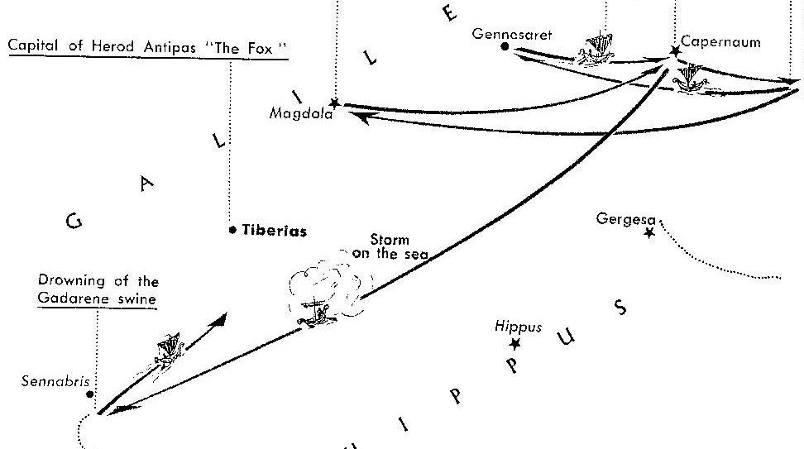

3. “And so they set sail.”
a. After Jesus suggested where they should go, the boat set sail for the intended destination. No one objected to making this journey.
b. Remember that at least four of the disciples were expert fisherman and made their living sailing this lake. They knew the time it would take, if the winds were favorable, if there was inclement weather, or any other conditions that suggested how easy or difficult the journey might be. Considering they could sail at anywhere from four to six miles per hour, they would normally make this trip in two to three hours. With the prevailing winds out of the west there should be no problem heading south.

4. Commentators’ comments.
a. “A general temporal note indicates that on one day during this period, Jesus and His disciples launched out to cross the Sea of Galilee, also known as the Lake of Gennesaret (Lk 5:1). Only Luke refers to the body of water here as a ‘lake’, while Mark and Matthew refer to the ‘sea’. Luke uses the same term to describe the boat (ploion) as he did in Lk 5:2, 3, 7, 11. A fishing boat that could hold many disciples would be a substantial vessel. Giving detail that Luke lacks, Mk 4:35 notes that it is evening and that it is the same day on which Jesus taught in parables. Jesus is already in the boat in Mk 4:1, and so Mark does not mention entering the boat in 4:35. It is curious, however, why Luke should be so general about the timing, when Mark is specific. Mark also notes that other vessels crossed with the disciples.”
b. “Who is present on the boat? Because Luke provides no explicit evidence to the contrary, we might imagine the crew and passenger list to include the twelve and Jesus’ women followers; this seems unlikely, however. Although Luke’s ‘boat’ might be used to designate a larger, seafaring ship, it is also used with reference to the smaller fishing vessels found on the Lake. The latter is in mind in Lk 5:2, and we might be hard-pressed to imagine that Jesus, the twelve, Mary, Joanna, Susanna, and ‘many’ other women made their way onto a boat of this capacity. The twelve are probably in view here.”
c. “The rejection probably took place in Capernaum, so Jesus would have set sail from there to Gergesa [wrong location; he is confusing the city of Gergesa with the district of Gerasenes, near the city of Sennabris at the extreme southern end of the lake; see the map above], some six miles across the lake [southeast of Capernaum], a voyage that would normally take two to three hours.”

Arndt, W., Danker, F. W., & Bauer, W. (2000). A Greek-English lexicon of the New Testament and other early Christian literature (3rd ed., p. 494 meaning 1.b.b.). Chicago: University of Chicago Press.
BDAG, p. 321.
BDAG, p. 244, meaning 1.b.b.
BDAG, p. 795.
Arndt, W., Danker, F. W., & Bauer, W. (2000). A Greek-English Lexicon of the New Testament and other early Christian literature (3rd ed., p. 62). Chicago: University of Chicago Press.
The Macmillan Bible Atlas by Yohanan Aharoni and Michael Avi-Yonah, Revised Edition, 1977; page 146, map 231.
Bock, D. L. (1994). Luke: 1:1–9:50 (Vol. 1, pp. 759–760). Grand Rapids, MI: Baker Academic.
Green, J. B. (1997). The Gospel of Luke (p. 332). Grand Rapids, MI: Wm. B. Eerdmans Publishing Co.
Mills, M. S. (1999). The Life of Christ: A Study Guide to the Gospel Record (Mt 8:23–Lk 8:25). Dallas, TX: 3E Ministries.

