    

     is the third person singular aorist active indicative from the verb APHIĒMI, which means “to leave; to depart from somewhere.”
The aorist tense is a constative/historical aorist, which views the entire past action as a fact.
The active voice indicates that Jesus produced the action.
The indicative mood is declarative for a simple statement of fact.
Then we have the accusative direct object from the feminine singular article and noun IOUDAIA, meaning “Judea.”

“He left Judea”

  is the additive/continuative use of the conjunction KAI, meaning “and” plus the third person singular aorist active indicative from the verb APERCHOMAI, which means “to go, to go away, to depart.”
The aorist tense is a constative/historical aorist, which views the entire past action as a fact.
The active voice indicates that Jesus produced the action.
The indicative mood is declarative for a simple statement of fact.
Then we have the adverb of time PALIN, meaning “again.” Finally, we have the preposition EIS plus the accusative of place from the feminine singular article and proper noun GALILAIA, meaning “into Galilee.”

“and went again into Galilee.”

Jn 4:3 corrected translation
“He left Judea and went again into Galilee.”

Explanation:

1. “He left Judea”
a. The entire sentence begun in verse one is now complete and reads: “Now when Jesus knew that the Pharisees had heard that Jesus was making and baptizing more disciples than John (though Jesus Himself was not baptizing, but His disciples [were baptizing]), He left Judea and went again into Galilee.”
b. The basic thought here is that when Jesus knew that the Pharisees had heard that Jesus was more popular with the people than John the Baptist, Jesus left the countryside of Judea and went back to Galilee.
c. Jesus knew that the Pharisees would not believe in Him and would oppose Him, and He didn’t want to come into open opposition with them at the beginning of His ministry. He had to bring the Father’s message of salvation to the people of Israel and give them every opportunity to believe in Him before the opposition of the Pharisees and Sadducees reached its peak against Him. “Evidently because Jesus did not wish to bring the coming conflict with the Pharisees to an issue yet. So he mainly avoids Jerusalem and Judea now till the end. Each time hereafter that Jesus appears in Jerusalem and Judea before the last visit there is an open breach with the Pharisees who attack him.”

2. “and went again into Galilee.”
a. From the Jordan River near where John was Baptizing (in Aenon near Salim—Jn 3:23) to Galilee was about 15 miles due North. (See the map below.) However, based on the statement in the next verse that Jesus went through the Samarian town of Sychar, had He been near where John was baptizing He would have had to go 20 miles Southwest. If Aenon near Salim is where scholars think it is, then Jesus would have deliberately gone in the opposite direction away from Galilee as a detour to save the Samaritan woman at the well of Jacob. However, the next verse tells us that it was necessary for Jesus to pass through Samaria, which means that Jesus had to be somewhere south of Samaria (and north of Jerusalem), when He made the decision to go back to Galilee. Look carefully at the map below and in the southern part of the map you will see the Wadi Farah, which continues south to the Jordan River. Jesus may have been somewhere south of Sychar (Jn 3:5) along this Wadi or perhaps where it joins the Jordan River. We are not told exactly where Jesus was having His disciples baptize, but it was more likely south of the city of Sychar rather than in the north near Aenon or Salim.
b. Therefore, John’s statement here implies that Jesus went directly from the countryside of Judea into Galilee, but passed through Samaria on His way north and stops at a little town called Sychar along the way.
c. The word “again” alludes to the previous return to Galilee mentioned in Jn 1:44.

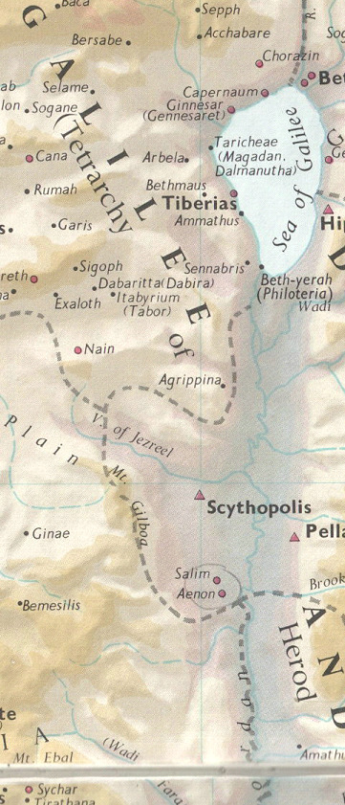

BDAG, p. 156.
BDAG, p. 102.
Robertson, A. (1997). Word Pictures in the New Testament. (Jn 4:3). Oak Harbor: Logos Research Systems.

