   □  □ □  □ □   

 is the preposition META plus the adverbial accusative of extent of time from the neuter singular demonstrative pronoun HOUTOS, meaning “After this.” Then we have the third person singular aorist active indicative from the verb KATABAINW, which means “to go down; to descend.”
The aorist tense is a constative/historical aorist, which views the entire past action as a fact.
The active voice indicates that Jesus, His mother, His four brothers, and His six disciples produced the action.
The indicative mood is declarative for a simple statement of fact.
This is followed by the preposition EIS plus the accusative of place from the feminine singular proper noun KAPHARNAOUM, meaning “to Capernaum,” which should have been transliterated as “Kafarnaum.”

“After this He went down to Capernaum,”

□    □  □ □  □ □  is the appositional nominative subject from the third person masculine singular personal use of the intensive pronoun AUTOS, meaning “He” and referring to Jesus. Then we have the additive use of the conjunction KAI, meaning “and,” which is repeated two more times. With this we have the nominative subject from the feminine singular article and noun MĒTĒR with the possessive genitive from the third person masculine singular personal use of the intensive pronoun AUTOS, meaning “His mother.” Then we have the nominative subject from the masculine plural article, which is used as a personal pronoun, and noun ADELPHOS, meaning “His brothers.” The word AUTOS in brackets is not found in all the best manuscripts and it is highly questionable that it was in the original manuscript. This is followed by the nominative subject from the masculine plural article and noun MATHĒTĒS plus the possessive genitive from the third person masculine singular personal use of the intensive pronoun AUTOS, meaning “His disciples.”

“He and His mother and His brothers and His disciples;”

   is the continuative use of the conjunction KAI, meaning “and” plus the adverb of place EKEI, meaning “there.” Then we have the third person plural aorist active indicative from the verb MENW, which means “to remain, stay, live, or reside,” depending on the context of what is being said.
The aorist tense is a constative/historical aorist, which views the entire past action as a fact.
The active voice indicates that Jesus, His family, and His disciples produced the action.
The indicative mood is declarative for a simple statement of fact.
Finally, we have an idiom, which begins with the negative OU, meaning “not” plus the feminine plural adjective POLUS, meaning “many” and the noun HĒMERA, meaning “days.” The phrase “not many days” refers to short period of time. The translation in the NASV (“a few days”) is a good an English idiom for this translation.

“and they stayed there a few days.”

Jn 2:12 corrected translation
“After this He went down to Capernaum, He and His mother and His brothers and His disciples; and they stayed there a few days.”

Explanation:

1. “After this He went down to Capernaum,”
a. After the wedding was over, which may have been a few days later, Jesus, His mother Mary, His four brothers, and five or six disciples go with Him down to Capernaum.
b. Capernaum was west of Cana (about 18-19 miles away) on the north coast of the Sea of Galilee. Since Cana was at a higher elevation than Capernaum, you have to do “down” (downhill) to get there. The Sea of Galilee is 680 feet below sea level. Therefore the descent from Cana was at least a couple of thousand feet.
c. This trip would have taken no more than one day to walk.

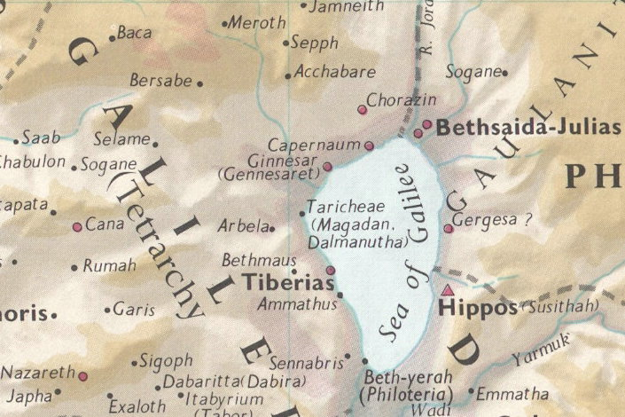

2. “He and His mother and His brothers and His disciples;”
a. Not only did Jesus go to Capernaum, but so did His mother, His four brothers and His disciples.
(1) We should remember that even if Mary was married at age 13 (the earliest age a girl could marry) and Jesus was thirty years old at this time, then Mary would have been at least 43 years old when making this trip. If she were twenty years old when Jesus was born, then she would be fifty years old at this time. So Mary was probably in good health and excellent physical shape to make a 18-19 mile walk in one day.
(2) Jesus had four brothers, who are mentioned in Mt 13:55, “Is not this the carpenter’s son? Is not His mother called Mary, and His brothers, James and Joseph and Simon and Judas?” So also Mk 6:3. They are also mentioned in Jn 7:3. Notice that the mention of the brothers here indicates that they too were at the wedding feast in Cana, and now probably knew full well that Jesus had performed a miracle.
(3) The disciples with Jesus at this time are Andrew (Jn 1:40), the unnamed disciple—most likely John (Jn 1:37), Peter (Jn 1:41), Philip (Jn 1:43), Nathanael (Jn 1:45), and it is likely that James was with the group that had gone to see John the Baptist and that John went and got his brother and brought him to Jesus. So there are certainly five and probably six disciples traveling with Jesus on this trip.
(4) All commentators agree that the absence of the mention of Joseph at this point is due to the assumption that he has already died.
b. Since Nazareth was nine miles due south of Cana and the group went west to Capernaum, we must assume that the sisters of Jesus were married, had their own families, and were still living in Nazareth. The people of Nazareth make this statement in Mt 13:46, “And His sisters, are they not all with us?” We do not know the number or names of Jesus’ sisters. This is the only statement about them in Scripture. It is highly likely given the Jewish custom at the time that girls married very young (they were betrothed between 13 and 15 years of age, and married within a few years after that) that the sisters of Jesus were already married.

3. “and they stayed there a few days.”
a. Jesus, Mary, His four brothers, and six disciples stayed for a few days in Capernaum.
b. John does not tell us why Jesus went to Capernaum, but we get the answer from a comparison of three passages in the Synoptic gospels.
(1) Mt 4:13-17 says, “Now when Jesus heard that John [the Baptist] had been taken into custody, He withdrew into Galilee; and leaving Nazareth, He came and settled in Capernaum, which is by the sea, in the region of Zebulun and Naphtali. This was to fulfill what was spoken through Isaiah the prophet: ‘The land of Zebulun and the land of Naphtali, By the way of the sea, beyond the Jordan, Galilee of the Gentiles—The people who were sitting in darkness saw a great Light, And those who were sitting in the land and shadow of death, upon them a Light dawned.’ From that time Jesus began to preach and say, ‘Repent, for the kingdom of heaven is at hand.’” So the first reason for going to Capernaum is that Jesus would make His home in this city. It would be the ‘base camp’ for all His further operations.
(2) Lk 4:31, “And He came down to Capernaum, a city of Galilee, and He was teaching them on the Sabbath.” The second reason for going to Capernaum was because He would begin His teaching ministry there, and because a prophet is not honored in his own city.
(3) Lk 4:38, “Then He got up and left the synagogue, and entered Simon’s [Peter’s] home. Now Simon’s mother-in-law was suffering from a high fever, and they asked Him to help her.” Remember from Jn 1:44 that Bethsaida was the hometown of Andrew and Peter. Bethsaida was considered a ‘suburb’ of Capernaum. Capernaum was only a couple of miles away on the north shore of the Sea of Galilee from Bethsaida. So it is not difficult to imagine the reason for Jesus going to Capernaum. We must also compare Mk 1:21, where Jesus enters the synagogue of Capernaum to teach, and Mk 1:29, which says that Andrew and Peter, were living in Capernaum at the time: “And immediately after they came out of the synagogue, they came into the house of Simon and Andrew, with James and John.” Andrew, Peter, James and John had been away from their families and their fishing business for at least three weeks (if not longer—three days travel from the northern coast of the Sea of Galilee to where John the Baptist was baptizing, being disciples of John for days if not weeks, the four days mentioned in chapter one surrounding John’s identification of Jesus as the Lamb of God, the three day walk back to Cana, and several days at the wedding, then finally one day to get to Capernaum). Capernaum was only three miles from Bethsaida, the hometown of Andrew, Peter, James and John. Can you imagine Peter being away from his wife for three weeks or more, and coming to Capernaum and not going the next three miles to let his wife know he was back home? “This action demonstrates Jesus’ concern for His disciples, for He granted them time with their families, time to share their discovery about the Messiah with their loved ones, and simply time together before He would lead them on His Judean and Samarian tour. They only remained in Capernaum for a few days as they soon left for Jerusalem to celebrate the first Passover of Jesus’ ministry (Jn 2:13).”
c. During the few days mentioned here by John, Jesus began teaching, people were healed, miracles were performed, Jesus made a second and permanent call for His disciples to follow Him, and then Jesus made a trip back to Nazareth. At some point He returns to Nazareth and the events of Lk 4:14-30 take place. We know this because of the statement by Jesus in Lk 4:23, “And He said to them, ‘No doubt you will quote this proverb to Me, ‘Physician, heal yourself! Whatever we heard was done at Capernaum, do here in your hometown as well.’” After this trip to Nazareth Jesus returns to Capernaum. The purpose of this trip was probably for He and His brothers to get the belongings of the family, sell the home there, and move to Capernaum permanently.
d. “It might be suggested that the transition could represent the movement of the family home to an area where Jesus did much of his ministry in Galilee, except that it is not actually certain from the verse that even his mother and brothers continued there any longer than Jesus and his disciples.”

Mills, M. (1999). The Life of Christ: A Study Guide to the Gospel Record. Dallas, TX: 3E Ministries.
Borchert, G. L. (2001, c1996). Vol. 25A: John 1-11 (electronic ed.). Logos Library System; The New American Commentary (p. 159). Nashville: Broadman & Holman Publishers.

