 □ □     □ □  □

 □ □    is the accusative direct object from the feminine singular demonstrative pronoun HOUTOS, meaning “this” plus the accusative complement from the noun ARCHĒ, meaning “the beginning.” “The NASB has ‘This beginning of [his] signs Jesus did…’ The problem with this translation is that it takes the demonstrative as a modifying adjective rather than an independent pronoun. But such could not be the case without an article before ” As an object-complement construction we have to add ‘as’, ‘to be’, or ‘namely’ before the complement.
Then we have the third person singular aorist active indicative from the verb POIEW, which means “to make, do, or perform.”
The aorist tense is a constative/historical aorist, which views the entire past action as a fact.
The active voice indicates that Jesus produced the action.
The indicative mood is declarative for a simple statement of fact.
This is followed by the descriptive genitive from the neuter plural article, used as a personal pronoun (“His”) and noun SĒMEION, meaning “of His miracles.” Then we have the nominative subject from the masculine singular article and proper noun IĒSOUS, meaning “Jesus.” This is followed by the preposition EN plus the locative of place from the feminine singular proper noun KANA, meaning “in Cana.” With this we have the genitive of possession or adverbial genitive of place from the feminine singular article and proper noun GALILAIA, meaning “of Galilee.”

“Jesus did this as the beginning of His miracles in Cana of Galilee,”

 is the continuative use of the conjunction KAI, meaning “and” plus the third person singular aorist active indicative from the verb PHANEROW, which means “to reveal; disclose, show, or make known.”
The aorist tense is a constative/historical aorist, which views the entire past action as a fact.
The active voice indicates that Jesus produced the action.
The indicative mood is declarative for a simple statement of fact.
Then we have the accusative direct object from the feminine singular article and noun DOXA with the possessive genitive from the third person masculine singular personal use of the intensive pronoun AUTOS, meaning “His glory.”

“and made known His glory,”

  □ □ □  is the continuative use of the conjunction KAI, meaning “and” plus the third person plural aorist active indicative from the verb PISTEUW, which means “to believe.”
The aorist tense is a constative/historical aorist, which views the entire past action as a fact.
The active voice indicates that the disciples of Jesus produced the action.
The indicative mood is declarative for a simple statement of fact.
Then we have the preposition EIS plus the accusative of place from the third person masculine singular personal use of the intensive pronoun AUTOS, meaning “in Him” and referring to Jesus. Finally, we have the nominative subject from the masculine plural article and noun MATHĒTĒS with the possessive genitive from the third person masculine singular personal use of the intensive pronoun AUTOS, meaning “His disciples.”

“and His disciples believed in Him.”

Jn 2:11 corrected translation
“Jesus did this as the beginning of His miracles in Cana of Galilee, and made known His glory, and His disciples believed in Him.”

Explanation:

1. “Jesus did this as the beginning of His miracles in Cana of Galilee,”
a. John continues by reminding us that Jesus began His ministry in the city of Cana of Galilee. He did not begin it in His home town of Nazareth or in the home town of several of His disciples—Bathsaida. Nor did He begin it in Capernaum or Jerusalem or any other large city. Jesus began His ministry in a small, obscure, out-of-the way little town that hardly anyone cared about.
b. John identifies what happened to the water at this wedding as a real, true miracle. He was an eyewitness to the omnipotence of God acting to do whatever He wanted with His creation. All the critics of Christianity in the world cannot change the fact that this was a miracle and not some kind of magic trick. Just as Jesus turned the Nile River to blood as the first miracle of the Exodus, so He turned water to wine as the first miracle of His incarnation. Many commentators prefer the translation “sign” here instead of “miracle” because of the deeper meaning to which the word “sign” points. The deeper meaning is the fact that Jesus is God and has manifested a portion of the glory of God. However, the first sign that Jesus was the God was manifest at His baptism, and the second sign was when He told Nathanael that He had seen him under the fig tree. But this was the first miracle Jesus performed.
c. Since this was the very beginning of His miracles, the statement implies two things: (1) that Jesus had never performed any miracles prior to this as He was growing up; and (2) the plural of the word miracles indicates that there are many more to come. In fact, there are thirty-five miracles mentioned by Jesus in Scripture.

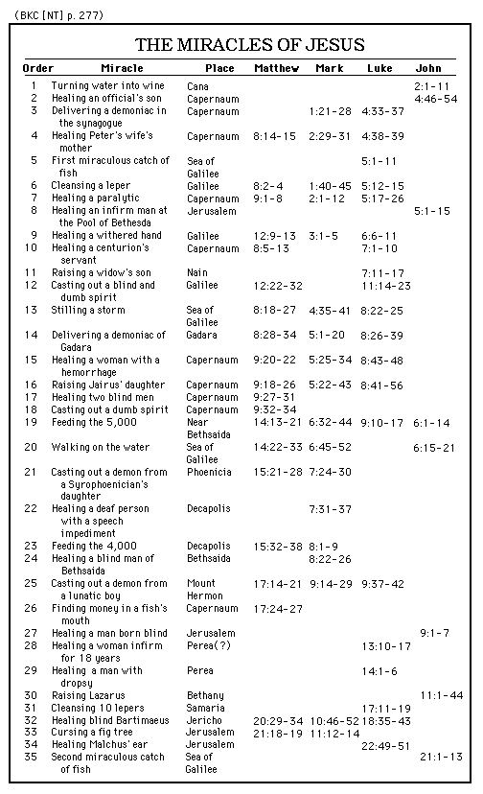

d. “The signs [miracles] of Jesus, like His teaching, provoke both belief (Jn 2:11, 23; 4:50, 53; 5:9; 6:14, 21; 9:11, 17, 33, 38; 11:27, 45; 12:11) and unbelief (Jn 5:18; 6:66; 9:16, 24, 29, 40f; 11:53).”
e. “The ministry of Jesus consisted of a series of signs (Jn 2:11; 4:54; 20:30) and mighty works (6:30; 17:4). These were not meant merely to provide evidence of a miraculous, supernatural power (4:48); Jesus is not the wonder-working ‘divine man’ of Hellenism. Rather, the mighty works were meant to point beyond themselves to the character of Jesus as the Son of God and Savior of the world (Jn 3:2; 6:14; 7:31; 9:16). They are not empty symbols, but themselves contain saving power and point to the saving significance of Jesus — as is often brought out in the accompanying discourses; their purpose was to lead people to faith (2:23; 12:37).”
f. “Seven of Jesus’ sign-miracles are recorded in the first major section of the gospel of John. The first is the changing of water into wine. The second is the healing of the nobleman’s son (4:46–54). The healing of the paralytic at Bethesda (5:2–9) is the third, followed by the feeding of the multitude (6:1–14) and Jesus walking on the sea (6:16–21). The sixth is the healing of the man born blind (9:1–7), and the seventh is the raising of Lazarus (11:1–44).”

2. “and made known His glory,”
a. This statement is the evidence of the previous statement in Jn 1:14, “And the Word became flesh, and tabernacled among us, and we saw His glory, glory as of the uniquely-begotten from the Father, full of grace and truth.”
b. The disciples saw His glory because Jesus first made His glory known at the wedding in Cana. Jesus would continue to make known His glory as God with miracle after miracle. As Jesus promised Nathanael, “You will see greater things than these,” (Jn 1:50).
c. Miracles are a manifestation of the glory of God because they are a manifestation of the essence of God or attributes of God. The composite of the attributes of God make up the glory of God. Miracles manifest as a minimum the omnipotence, omniscience, sovereignty, righteousness, justice, and love of God. “His works are signs of the glory of God.”

d. The disciples would never have seen or understood the glory of Jesus as the God-man had not Jesus made known His glory as God. A main purpose of the incarnation of Christ was to reveal or make known to the men around Him that He was indeed God on earth, living as a real human being.

3. “and His disciples believed in Him.”
a. In addition to revealing that He was in fact God and could demonstrate the glory of God, there was a significant result that followed on the part of the disciples—they believed in Him. “In John, however, miracles are signs which reveal the glory of Jesus as the Son of God and Messiah who gives new life, and thus which lead people to faith in Jesus (Jn 2:11; cf. 20:30–31).”
b. What does it mean to believe in Him? In this context it means specifically that the disciples believed that Jesus was truly God. Some commentators say that the disciples only gradually believed in the fact that Jesus was God, the Christ, the Messiah, etc. That is only partially true. For the five or six (there is some question as to whether or not James was there) disciples that were with Jesus at the wedding in Cana, there was no longer any doubt that He was God. John is making this point very clear. It would take other disciples longer (such as Thomas) and at least one disciple (Judas) never did believe. “It should be noted that believing in Christ is rare in the Synoptic Gospels, Acts, and Paul, but common in John’s Gospel, where it is found over 30 times between 2:11 and 17:20.”
c. Significant by its absence here is the silence of John with regard to the belief of Jesus’ mother and brothers. We cannot go too far with the silence of Scripture at this point and say definitively that His mother did not yet believe that He was God, the Christ; that is, the Messiah. Mary probably did believe in Him based on all that happened to her with regard to her pregnancy and the events surrounding His birth and childhood. And wouldn’t it be likely that of all people, Jesus would sit down with His family and tell them who He was, so that they might have eternal life? He probably did so, but as yet His brothers did not believe in Him, “After these things Jesus was walking in Galilee, for He was unwilling to walk in Judea because the Jews were seeking to kill Him. Now the feast of the Jews, the Feast of Booths, was near. Therefore His brothers said to Him, ‘Leave here and go into Judea, so that Your disciples also may see Your works which You are doing. For no one does anything in secret when he himself seeks to be known publicly. If You do these things, show Yourself to the world. For not even His brothers were believing in Him,” Jn 7:1-5.
d. “This spectacular miracle should, in all logic, have caused all who saw it to believe, but Jn 4:48 reveals the sad truth: this miracle did not convert mankind in general into believers, and this is consistently true of miracles in general.” “Signs, miracles, and wonders do not necessarily convince people to believe in the Lord and the gospel (2:23–25; 12:37; 15:24; Mt 11:20–24; 13:58; Lk 16:31). There is no record that any of the servants who witnessed Jesus’ turning the water into wine followed Him. Amazingly, Jesus seems to have left Cana with only the disciples who came there with Him [meaning that no new disciples were added from the men at the wedding], despite having performed a miracle. The obvious deduction that He was the Messiah escaped them; they saw the sign, but missed what it pointed to. As he does with all unbelievers, Satan “blinded [their] minds … so that they might not see the light of the gospel of the glory of Christ, who is the image of God” (2 Cor 4:4). This incident was another tragic illustration of the truth of Jesus’ saying, ‘A prophet has no honor in his own country’ (Jn 4:44; cf. Mt 13:58).”

Wallace, D. B. (1999, c1996). Greek Grammar Beyond the Basics: An exegetical syntax of the Greek New Testament (electronic ed.). Garland, TX: Galaxie Software. Page 187, footnote 40.
Wallace, Daniel B., Greek Grammar Beyond the Basics, p. 184. Lenski sees it the same way, p. 198f.
BDAG, p. 920.
BDAG, p. 1048.
Walvoord & Zuck, The Bible Knowledge Commentary, p. 277 lists them.
Bromiley, G. W. (1988; 2002). The International Standard Bible Encyclopedia, Revised (3:376). Eerdmans.
Bromiley, G. W. (1988; 2002). The International Standard Bible Encyclopedia, Revised (2:1083). Eerdmans.
Zuck, R. B. (1994; Published in electronic form by Logos Research Systems, 1996). A Biblical Theology of the New Testament (electronic ed.) (170). Chicago: Moody Press.
Freedman, D. N., Myers, A. C., & Beck, A. B. (2000). Eerdmans Dictionary of the Bible (p. 508). Grand Rapids, Mich.: W.B. Eerdmans
Freedman, D. N., Myers, A. C., & Beck, A. B. (2000). Eerdmans Dictionary of the Bible (p. 904). Grand Rapids, Mich.: W.B. Eerdmans
Kittel, G., Friedrich, G., & Bromiley, G. W. (1995, c1985). Theological Dictionary of the New Testament. (p. 213). Grand Rapids, Mich.: W.B. Eerdmans.
Mills, M. (1999). The Life of Christ: A Study Guide to the Gospel Record. Dallas, TX: 3E Ministries.
MacArthur, J. (2006). The MacArthur New Testament commentary: John 1-11 (p. 83). Chicago: Moody Press.

