    ◻

     is the parenthetical use of the postpositive conjunction DE, which means “Now” plus the third person singular imperfect active indicative from the verb EIMI, which means “to be: was.”
The imperfect tense is a descriptive imperfect, which describes the past, continuing state of being.
The active voice indicates that Bethany produced the state of being near Jerusalem.
The indicative mood is declarative for a simple statement of fact.
Then we have the nominative subject from the feminine singular article and proper noun BĒTHANIA, meaning “Bethany.” This is followed by the adverb of place EGGUS, meaning “near.” Then we have the adverbial genitive of place from the neuter plural article and proper noun HIEROSOLUMA, meaning “Jerusalem.”

“Now Bethany was near Jerusalem,”

◻ is the relative adverb HWS (from the relative pronoun HOS), which, “when used with numerals, means: a degree that approximates a point on a scale of extent: about, approximately, nearly Mk 5:13; 8:9; Lk 1:56; 8:42; Jn 1:39; 4:6; 6:10, 19; 19:14, 39; 21:8; Acts 4:4; 5:7, 36; 13:18, 20; Rev 8:1.” Then we have the preposition APO plus the ablative of separation from the masculine plural noun STADIOS plus the adjective DEKAPENTE, meaning “fifteen stadia.” A stadion was one-eighth of a mile; so 15 stadia would be 1 and 7/8 miles or about two miles. The preposition means “away from” or simply “away.” “The Greeks reckon the distance from (APO) the far point forward; hence APO: ‘from’ the capital to Bethany.”

“about two miles away;”

Jn 11:18 corrected translation
“Now Bethany was near Jerusalem, about two miles away;”

Explanation:

1. “Now Bethany was near Jerusalem,”
a. John continues with another parenthetical statement, telling us where Bethany was in relationship to Jerusalem.
b. The purpose of this statement is to indicate the danger Jesus was in, since He was so close to Jerusalem. And the principle of application for us is that no person is in danger, when they are in the will of God. Ps 118:6, “The Lord is for me; I will not fear; what can man do to me?” This is quoted in the New Testament in Heb 13:6. Perhaps Jesus sang this psalm (taught it to the disciples) as they walked from Perea to Bethany.
c. “The nearness of Bethany to Jerusalem is mentioned here to account for the presence of so many Jews who had come to comfort the sisters (verse 19).”
d. “John’s explanation that Bethany was near Jerusalem serves a twofold purpose. It highlights the risk Jesus took by coming so near to Jerusalem, which was a hotbed of murderous opposition to Him. And it also implies that many of the Jews who had come to Martha and Mary came from Jerusalem. That so many Jews from the capital came to console them concerning their brother suggests that the family was prominent, and probably wealthy (Jn 12:1–3). From the human perspective, the mourners were there to comfort the sisters in their loss. But from God’s perspective, they were there to witness Jesus’ stunning miracle. The raising of Lazarus would be done in public before numerous onlookers, many of whom were hostile to the Lord. As a result, not even Jesus’ enemies would be able to deny what He had done (Jn 11:47).”

2. “about two miles away;”
a. John adds this to help his Greek readers/listeners, who probably do not know the geography of Judea. Bethany was less than two miles Southwest of Jerusalem (about three kilometers). See the map below.
b. The Greek literally says “about fifteen stadia away.” A stadion was one-eighth of a mile. So fifteen stadia is 1 7/8th miles or “about two miles away.” This distance could easily be walked in less than a half hour. The point is that anyone who wanted to betray Jesus could slip away to Jerusalem and return with soldiers from the Temple Guard in about an hour. Clearly a dangerous situation for Jesus from human viewpoint.

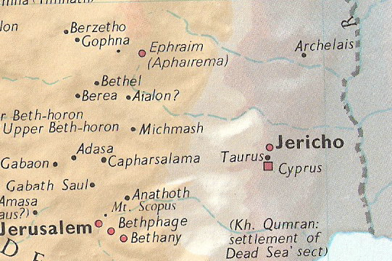

Arndt, W., Danker, F. W., & Bauer, W. (2000). A Greek-English Lexicon of the New Testament and Other Early Christian Literature. (3rd ed.) (p. 1105). Chicago: University of Chicago Press.
BDAG, p. 106, meaning 4.
Lenski, p. 795; so also Godet.
Carson, D. A. (1994). New Bible Commentary: 21st century edition (4th ed.) (Jn 11:1–44). Leicester, England; Downers Grove, Ill., USA: Inter-Varsity Press.
MacArthur, J. (2006). The MacArthur New Testament Commentary: John 1-11 (p. 462). Chicago: Moody Press.

