  □ 

- is the instrumental of means from the feminine singular noun PISTIS, used in both its active and passive sense here, translated “By means of confidence in doctrine.” (See verse 3 for the full explanation.) This is followed by the ascensive or emphatic use of the conjunction KAI, meaning “even, certainly, indeed, or in fact.” Then we have the preposition PERI plus the adverbial genitive of reference from the neuter plural present active participle of the verb MELLW, which means “to be about to be; to take place; to be accomplished; to be destined, inevitable; the participle is used in an absolute sense in the meaning: (in the) future, to come: as in the age to come Mt 12:32; Eph 1:21; Heb 2:5; 6:5; 13:14; 1 Tim 4:8.”
The present tense is a futuristic present, for a confident assertion about what is going to take place.
The active voice indicates the future produced the action of being about to happen or come.
The participle is used in an absolute sense as an ascriptive or substantive noun, meaning “the future.”
The phrase “even concerning the future” goes with or modifies/explains the main verb which follows and not with the word PISTIS.

“By means of confidence in doctrine…even concerning the future”

  □  - is the third person singular aorist active indicative from the verb EULOGEW, which means “to bless: blessed.”
The aorist tense is a constative/historical aorist, which regards the entire action of Isaac blessing Jacob and Esau as a historical fact.
The active voice indicates that Isaac produced the action.
The indicative mood is declarative for a simple statement of fact.
Then we have the nominative subject from the masculine singular proper noun ISAAK, which we transliterate as “Isaac.” Finally, we have the accusative direct object from the masculine singular articles and proper nouns IAKWB and ĒSAU, connected by the conjunction KAI, meaning “Jacob and Esau.”

“Isaac blessed Jacob and Esau.”

Heb 11:20 corrected translation
“By means of confidence in doctrine Isaac blessed Jacob and Esau even concerning the future.”

Explanation:

1. “By means of confidence in doctrine”
a. Isaac was a mature believer and a great believer. His greatness came from his absolute confidence in the doctrines related to the future.
b. His confidence in doctrine concerning the future was first demonstrated when he permitted his father to place him on a pile of wood on an altar for a burnt offering. That act demanded great confidence in the doctrine in his soul regarding his immediate future.
c. His confidence in doctrine concerning the future was again demonstrated at the end of his life, with the absolute confidence in doctrine he had concerning the future repercussions of his blessing of his two sons.
d. The point of this illustration is that the mature believer must have absolute confidence in the future and in God’s promises related to the future.
e. As the family priest, Isaac represented his entire family before God. Therefore, he had the honor of giving the Lord’s blessing to each of his sons. Whatever Isaac announced as the Lord’s blessing for each son would be honored and fulfilled by the Lord under the doctrine of the heritage blessing of the mature believer.
f. Isaac had absolute confidence in the fact that the Lord would honor in the future everything that Isaac asked for his two sons by way of blessing.

2. “Isaac blessed Jacob and Esau even concerning the future.”
a. Isaac had absolute confidence in the doctrine of heritage blessing.
(1) The doctrine of heritage blessing is that the Lord will do for the next generation whatever the mature believer wants after his death.
(2) Isaac was a mature believer and believed in the doctrine of heritage blessing.
(3) Isaac knew that in whatever manner he blessed his sons, the Lord would honor his blessing. This is the heritage blessing of the mature believer.
(4) Because Isaac was a mature believer, whatever he said concerning his two sons, the Lord was going to fulfill. Isaac had absolute confidence in this fact, which explains his distress when Jacob conned Esau out of Esau’s blessing.
b. The story of Isaac’s blessing of Jacob and Esau is found in Gen 27:1-28:9.
c. Isaac’s blessing of Jacob fulfilled the will of the Lord Jesus Christ, even though Isaac had intended his blessing for Esau.
d. Paul’s commentary on God’s attitude toward these two brothers is given by an anthropopathism in Rom 9:11-13, “for though having not yet been born, and though having not accomplished anything good or evil, in order that the purpose of the election of God might remain, not from works, but from Him Who elects, it was said to her, ‘The older [Esau] will be subservient to the younger [Jacob]’. Just as it stands written, ‘I love that Jacob, but I hate that Esau.’”
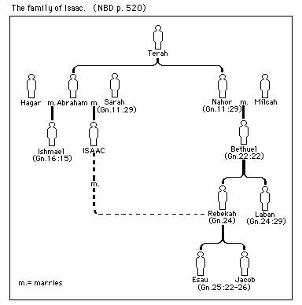

Arndt, W., Danker, F. W., & Bauer, W. (2000). A Greek-English Lexicon of the New Testament and other early Christian literature. (3rd ed.) (Page 628). Chicago: University of Chicago Press.

