□           

□   is the transitional use of the postpositive conjunction DE, meaning “Now” plus the nominative subject from the masculine singular proper noun SAULOS, transliterated as “Saul.” Then we have an imperfect periphrastic construction, which is the use of a finite verb in the imperfect tense and a present participle. First, we have the third person singular imperfect active indicative from the verb EIMI, meaning “to be: was; kept on being.”
The imperfect tense is a descriptive imperfect, which describes an action in progress in the past.
The active voice indicates that Saul produced the action or state of being.
The indicative mood is declarative for a simple statement of fact.
With this we have the nominative masculine singular present active participle from the verb SUNEUDOKEW, which means “to join in approval, agree with, approve of, consent to, sympathize with Rom 1:32; approve of, give approval to Lk 11:48; Acts 8:1; 22:20.”
The present tense is a descriptive present of what was occurring at that time.
The active voice indicates that Paul produced the action.
The participle is circumstantial.
This is followed by the dative of direct object from the feminine singular article and noun ANAIRESIS with the possessive genitive from the third person masculine singular personal use of the intensive pronoun AUTOS, meaning “with his [Stephen’s] murder, killing; (Saul) consented to his murder Acts 8:1.”

“Now Saul was agreeing with his murder.”

       is the transitional use of the postpositive conjunction DE, meaning “Then” plus the third person singular aorist deponent middle indicative from the verb GINOMAI, which means “to happen, occur, or take place.
The aorist tense is a constative/historical aorist, which views the entire past action as a fact.
The deponent middle functions like an active voice—a great persecution producing the action of occurring or taking place.
The indicative mood is declarative for a simple statement of fact.
Then we have the preposition EN plus the locative of time from the feminine singular demonstrative pronoun EKEINOS, used as an adjective the article and feminine singular noun HĒMERA, meaning “in/on/during that day.” This is followed by the nominative subject from the masculine singular noun DIWGMOS with the adjective MEGAS, meaning “a great persecution: ‘a severe persecution’ Acts 8:1; 13:50; Mk 4:17; 10:30; 2 Tim 3:11; Mt 13:21; 2 Thes 1:4; 2 Cor 12:10; Rom 8:35.” Then we have the preposition EPI plus the accusative of relationship (here hostile relationship—see Brooks & Winbery, p. 62) from the feminine singular article and noun EKKLĒSIA plus the feminine singular article, used to identify the prepositional phrase that follows as an adjective and modifier of the noun EKKLĒSIA, with the preposition EN plus the locative of place from the neuter plural noun IEROSOLUMA, meaning “against the church in Jerusalem.” Literally this says “against the church, the one in Jerusalem.” With the article making the prepositional phrase ‘in Jerusalem’ the modifier of the prepositional phrase ‘against the church’, what we actually have is: “against the in Jerusalem church.” This is awkward English, but great Greek, which is why you can’t always translate Greek literally.

“Then on that day a great persecution occurred against the church in Jerusalem.”

     is the additive use of the postpositive conjunction DE, meaning “And” plus the nominative subject from the masculine plural adjective PAS, meaning “all.” Then we have the third person plural aorist passive indicative from the verb DIASPEIRW, which means “to scatter someone; in the passive voice of scattered communities of Christians Acts 8:1, 4; 11:19.”
The aorist tense is a constative/historical aorist, which views the entire past action as a fact.
The passive voice indicates that the various groups of Christians in the city of Jerusalem received the action of being scattered throughout Judea and beyond Judea into other lands.
The indicative mood is declarative for a simple statement of fact.
This is followed by the preposition KATA plus the adverbial accusative of measure (which conveys the idea of distribution—see Brooks & Winbery, p. 52) from the feminine plural article and noun CHWRA plus the possessive genitive from the feminine singular article and noun IOUDAIA, which means “over, through, throughout the districts, regions, country of Judea.” With this we have the connective conjunction KAI, meaning “and” plus the possessive genitive from the feminine singular noun SAMAREIA, transliterated as “Samaria.”

“And they were all scattered throughout the regions of Judea and Samaria,”

  is the preposition PLĒN (BDAG, p. 826) plus the ablative of separation from the masculine plural article and noun APOSTOLOS, meaning “except the apostles.”

“except the apostles.”

Acts 8:1 corrected translation
“Now Saul was agreeing with his murder. Then on that day a great persecution occurred against the church in Jerusalem. And they were all scattered throughout the regions of Judea and Samaria, except the apostles.”

Explanation:

1. “Now Saul was agreeing with his murder.”
a. Luke continues by focusing on the attitude of the center figure of his history—the apostle Paul. Luke establishes the historical picture of Paul as he was before becoming a believer—he was the chief persecutor of the church in Judea and regions beyond Judea. Luke begins this historical sketch of Paul by indicating Paul’s attitude toward Stephen at the time of Stephen’s murder. Saul of Tarsus was in full and complete agreement with the mob violence that produced Stephen’s murder.
b. Paul approved of the murder of Stephen. He gave his full consent to this murder without hesitation. He was in full agreement with the actions of the high priest and the Sanhedrin mob.
c. By agreeing with the murder of Stephen, Saul establishes himself as a co-conspirator in the execution of Stephen. Paul was as guilty of the murder of Stephen as those throwing the rocks to kill him.
d. Saul completely approved of what was being done, and he never forgot his guilt in this matter, 1 Cor 15:9, “For I am the least of the apostles, and not fit to be called an apostle, because I persecuted the church of God.” Acts 22:20, “And when the blood of Your witness Stephen was being shed, I also was standing by approving, and watching out for the coats of those who were slaying him.”

2. “Then on that day a great persecution occurred against the church in Jerusalem.”
a. The murder of Stephen unleashed the hatred of the Sanhedrin against the believers in Jerusalem.
b. We have already seen that the motivation for this hatred was the jealousy of the Sadducees, Acts 5:17, “Then rising up [in opposition], the high priest and all those with him (that being the sect of the Sadducees) were filled with jealousy.”
c. This persecution was so great, its effects lasted until the destruction of Judea in 70 A.D. People lost their lives, homes, jobs, everything. Many were imprisoned.
d. Remember that there were now over 8000 members of the church in Jerusalem, so that this was no small scale persecution. It was the first ‘witch-hunt’ in the history of the Church. The leader of this ‘witch-hunt’ would become Saul of Tarsus.

3. “And they were all scattered throughout the regions of Judea and Samaria,”
a. The result of the great persecution of the church of Jerusalem was the beginning of the mission of the gospel to the Gentiles.
(1) Persecution forced the Greek speaking Jews out of Jerusalem and back to the countries from which they had come. They would take the gospel message to those lands.
(2) Jewish believers living in Jerusalem who were persecuted would flee to family and friends in other places within Judea and Samaria outside of the city of Jerusalem. This would spread the message of the gospel more quickly throughout the area of Israel.
(3) Once the persecution died down, these believers would return to the city to continue their lives, but in many cases they lost their homes, land, jobs, etc., so that the ‘poor’ believers in Jerusalem became a continual problem for the church. Even fourteen years later at the Jerusalem council the leaders of the Jerusalem church were asking Paul and Barnabas to remember the poor among them. This persecution had its lasting effects until 70 A.D., that is, for that entire generation.
b. The word “all” here is important, because we have to define who the “all” are. We know that it cannot be all the believers in Jerusalem, because the apostles remained as the next phrase says (‘except the apostles’) and the church of Jerusalem continued to exist. Walter Kaiser gives the following hypothesis that only the Greek speaking believers of the church of Jerusalem were scattered: “In the eyes of the authorities the Greek-speaking Christians (already suspect because they came from outside Palestine and spoke only Greek) were the problem. They were persecuted and scattered, pursued as far as Damascus (Acts 8:1; 9:1–2). But the Aramaic-speaking Christians, including the apostles, were not suspect. Were they not known to be people of exemplary piety, frequently in the temple? The persecutors, principally the Pharisees, did not consider them in the same category as their Greek-speaking brothers and sisters. Persecution would come to the Aramaic-speaking Christians about a decade later (Acts 12), but even then it would come from Herod, not from the Sanhedrin, and would not be enough to drive them all out of Jerusalem. They would remain until the Romans began to surround the city in the war of A.D. 66–70. In the providence of God, then, the Greek-speakers, linguistically and culturally equipped to fit into other areas from which many of them had originally come, were scattered to bring the gospel to the Roman world. At the same time the core of the church remained in Jerusalem to carry on the Jewish-Christian mission in the very heart of Judaism.”
c. We know that there were still believers in the city of Jerusalem along with the apostles not long after this persecution because of Luke’s statement about Paul not long after his conversion in Acts 9:26, “When he came to Jerusalem [after fleeing Damascus], he was trying to associate with the disciples; but they were all afraid of him, not believing that he was a disciple.”
d. Samaria is the territory north of Judea. See the map below.
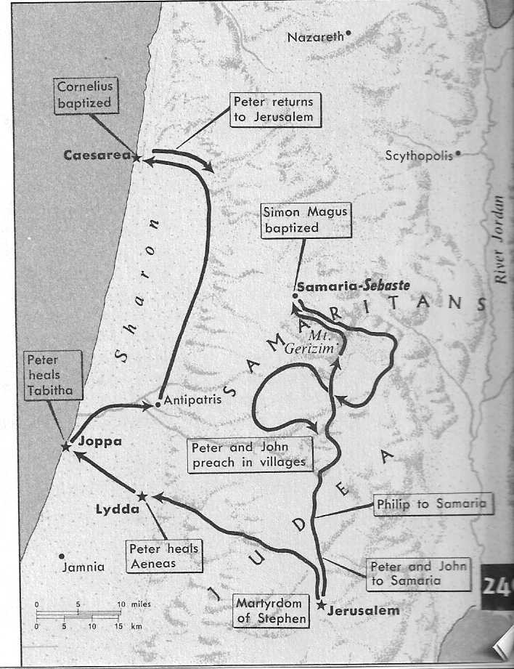

e. Our Lord’s words of Acts 1:8b will now begin to be fulfilled, “Furthermore you shall be My witnesses both in Jerusalem and in all Judea and Samaria, even to the end [remotest part] of the earth.”
f. Note the very important principle that the wrath of man accomplishes the will of God. The chief priests, the Sadducees, and now the Pharisee Saul all sought to bring the ‘Christian’ movement to a violent end. The great persecution had the opposite effect of spreading the message of Christianity to an even greater number of Jews and Gentiles.

4. “except the apostles.”
a. Luke makes a point of telling us that the apostles were not scattered with the Greek speaking Christians.
b. It is not hard to understand why they were not driven out of the city:
(1) Acts 5:12, “Now through the hands of the apostles many miracles and wonders were taking place among the people.”
(2) Acts 5:13, “the people spoke highly of them.”
(3) Acts 5:26, “the commander [of the temple guards] arrested them without force (for they were afraid of the people, that they might be stoned).”
c. The people wanted the apostles who were healing many to remain in Jerusalem unharmed, and the leaders of the Sanhedrin were afraid of being stoned by the people of Jerusalem if they did anything to harm the apostles.
d. In addition, God had a plan and purpose for keeping the apostles in Jerusalem. The Jews from all over the world came there, and God wanted them evangelized. God also wanted to evangelization of the Jews living in Judea to continue. Rom 1:16, “For I am not ashamed of the gospel, because it is the power of God for the purpose of salvation for all those who believe, not only to the Jew first but also to the Gentile.”

Arndt, W., Danker, F. W., & Bauer, W. (2000). A Greek-English Lexicon of the New Testament and other early Christian literature. (3rd ed.) (p. 970). Chicago: University of Chicago Press.
Arndt, W., Danker, F. W., & Bauer, W. (2000). A Greek-English Lexicon of the New Testament and other early Christian literature. (3rd ed.) (p. 64). Chicago: University of Chicago Press.
Arndt, W., Danker, F. W., & Bauer, W. (2000). A Greek-English Lexicon of the New Testament and other early Christian literature. (3rd ed.) (253). Chicago: University of Chicago Press.
Arndt, W., Danker, F. W., & Bauer, W. (2000). A Greek-English Lexicon of the New Testament and other early Christian literature. (3rd ed.) (236). Chicago: University of Chicago Press.
Kaiser, W. C. (1997, c1996). Hard sayings of the Bible (523). Downers Grove, Il: InterVarsity. Polhill, p. 211, Barrett, p. 390 and Bruce, p. 162f agree with this assessment.

