 □  

 □    is the transitional use of the postpositive conjunction DE, meaning “Now,” which transitions the narrative along to a new scene. With this we have the genitive absolute construction, which includes a genitive participle functioning as a finite verb and a pronoun in the genitive functioning as the subject of the participle. The construction is absolute because it is grammatically independent of the rest of the sentence. First, we have the genitive masculine singular present active participle from the verb KRATEW, which means “to use one’s hands to establish a close contact, hold someone (fast) with the hand, so that the person cannot go away Acts 3:11.” When the genitive case follows the verb KRATEW it connotes “tenderness, which is contrasted with the use of the accusative case following the verb, which indicates grasping or completely embracing someone (Mt 12:11; 28:9; Mk 73: Acts 3:11).”
The present tense is a durative present, which describes the action as continuous—the healed man wouldn’t let go of Peter and John.
The active voice indicates that the healed man produced the action.
The participle is temporal, indicating that this action occurred at the same time as the action of the main verb “all the people ran together.” It is translated “while he was holding.”
With the participle we have the genitive subject of the participle from the third person masculine singular personal use of the intensive pronoun AUTOS, meaning “he” and referring to the healed man. Then we have the accusative direct object from the masculine singular article and proper noun PETROS, “Peter” with the connective conjunction KAI, “and” plus the accusative masculine singular article and proper noun IWANNES, “John.”

“Now while he was holding Peter and John,”

 is the third person singular aorist active indicative from the verb SUNTRECHW, which means “to run together” (BDAG, p. 976).
The aorist tense is a constative/historical aorist, which regards the entire past action as a fact.
The active voice indicates that all the people in the temple produced the action.
The indicative mood is declarative for a simple statement of fact.
Then we have the nominative subject from the masculine singular adjective PAS, meaning “all” plus the nominative masculine singular article and noun LAOS, meaning “the people.” This is followed by the preposition PROS plus the accusative of direction/place from the third person masculine plural personal use of the intensive pronoun AUTOS, meaning “to them” and referring to Peter and John.

“all the people ran together to them”

 is the preposition EPI plus the locative of place from the feminine singular article and noun STOA, meaning “on or in, a roofed colonnade open normally on one side, portico [Latin = a porch] Jn 5:2; 10:23; Acts 3:11; 5:12.” With this we have the appositional locative/dative from the feminine singular articular present passive participle of the verb KALEW, which means “to be called: which is called.”
The article is used as a relative pronoun, “which.”
The present tense is a durative present for an action that began in the past (when this was built) and continues in the present (when Luke writes).
The passive voice indicates that this structure received the action of being called or named something.
The participle is circumstantial and explanatory.
Then we have the possessive genitive from the masculine singular noun SOLOMWN, meaning “Solomon’s” and the nominative of explanation from the masculine plural adjective EKTHAMBOS, meaning “utterly astonished Acts 3:11.” This plural adjective modifies the collective singular noun LAOS = people. They were ‘utterly astonished people’.

“on the porch which is called ‘Solomon’s’, utterly astonished.”

Acts 3:11 corrected translation
“Now while he was holding Peter and John, all the utterly astonished people ran together to them on the porch which is called ‘Solomon’s’.”

Explanation:

1. “Now while he was holding Peter and John,”
a. The healed man kept on affectionately holding onto Peter and John. He would walk around, jump, leap and run up to someone to tell them what had happened to him, and then run back to Peter and John and hug them, put his arm around them or hold their hands.
b. The point here is that the man had genuine gratitude for them and showed his sincere affection for and attachment to them. The man clearly identified himself with them, and the people all recognized Peter and John as two of the men involved in the incidents on Pentecost, especially Peter with his speech about the resurrection and session of Christ.
c. So while the healed man was holding on to the two people he now had the greatest of affection for, God the Holy Spirit’s purpose for this miracle is accomplished.

2. “all the utterly astonished people ran together to them”
a. Thousands of people who recognized this man as the former lame man rushed to the three of them (Peter, James, and the healed man). This was exactly what God wanted to have happen, so that Peter and John would have another opportunity to share the gospel message with thousands of Jews.
b. The people were utterly astonished because they recognized the lame man and saw that he was truly and miraculously healed.
c. The people couldn’t believe their eyes and everyone wanted to see if it was really true.
d. God the Holy Spirit clearly drew the attention of the crowd away from the afternoon animal sacrifice, so they could hear the message from Peter and John of the real sacrifice of Christ on the Cross.
e. The total amazement of these people gives Peter the opportunity and open door to explain that their total amazement is misplaced.

3. “on the porch which is called ‘Solomon’s’.”
a. Luke identifies the actual area of the temple complex where this event took place, so that his readers will understand how such a large crowd could be gathered. The crowd gathered in a large area near the eastern entrance to the temple area called Solomon’s porch.
b. Solomon’s porch was a “a colonnade on the east of the temple, so called from a tradition that it was a relic of Solomon’s temple left standing after the destruction of Jerusalem by the Babylonians.” “According to Josephus, who regarded this area as a remnant of Solomon’s temple, its Herodian expansion is said to have included a span of 49 feet of double monolithic columns some 38 feet tall, fashioned of white marble supporting an impressive roof paneled with cedar. This colonnaded area of the temple precinct served as a gathering place for Jesus and his disciples (Jn 10:23) as well as the early Jerusalem Church (Acts 2:46; 5:12).” “The four sides of the temple platform were surrounded by colonnaded stoas [porches or roofs supported by columns], of which the eastern was known as “Solomon’s” and the southern as “Royal.” Josephus apparently believed that the east portico remained from Solomon’s temple, but this is contradicted not only by the structure itself but also by Josephus’s own testimony concerning the Herodian expansion of the temple platform.” “In these colonnades the scribes held their schools and debates and the merchants and money-changers had their stalls.”
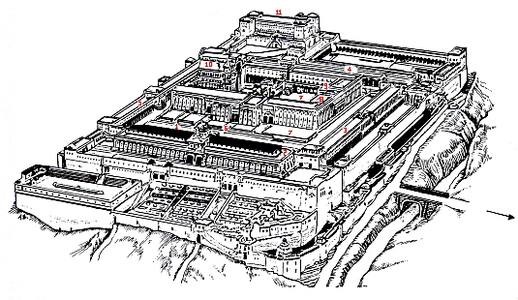

The Heathen Forecourt [1] is enclosed by pillar passages (see [2], [3], [4] and [5]). Many activities took place here. [3] is Solomon’s famous pillar passage. [6] indicates the dividing wall between the Heathen Forecourt and the Women’s Forecourt [7], with its warning signs. To the east the Beautiful Gate [8] provided entrance to the Women’s Forecourt. Moving further westward one could go through the ornate Nicanor gateway [9] to the Men’s Forecourt. The latter was, in turn, separated from the Priests’ Forecourt by a low partition, where the altar for burnt offerings stood, amongst others. The actual sanctuary [10] consisted of a foyer, as well as the Holy Place and the Holiest of Holies, which were separated from each other by a heavy curtain. The Holy Place contained the altar for scented offerings. The Holiest of Holies was entered only on the Day of Atonement, and then only by the High Priest. [11] is the Tower of Antonia where a permanent cohort of Roman soldiers was stationed to quell riots. Across the bridge on the eastern side, a path leads through the Kidron Valley to the Mount of Olives and Gethsemane.”
c. Below is a reconstruction of the Temple area with an excellent view of the Royal porch, to give you an idea of the size of this area and why it could hold a crowd of several thousand people.

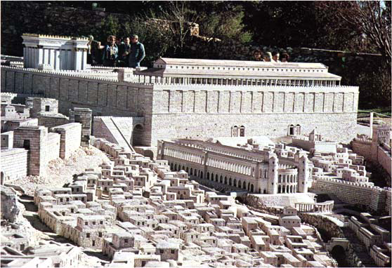

Arndt, W., Danker, F. W., & Bauer, W. (2000). A Greek-English lexicon of the New Testament and other early Christian literature. (3rd ed.) (564). Chicago: University of Chicago Press.
Wallace, Daniel B., Greek Grammar Beyond the Basics, p. 132.
Arndt, W., Danker, F. W., & Bauer, W. (2000). A Greek-English Lexicon of the New Testament and other early Christian literature. (3rd ed.) (p. 945). Chicago: University of Chicago Press.
Arndt, W., Danker, F. W., & Bauer, W. (2000). A Greek-English Lexicon of the New Testament and other early Christian literature. (3rd ed.) (p. 303). Chicago: University of Chicago Press.
Easton, M. (1996, c1897). Easton's Bible dictionary. Oak Harbor, WA: Logos Research Systems, Inc.
Freedman, D. N., Myers, A. C., & Beck, A. B. (2000). Eerdmans dictionary of the Bible (1240). Grand Rapids, Mich.: W.B. Eerdmans
Bromiley, G. W. (1988; 2002). The International Standard Bible Encyclopedia, Revised (2:1028). Wm. B. Eerdmans.
Wood, D. R. W., & Marshall, I. H. (1996). New Bible dictionary (3rd ed.) (1158). Leicester, England; Downers Grove, Ill.: InterVarsity Press.
du Toit, A. (1998). The New Testament Milieu. Halfway House: Orion.

