   □    

 is the continuative/transitional use of the postpositive conjunction DE, meaning “Then” with preposition META plus the adverbial accusative of measure of extent of time from the feminine plural noun HĒMERA and the adjectival use of the indefinite pronoun TIS, meaning “after some days.” Then we have the nominative masculine singular aorist deponent middle participle from the verb PARAGINOMAI, which means “to come; to arrive.”
The aorist tense is a constative/historical aorist, which views the entire past action as a fact.
The deponent middle voice is middle in form, but active in meaning with the subject (Felix) producing the action.
The participle expresses attendant circumstances that precede the action of the main verb (he sent). This participle can also be regarded as a temporal participle and translated “after arriving.”
This is followed by the nominative subject from the masculine singular article and proper noun PHĒLIX, transliterated “Felix.” (It is translated with the main verb “to send for” (see below).

“Then after some days, after arriving”

   □   is the preposition SUN plus the instrumental of association from the feminine singular proper noun DROUSILLA, which means “with Drusilla.” Then we have an appositional/explanatory instrumental from the feminine singular article, the adjective IDIOS and the noun GUNĒ, meaning “his own wife.” This is followed by the instrumental feminine singular present active participle from the verb EIMI, meaning “to be: being.”
The present tense is an aoristic present, which regards the situation being described as a fact.
The active voice indicates that Drusilla produced the action of being Jewish.
The participle is circumstantial.
Then we have the instrumental feminine singular from the predicate adjective IOUDAIOS, meaning “Jewish.” This is also called a “predicate dative: the dative substantive makes an assertion about another dative substantive, much like a predicate nominative does. The difference, however, is that with the predicate dative, the equative verb is a participle (in the dative case) rather than a finite verb.” This appositional/explanatory statement is better rendered into the English translation as a parenthesis.

“with Drusilla (his own wife being Jewish)”

    is the third person singular aorist middle indicative from the verb METAPEMPW, which means “to send for; to summon” someone.
The aorist tense is a constative/historical aorist, which views the entire past action as a fact.
The middle voice emphasizes the personal responsibility of the subject in producing the action. Here Felix is personally responsible for sending for Paul.
The indicative mood is declarative for a simple statement of fact.
Then we have the accusative direct object from the masculine singular article and proper noun PAULOS, meaning “Paul.” This is followed by the additive use of the conjunction KAI, meaning “and” plus the third person singular aorist active indicative from the verb AKOUW, meaning “to hear: heard.”
The aorist tense is a constative/historical aorist, which views the entire past action as a fact.
The active voice indicates that Felix produced the action of hearing.
The indicative mood is declarative for a simple statement of fact.
Then we have the objective genitive or genitive direct object (the verb AKOUW takes its objects in the genitive case) from the third person masculine singular personal use of the intensive pronoun AUTOS, meaning “him” and referring to Paul. This is followed by the preposition PERI plus the adverbial genitive of reference from the feminine singular article and noun PISTIS, meaning “about or concerning faith.” Between the article and its noun we have a prepositional phrase, which indicates that this prepositional phrase is intimately involved with the noun PISTIS and modifies it. We have the preposition EIS plus the accusative of place from the masculine singular proper nouns CHRISTOS and IĒSOUS, meaning “in Christ Jesus.”

“Felix sent for Paul and heard him [speak] about faith in Christ Jesus.”

Acts 24:24 corrected translation
“Then after some days, after arriving with Drusilla (his own wife being Jewish), Felix sent for Paul and heard him [speak about faith in Christ Jesus.”

Explanation:

1. “Then after some days, after arriving with Drusilla (his own wife being Jewish)”
a. As we have already seen from the time it would take for Felix to send for Claudius Lysias, the phrase “after some days” has to refer to at least a week after the initial appearance of Paul before Felix. The phrase “after some days” is certainly less than a month, but is still an unknown period of time. Luke is making the point that Felix was in no hurry to take action in the case of Paul.
b. “The chief extrabiblical source of information regarding Drusilla is Josephus. He records that she was the youngest of three daughters of Herod Agrippa I, her sisters being Bernice and Mariamne. She was born about A.D. 38, (“She was engaged as a child to marry Epiphanes, son of King Antiochus IV of Commagene. After Agrippa’s death (44 A.D.), however, Epiphanes backed out on his commitment to convert to Judaism and so the marriage was off.”) and at the age of fourteen was given in marriage by her brother Agrippa II to Azizus king of Emesa. Shortly afterward, Felix, when he was procurator of Judea (a.d. 52–60), employed a Cyprian sorcerer named Simon to persuade her to desert her husband and marry himself. Her decision to break the Jewish law and marry Felix [she did so at age 16] was also influenced by the cruelty of Azizus and the hatred of Bernice, who was jealous of her beauty. By Felix she had one son, Agrippa, who died in the eruption of Mt. Vesuvius in A.D. 79 [along with his mother].” “Incidentally, of his three wives, Felix is reported to have married another Drusilla, the granddaughter of Cleopatra and Antony (Tacitus).” “Her father killed James [the brother of John, the sons of Zebedee], her great-uncle Herod Antipas slew John the Baptist, her great-grandfather Herod the Great murdered the babes of Bethlehem.”
c. Drusilla was the third wife of Felix. Luke’s emphasis on the fact that Drusilla was a Jew is for the benefit of his Gentile reader, Theophilus, who may not have known this. This also tells us that she was probably Felix’s primary source of information about the theological differences between the Sadducees and Pharisees. The fact that she wanted to hear Paul speak indicates nothing more than her curiosity in the man who had turned the Roman world upside down with his message about a carpenter from Nazareth.
d. The fact Felix is accompanied by his wife tells us that this is not an official court hearing, but a private or semi private audience with the apostle. The Western text adds to this verse that Drusilla “asked to see Paul and hear him speak” and that Felix consequently summoned Paul “wishing to satisfy her.”

2. “Felix sent for Paul and heard him [speak] about faith in Christ Jesus.”
a. Felix, accompanied by his wife, summons Paul, who is brought to him by the centurion who was charged with guarding Paul.
b. The fact that Paul spoke about faith in Christ Jesus indicates that Paul was not asked specific questions, but given the opportunity to say whatever he wanted. Felix would have said something like, “Paul, tell us what it is that you have been proclaiming all these years about this fellow named Jesus.”
c. The phrase “heard him speak about faith in Christ Jesus” indicates that Paul was able to make a complete presentation of the gospel to this Roman official and his wife, as well as anyone else who was in attendance (soldiers, slaves, servants, other Roman officials, etc.)
d. Felix and his wife clearly and completely heard the message of the gospel. They had every opportunity to be saved. They will be without excuse at the Last Judgment.
e. Notice that the message of the gospel is “about faith in Christ Jesus.”
f. The title “Christ Jesus” emphasizes the mission of the Son of God as the Messiah (“Christ”) or Savior of mankind and the true humanity of the Son of God (“Jesus”). The Son of God had to become true humanity to be the “Christ.”
g. Luke has already told us what this message was: Acts 4:12, “Furthermore, there is salvation in no one else; for there is no other person under heaven, who has been given among men, by whom it is necessary that we be saved.’”

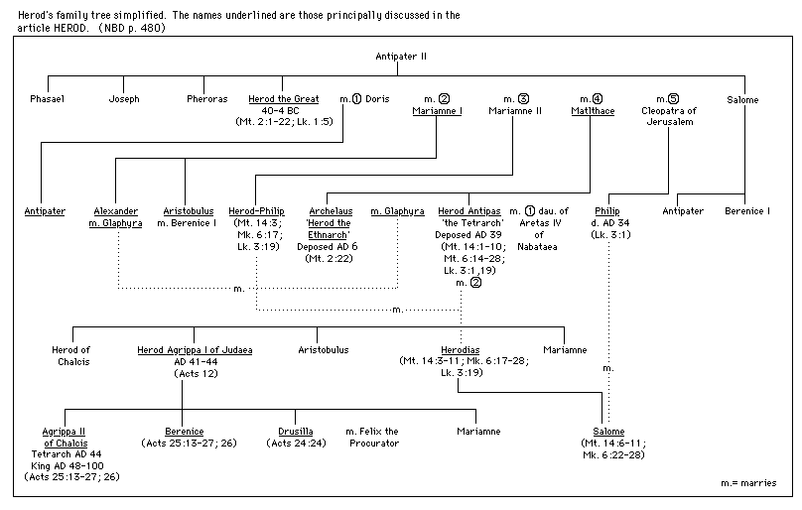

BDAG, p. 637.
BDAG, p. 760.
Wallace, Greek Grammar Beyond the Basics, p. 152f.
Wallace, D. B. (1999, c1996). Greek Grammar Beyond the Basics: An exegetical syntax of the Greek New Testament (electronic ed.). Garland, TX: Galaxie Software. Page 152.
BDAG, p. 640.
Freedman, D. N., Myers, A. C., & Beck, A. B. (2000). Eerdmans Dictionary of the Bible (p. 358). Grand Rapids, Mich.: W.B. Eerdmans
Bromiley, G. W. (1988; 2002). The International Standard Bible Encyclopedia, Revised (1:995)..Eerdmans.
Freedman, D. N., Myers, A. C., & Beck, A. B. (2000). Eerdmans Dictionary of the Bible (p. 358). Grand Rapids, Mich.: W.B. Eerdmans
Lenski, p. 979.
Polhill, p. 486, footnote 119.

