  

   is the continuative use of the postpositive conjunction DE, meaning “Then” plus the nominative masculine singular aorist active participle from the verb ANAGINWSKW, which means “to read.”
The aorist tense is a constative/historical aorist, which views the entire past action as a fact.
The active voice indicates that Felix produced the action.
The participle is temporal and precedes the action of the main verb. It is translated “after reading.” We need to supply the object “[it],” referring to the letter of Lysias to Felix for the sake of proper English grammar.
Then we have the additive or connective use of the conjunction KAI, meaning “and” plus the nominative masculine singular aorist active participle from the verb EPERWTAW, which means “to ask.” The morphology of this participle is the same as the previous participle. It is translated “after asking.” This is followed by the preposition EK plus the ablative of origin (translated “from”) from the feminine singular interrogative adjective POIOS, meaning “which, what?; used in an indirect question Mt 24:42f; Lk 12:39; Rev 3:3; Acts 23:34.” With this adjective we have the ablative feminine singular from the noun EPARCHEIA, meaning “a Roman administrative area ruled by an  or prefect, province Acts 23:34; 25:1.” Then we have the third person singular present active indicative from the verb EIMI, meaning “to be: he was.”
The present tense is an aoristic/historical/static present for a state of being that is always true and is a fact. The time element of this main verb is related to the time element of the general context of the story and the previous aorist participles. Therefore, it is translated like a past tense. The indirect question retains the tense of the direct question. The direct question would have been, “From what province is he?”
The active voice indicates that where Paul is from produces the state of being what it is.
The indicative mood is an interrogative indicative, which is used in questions that can be answered by providing factual information. Here we have an indirect question.

“Then, after reading [it] and asking from what province he was,”

  is the additive use of the conjunction KAI, meaning “and” plus the nominative masculine singular aorist deponent middle participle of the verb PUNTHANOMAI, which means “to learn” by inquiry.
The aorist tense is a constative/historical aorist, which views the entire past action as a fact.
The deponent middle voice is middle in form, but active in meaning with the subject (Felix) producing the action.
The participle is temporal and precedes the action of the main verb. It is translated “after learning.”
Then we have the explanatory use of the conjunction HOTI, meaning “that,” which introduces the content of what was learned. This is followed by the preposition APO plus the ablative of origin from the feminine singular proper noun KILIKIA, meaning “from Cilicia.” The main verb is the ellipsis or deliberate omission of the third person singular present or imperfect active indicative of the verb EIMI, meaning “[he was].”

“and after learning that [he was] from Cilicia,”

Acts 23:34 corrected translation
“Then, after reading [it] and asking from what province he was, and after learning that [he was] from Cilicia,”

Explanation:

1. “Then, after reading [it] and asking from what province he was,”
a. Felix reads the letter from the tribune, Claudius Lysias, and as was customary in the ancient world, the letter was read aloud. This is how Paul learned of the contents of the letter, and subsequently how Luke learned of the letter’s contents. Therefore, Luke’s quote of the letter is both accurate and trustworthy contrary to many critics of the New Testament.
b. After reading the letter, Felix asked one of two people what province Paul was from. He either asked the centurion, who would have had many hours to talk with Paul on his way from Jerusalem to Caesarea and may have known a great deal about Paul or Felix asked Paul himself. In either case it was a simple question and a short answer.

2. “and after learning that [he was] from Cilicia,”
a. Felix learned that Paul was from the Roman province of Cilicia, which is in the southeast corner of what is now Turkey (see the map below).
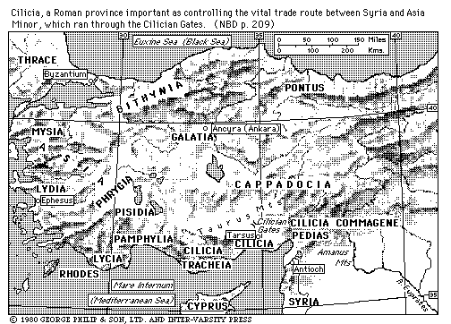
b. “Felix asked Paul in what province he had originally resided. This procedural method of questioning the accused helped Felix to determine whether he would hear Paul’s case. After learning that Paul was from Cilicia, Felix had a choice either to hear the case himself or to defer it to the legate of Syria.”
c. “One may wonder why Felix did not avail himself of the option of referring the case to the Legate of Syria and save himself some trouble. The answer in part probably lies in the fact that eastern Cilicia, where Tarsus was, was in all probability still part of the combined province Syria-Cilicia. The legate of Syria was in charge of both this region and Judea. Had Felix transferred Paul to another Roman official in the region, it would have had to have been to the legate of Syria. But this would be problematic on two accounts: (1) the legate would probably not want to be bothered with a minor matter of this sort and would wonder why Felix, who had the imperium [authority] to do so, since he was not required to send Paul back to Tarsus, had not settled the matter; (2) it would make it much more difficult for Paul to face his accusers, for they would have to travel a much greater distance, and Roman law placed a premium on the accusers appearing in person and making formal charges that the defendant would then be expected to answer in his defense. Had Felix sent Paul on to Syria he would likely have only created more troubles for himself with both Roman and Jewish officials with whom he had to have ongoing dealings.”

Arndt, W., Danker, F. W., & Bauer, W. (2000). A Greek-English Lexicon of the New Testament and other early Christian literature. (3rd ed.) (p. 843). Chicago: University of Chicago Press.
Arndt, W., Danker, F. W., & Bauer, W. (2000). A Greek-English Lexicon of the New Testament and other early Christian literature. (3rd ed.) (p. 359). Chicago: University of Chicago Press.
BDAG, p. 897.
Bromiley, G. W. (1988; 2002). The International Standard Bible Encyclopedia, Revised (3:1026).. Eerdmans.
Witherington, p. 701f.

