              

 is the continuative use of the postpositive conjunction DE, meaning “Then” with the preposition META plus the adverbial accusative of measure of extent of time from the feminine plural article and noun HĒMERA with the demonstrative pronoun HOUTOS, meaning “after these days.” This is followed by the nominative first person masculine plural aorist deponent middle participle from the verb EPISKEUAZOMAI, which means “to get ready.”
The aorist tense is a culminative aorist, which views the entire past action as a fact with emphasis on its completion. It is translated using the English auxiliary verb “has/have.”
The deponent middle voice functions in an active sense, indicating that Paul and his team produced the action.
The participle is a temporal participle that precedes the action of the main verb and can be translated “having gotten ready.”

“Then after these days, having gotten ready,”

   is the first person plural imperfect active indicative from the verb ANABAINW, which means “to go up.”
The imperfect tense is a descriptive imperfect, which describes a continuing, past action. This continuous past action can be expressed by the English word “proceeded,” which emphasizes a past process.
The active voice indicates that Paul, Luke, and the others produced the action.
The indicative mood is declarative for a simple statement of fact and reality.
Finally, we have the preposition EIS plus the accusative of place from the neuter plural proper noun HIEROSOLUMA, which means “to Jerusalem.”

“we proceeded to go up to Jerusalem.”

Acts 21:15 corrected translation
“Then after these days, having gotten ready, we proceeded to go up to Jerusalem.”

Explanation:

1. “Then after these days, having gotten ready,”
a. Luke continues the story of Paul’s final trip to Jerusalem with what happened after the stay at Philip the evangelist’s home in Caesarea. Paul and his group had been there several days. Luke’s expression from Acts 21:10, “for many days” has now become “after these days.” The exact length of time has to be less than two weeks, since it was only a couple of weeks until Pentecost.
b. The phrase “having gotten ready” implies several things:
(1) Their luggage had to be packed and made ready for travel.
(2) Travel arrangements had to be made for transport of the group’s luggage. They were not going to be able to carry their suitcases the sixty miles to Jerusalem. They would hire a cart and driver or borrow one from Philip or someone else in the church of Caesarea.
(3) The group had to thank Philip and the church for their hospitality and say their goodbyes.

2. “we proceeded to go up to Jerusalem.”
a. This statement summarizes the entire sixty-mile plus (some say 64 miles, some say 67 miles) trip from Caesarea to Jerusalem (see the map below).
b. Walking a comfortable two miles an hour, a person can walk about twenty miles a day in twelve hours with a few rest stops along the way. Thus it would take probably three days to make this trip. If a person was in a hurry, they could walk faster and do it in two days, but would be completely exhausted upon arrival. It is more likely that Paul and his team made the trip in three days.
c. At this point they either arrived in Jerusalem on Pentecost or a day or two before.

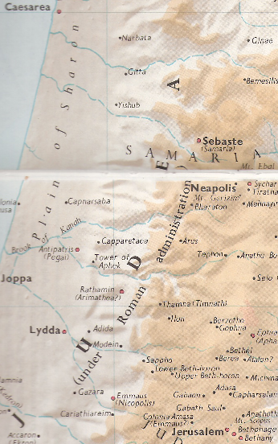

BDAG, p. 378.

