◻    

◻     is the continuative use of the postpositive conjunction DE, meaning “Now” plus the temporal use of the conjunction HWS, meaning “when.” Then we have the third person singular imperfect active indicative from the verb SUMBALLW, which means “to come together at a point, meet, Acts 20:14.”
The imperfect tense is a descriptive imperfect, which described what took place in the past.
The active voice indicates that Paul produced the action.
The indicative mood is declarative for a simple statement of fact.
This is followed by the dative of direct object from the first person plural personal pronoun EGW, meaning “us” and referring to the members of Paul’s team, mentioned in verse 4, plus Luke. Then we have the preposition EIS plus the accusative of place from the feminine singular article and proper noun ASSOS, meaning “at Assos.”

“Now when he met us at Assos,”

 is the nominative masculine first person plural aorist active participle from the verb ANALAMBANW, which means “to take up; to take someone along on a journey of a travel companion 2 Tim 4:11; of Paul’s escort Acts 23:31; to take on board Acts 20:13f.”
The aorist tense is a constative/historical aorist, which views the entire past action as a fact.
The active voice indicates that Paul’s team produced the action.
The participle is a temporal participle, which action precedes the action of the main verb and is translated “after taking…on board.”
Then we have the accusative direct object from the third person masculine singular personal use of the intensive pronoun AUTOS, meaning “him” and referring to Paul. This is followed by the first person plural aorist active indicative from the verb ERCHOMAI, which means “to come: we came.”
The aorist tense is a constative/historical aorist, which views the entire past action as a fact.
The active voice indicates that Paul and his team produced the action.
The indicative mood is declarative for a simple statement of fact.
Finally, we have the preposition EIS plus the accusative of place from the feminine singular proper noun MITULĒNĒ, which means “to Mitylene.”

“after taking him on board, we came to Mitylene.”

Acts 20:14 corrected translation
“Now when he met us at Assos, after taking him on board, we came to Mitylene.”
Explanation:

1. “Now when he met us at Assos,”
a. Luke continues the story of Paul’s trip from Troas to Miletus with Paul’s success in getting to Assos in time to meet his entourage, which had gone by way of ship from Troas to Assos.
b. We don’t know who arrived in Assos first, Paul or his team. It does not really matter. The team would have waited for Paul, as this statement seems to imply, or Paul would have waited for them.
c. Whatever was Paul’s motivation for separating from the team, the goal of that motivation was apparently accomplished, since Paul now joins the team and remains with them for the rest of the journey to Jerusalem.

2. “after taking him on board, we came to Mitylene.”
a. Once Paul arrives, he boards the ship. The other members of his team have already arranged and paid for his passage.
b. The team then sets off from Assos for Mitylene. See the map below. This was also a day’s journey (less than 30 miles).
c. “Under Rome’s rule the island became a favorite resort for Roman aristocrats. From the middle of the first century b.c., Mitylene was a free city within the province of Asia. An earthquake destroyed the city in a.d. 151.”

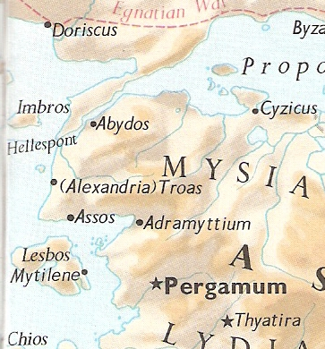

Arndt, W., Danker, F. W., & Bauer, W. (2000). A Greek-English lexicon of the New Testament and other early Christian literature. (3rd ed.) (p. 956). Chicago: University of Chicago Press.
Arndt, W., Danker, F. W., & Bauer, W. (2000). A Greek-English lexicon of the New Testament and other early Christian literature. (3rd ed.) (p. 67). Chicago: University of Chicago Press.
Bromiley, G. W. (1988; 2002). The International Standard Bible Encyclopedia, Revised (3:386). Eerdmans.

