  

 is the continuative use of the conjunction KAI, meaning “Then,” followed by the third person singular aorist passive indicative from the verb PIMPLĒMI, which means “to be filled.”
The aorist tense is a constative/historical aorist, which views the entire past action as a fact.
The passive voice indicates that the subject (the people of the city of Ephesus) received the action of being filled with something.
The indicative mood is declarative for a simple statement of fact and reality.
This is followed by the nominative subject from the feminine singular article and noun POLIS, meaning “the city.” Then we have the genitive of content (indicating the contents with which something is filled) from the feminine singular article and noun SUGCHUSIS, which means “confusion or tumult [uproar, turmoil].”

“Then the city was filled with confusion,”

 is the continuative use of the postpositive conjunction TE, meaning “and” plus the third person plural aorist active indicative from the verb HORMAW, which means “to make a rapid movement from one place to another, rush (headlong) Mt 8:32; Mk 5:13; Lk 8:33; Acts 19:29; 7:57.”
The aorist tense is a constative/historical aorist, which views the entire past action as a fact.
The active voice indicates that the people of the city of Ephesus produced the action.
The indicative mood is declarative for a simple statement of fact and reality.
Then we have the adverb of manner HOMOTHUMADON, which means “with one mind/purpose/impulse Acts 1:14; 2:46; 4:24; 7:57; 8:6; 12:20; 18:12; 19:29; Rom 15:6; unanimously Acts 15:25.” This is followed by the preposition EIS plus the accusative of place/direction from the neuter singular article and noun THEATRON, meaning “into the theater a place for public assemblies Acts 19:29, 31.”

“and they rushed with one mind into the theater,”

   is the nominative masculine plural aorist active participle of the verb SUNARPAZW, which means “to take hold of forcibly, seize someone Acts 6:12; 19:29; 27:15; Lk 8:29.”
The aorist tense is a constative/historical aorist, which views the entire past action as a fact.
The active voice indicates that the crowd produced the action.
The participle expresses additional attendant circumstances.
Then we have the appositional accusative direct object from the masculine singular proper nouns GAIOS and ARISTARCHOS with a connecting conjunction KAI, meaning “Gaius and Aristarchus.” This is followed by the accusative direct object from the masculine plural noun MAKEDWN, meaning “the Macedonians Acts 16:9; 19:29; 27:2; 2 Cor 9:2, 4.”

“seizing the Macedonians Gaius and Aristarchus,”

 is the appositional accusative direct object from the masculine plural noun SUNEKDĒMOS, meaning “traveling companions, with focus on official assignment Acts 19:29; 2 Cor 8:19.” Finally, we have the genitive of association from the masculine singular noun PAULOS, meaning “of Paul” in the sense of “with Paul.”

“traveling companions with Paul.”

Acts 19:29 corrected translation
“Then the city was filled with confusion, and they rushed with one mind into the theater, seizing the Macedonians Gaius and Aristarchus, traveling companions with Paul.”

Explanation:

1. “Then the city was filled with confusion,”
a. The result of Demetrius’ machinations and agitations was that the people of the city were filled with confusion, tumult, uproar, and turmoil.
b. Demetrius had successfully created agitation and anger among the tradesmen and workers, and now this uproar and turmoil has spilled over to the people of the city.
c. The people of the city were angry, confused, upset, and filled with all kinds of emotions, but didn’t know why. This is the state of mind of a mob. They are full of negative emotions but often don’t know why.
d. As believers in the Lord Jesus Christ we are not to be confused or in a mental state of tumult, uproar, or turmoil. We are expected to maintain a relaxed mental attitude at all times.
e. Satan is the author of confusion, and in this case he worked successfully through his human agent, Demetrius.
f. “Note that it was his appeal to religious and civic pride that was picked up [and chanted by the crowd]. They were not shouting ‘our business is in danger,’ even if that was the real issue.”

2. “and they rushed with one mind into the theater,”
a. Luke continues by describing the actions of the people of the city.
b. With one mind or purpose they rushed into the theater of Ephesus. This open-air theater “held more than 24,000 people on sixty-six tiers of seats with a great stage measuring about 115 ft by 70 ft. [The amphitheater itself was 495 feet in diameter.] Though the theater lies in ruins today, its acoustics are still superb.” See the photos below.

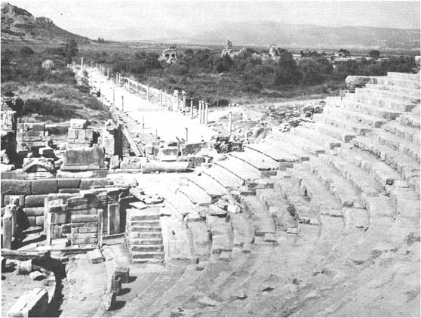

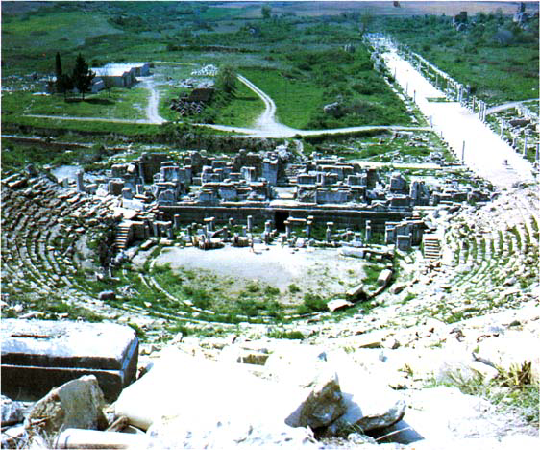
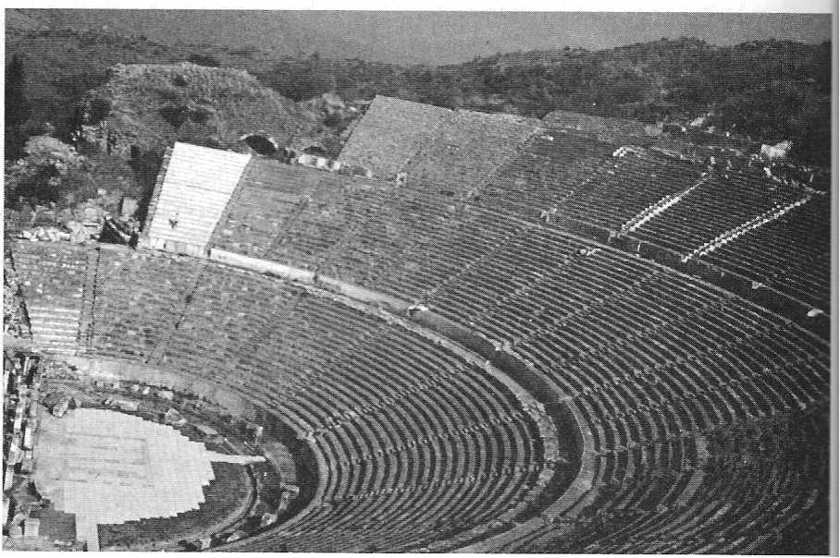
c. This mob was in a hurry to take action against someone, to find someone guilty of something, and to exact vengeance against them. It didn’t matter who it was. The mob was bloodthirsty. Their “one mind” was that they must find someone responsible for causing their fear, worry, hatred, anger, and punish them now.
d. Not only was the theater used for entertainment, but it was also the gathering place for official business of the Greek city-state. “Town meetings were held there, and since the technical term for town meeting () occurs in verses 30, 33, it could be that this was considered a sort of emergency meeting of the popular assembly.”

3. “seizing the Macedonians Gaius and Aristarchus,”
a. En route to the theater, the mob seized two Greeks from Macedonia, who were well-known to Luke. Luke does not tell us if they went to the place where Gaius and Aristarchus were staying or if they found them in the marketplace and dragged them along. The point being made here is that these two men had done nothing wrong, certainly nothing that justified the mob violence against them.
b. There are five men named Gaius mentioned in the New Testament.
(1) “The Gaius to whom 3 John is addressed. He is spoken of as the “beloved” (3 Jn 1f, 5, 11) and is commended for ‘the truth of [his] life’ and his hospitality (vv 3, 5f). [If the Gaius mentioned in our passage as the traveling companion of Paul was in his twenties when he began accompanying Paul, then he could possibly be the same person mentioned by John thirty-five years later. He would be in his late fifties or early sixties. We have no evidence for this.]
(2) Gaius of Macedonia, one of Paul’s ‘companions in travel’ (Acts 19:29). He was one of those who were seized by Demetrius and the other silversmiths in the riot at Ephesus during Paul’s third missionary journey.
(3) Gaius of Derbe, who was among those who awaited Paul at Troas and accompanied him on his return to Jerusalem on his third missionary journey (Acts 20:4). It is possible here that ‘Derbe’ should be taken with Timothy and that Gaius should be classed with the Thessalonians. According to the Western reading he was not from Derbe but “of Doberus,” another Macedonian town. [If true, then he is the Gaius of Macedonia as well, but this piece of speculation and emendation is hardly correct, because “(a)  applied to a man apparently called a Macedonian in the context would have been the harder reading in the second century, when everyone knew that Derbe was in Asia Minor, and (b)  would be a natural and intelligible emendation at that period. Furthermore, the grouping of the names in pairs (after the mention of Sopater) according to their place of residence suggests that this Gaius, who is mentioned in company with Timothy, was from Asia Minor and not from Macedonia.]
(4) Gaius, the host of Paul when he wrote the Epistle to the Romans (Rom 16:23). As Paul wrote this Epistle from Corinth, it is probable that this Gaius is identical with the next Gaius.
(5) Gaius, whom Paul baptized at Corinth (1 Cor 1:14).”
c. According to Acts 20:4 and 27:2, Aristarchus (his name means ‘best-ruler’) was a native of Thessalonica, which was the capital of Macedonia.
(1) Gaius and Aristarchus “were probably seized to extract from them information about their leader Paul, but when they could tell nothing, and since they were Greeks, nothing further was done to them.
(2) We do not know when Aristarchus attached himself to Paul, but he seems to have remained in Paul’s company even after the Ephesian uproar. He was one of those who accompanied Paul from Greece via Macedonia (20:4). Having preceded Paul to Troas, where they waited for him, they traveled with him to Palestine. He is next mentioned as accompanying Paul to Rome (27:2). There he attended Paul and shared his imprisonment. He is mentioned in two of the letters of the Roman captivity, Colossians (4:10) and Philemon (verse 24), in both of which he sends greetings. In the former Paul calls him ‘my fellow prisoner’. According to tradition he was martyred during the persecution by Nero.”
(3) “Possibly 2 Cor 8:18–19 refers to him as ‘the brother’ who traveled with Paul, since the noun ‘traveling companion’ is used only there and in Acts 19:29, which clearly refers to Aristarchus.”

4. “traveling companions with Paul.”
a. Paul rarely traveled alone. There was almost always someone with him as a fellow-worker. These traveling companions had various functions in addition to helping evangelize others. They made travel arrangements, secured lodging, secured employment, got directions, did the grocery shopping, cooking, laundry, paid the bills, etc. They were the adjutants, aide-de-camp, gofers, and assistants that are so necessary for any missionary to be free to devote his time to studying and teaching.
b. Another very important function of these men was to discourage bandits on the road. It is the concept of safety in numbers. This is not a denial of the protection of the Lord Jesus Christ, just the application of common sense to a given situation. A part of our Lord’s protection of us is giving us the good sense to not do seriously stupid things.
c. The service of these two men as traveling companions would be invaluable to Paul.

Wallace, Greek Grammar Beyond the Basics, p. 94.
Arndt, W., Danker, F. W., & Bauer, W. (2000). A Greek-English Lexicon of the New Testament and other early Christian literature. (3rd ed.) (p. 954). Chicago: University of Chicago Press.
Arndt, W., Danker, F. W., & Bauer, W. (2000). A Greek-English Lexicon of the New Testament and other early Christian literature. (3rd ed.) (p. 724). Chicago: University of Chicago Press.
Arndt, W., Danker, F. W., & Bauer, W. (2000). A Greek-English Lexicon of the New Testament and other early Christian literature. (3rd ed.) (p. 706). Chicago: University of Chicago Press.
Arndt, W., Danker, F. W., & Bauer, W. (2000). A Greek-English Lexicon of the New Testament and other early Christian literature. (3rd ed.) (p. 446). Chicago: University of Chicago Press.
Arndt, W., Danker, F. W., & Bauer, W. (2000). A Greek-English Lexicon of the New Testament and other early Christian literature. (3rd ed.) (p. 966). Chicago: University of Chicago Press.
Arndt, W., Danker, F. W., & Bauer, W. (2000). A Greek-English Lexicon of the New Testament and other early Christian literature. (3rd ed.) (p. 611). Chicago: University of Chicago Press.
Arndt, W., Danker, F. W., & Bauer, W. (2000). A Greek-English Lexicon of the New Testament and other early Christian literature. (3rd ed.) (p. 968). Chicago: University of Chicago Press.
Wallace, Greek Grammar Beyond the Basics, p. 128f.
Polhill, p. 411.
Bromiley, G. W. (1988; 2002). The International Standard Bible Encyclopedia, Revised (2:116). Eerdmans.
Polhill, p. 411; Bruce, p. 376, “It was the regular meeting place of the civic assembly, which was held three times a month; on this occasion the demonstrating populace appears to have constituted itself as a meeting of the assembly, but a highly irregular one.”
Metzger, B. M., & United Bible Societies. (1994). A textual commentary on the Greek New Testament, second edition a companion volume to the United Bible Societies' Greek New Testament (4th rev. ed.) (422). London; New York: United Bible Societies.
Bromiley, G. W. (2001, c1979-1988). The International standard Bible encyclopedia (2:377). Grand Rapids: Wm. B. Eerdmans.
Bromiley, G. W. (1988; 2002). The International Standard Bible Encyclopedia, Revised (1:290). Wm. B. Eerdmans.
Freedman, D. N., Myers, A. C., & Beck, A. B. (2000). Eerdmans dictionary of the Bible (101). Grand Rapids, Mich.: W.B. Eerdmans

