 

  is the continuative use of the postpositive conjunction DE, meaning “Then” plus the explanatory nominative masculine plural aorist active participle of the verb PARERCHOMAI, which means “(1) to go by; to pass by an area; (2) to pass through an area, go through (Antony made his way through [to the Forum] with difficulty) Acts 16:8.” You cannot possibly pass by the geographical area of Mysia to get to Troas, you must go through that geographical area to get to Troas. Look at the map below.
The aorist tense is a constative/historical aorist, which views the entire past action as a fact.
The active voice indicates that the missionary team produced the action.
The participle is circumstantial.
Then we have the accusative direct object from the feminine singular article and proper noun MUSIA, meaning “Mysia.”

“Then going through Mysia,”

   is the third person plural aorist active indicative from the verb KATABAINW, which means “to come/go down: they came down” (BDAG, p. 513).
The aorist tense is a constative/historical aorist, which views the entire past action as a fact.
The active voice indicates that Paul’s missionary team produced the action.
The indicative mood is declarative for a simple statement of fact.
Finally, we have the preposition EIS plus the accusative of place from the feminine singular proper noun TRWIAS, meaning “to Troas.”

“they came down to Troas.”

Acts 16:8 corrected translation
“Then going through Mysia, they came down to Troas.”

Explanation:

1. “Then going through Mysia,”
a. When the door into Bithynia was closed by the Holy Spirit, He opened the way for Paul’s team to going through Mysia to the coastal port city of Troas.
b. Look at the maps in the previous two verses for why you must go through Mysia to get to Troas. You cannot get to the city of Troas without going through the region or district of Mysia. ‘To go by’ is a terrible mistranslation of the verb in this context, since it was impossible to bypass Mysia in order to get to Troas.
c. For a map of the area, see below.

2. “they came down to Troas.”
a. After passing or going through the territory of Mysia, the missionary team finally arrives in the city of Troas on the western coast of Asia Minor. Troas was a Roman military colony. “It was an important center of commerce, trade, and travel, and very important in the Roman network of communications.” Since the missionary team was traveling from higher ground to the seacoast Luke correctly identifies that they were ‘going down’ as in going downhill.
b. Troas is mentioned in Acts 16:8, 11; 20:5f; 2 Cor 2:12; 2 Tim 4:13. It was “a large seaport city of Mysia in northwest Asia Minor, ten miles south of ancient Troy; in NT times it was the gateway from Asia to Macedonia and Thrace. Troas was founded by Antigonus (a successor of Alexander the Great) and named Antigonia Troas. In 133 B.C. the Romans gained control of the city. Augustus made Troas an independent Roman colony possessing the landholding privileges and immunities. Paul brought Christianity to Troas; there he found an “open door” for preaching (2 Cor 2:12f); but apparently he did not stay long. At Troas he received his Macedonian call and set sail to Philippi (Acts 16:7–12). He returned to Troas and there raised Eutychus from the dead before continuing on to Jerusalem and imprisonment (20:4–12). Also, Paul entrusted his cloak, books, and valuable parchments to Carpus at Troas (2 Tim 4:13).”
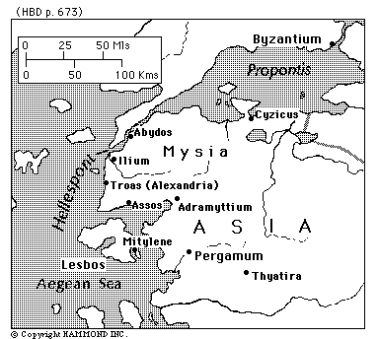

Arndt, W., Danker, F. W., & Bauer, W. (2000). A Greek-English Lexicon of the New Testament and other early Christian literature. (3rd ed.) (p. 776). Chicago: University of Chicago Press.
Witherington, p. 479.
Bromiley, G. W. (1988; 2002). The International Standard Bible Encyclopedia, Revised (4:922-923). Eerdmans.

