 

   is the transitional use of the postpositive conjunction DE, meaning “Then” or “Now.” With this we have the third person plural aorist active indicative from the verb DIERCHOMAI, which means “to come/go through; to travel through a place Acts 14:24; 15:3, 41; 16:6; 18:23; 19:21; 1 Cor 16:5.”
The aorist tense is a constative/historical aorist, which views the entire past action as a fact.
The active voice indicates that Paul’s missionary team produced the action.
The indicative mood is declarative for a simple statement of fact.
Then we have the accusative direct object from the feminine singular article and proper noun PHRUGIA with a connective KAI and adjective GALATIKOS and the noun CHWRA, meaning “Phrygia and the Galatian district, region.”

“Then they went through the Phrygian and Galatian region,”

  is the explanatory nominative masculine plural aorist passive participle from the verb KWLUW, which means “to hinder, prevent, forbid Mk 9:38f; 10:14; 19:14; Lk 9:49f; 11:52; 18:16; Acts 8:36; 11:17; 16:6; 27:43; 24:23; 3 Jn 10; Rom 1:13; 1 Thes 2:16; Heb 7:23.”
The aorist tense is a culminative aorist, which views the entire past action as a fact with emphasis on its conclusion. The culminative aorist is translated by the English auxiliary verb “has/have: having been forbidden.”
The passive voice indicates that Paul’s missionary team received the action of being forbidden and prevented by the Holy Spirit.
The participle expresses attendant circumstances with the action either preceding or being simultaneous with the action of the main verb. The Holy Spirit forbade them from going into Asia either before or at the same time as they were traveling from Derbe to Pisidian Antioch. It is also possible to take this participle as a causal participle. The missionary team passed through the same places as their first missionary journey because the Holy Spirit prevented them from going into Asia.
Then we have the preposition HUPO plus the ablative of agency from the neuter singular article and adjective HAGIOS with the noun PNEUMA, meaning “by the Holy Spirit.” This is followed by the aorist active infinitive from the verb LALEW, which means “to speak; to teach; assert, proclaim, say Acts 4:29, 31; 8:25; 14:25; 16:6, 32.”
The aorist tense is a constative aorist, which views the action in its entirety as a fact.
The active voice indicates that Paul and his team produced the action of being forbidden to speak.
The infinitive is a complementary infinitive, completing the thought of the previous participle.
Then we have the accusative direct object from the masculine singular article and noun LOGOS, meaning “the word,” and used as a technical designation for the presentation of the gospel message. Hence, it can also legitimately be translated “the message” here.
Finally, we have the preposition EN plus the locative of place from the feminine singular article and proper noun ASIA, meaning “in Asia.”

“having been forbidden by the Holy Spirit to proclaim the message in Asia.”

Acts 16:6 corrected translation
“Then they went through the Phrygian and Galatian region, having been forbidden by the Holy Spirit to proclaim the message in Asia.”

Explanation:

1. “Then they went through the Phrygian and Galatian region,”
a. Luke moves the narrative along with a general statement of the travels of the missionary team.
b. Luke is taking a step backward in his story to fill us in on the travels of the team from the point of origin of their movements in the Roman province of Asia.
c. This statement involves us in the north versus south Galatian theory, that is, were the churches of Galatia in northern Galatia or southern Galatia, and the other geographical regions mentioned here? The New Bible Dictionary has an excellent, short explanation. “It is clear from the account in Acts 13–14 that Paul visited south Galatia and established churches there. Did he ever conduct a mission in north Galatia? Two texts especially have been used to support such a ministry [right now we are only interested in our text]. The first (Acts 16:6) reads: ‘And they went through the region of Phrygia and Galatia…” North Galatian proponents understand ‘Phrygia’ here to be the territory in which Antioch and Iconium were located, whereas ‘Galatia’ refers to the geographical or ethnic kingdom by that name. Sir William Ramsay, however, takes the phrase   (‘the Phrygian and Galatian region’) to be a composite term describing a single area—the Phrygian-Galatic region. The word , ‘territory’, was the official word used to describe one of the regiones [a Latin word] into which Roman provinces were divided. Part of the old kingdom of Phrygia belonged to the Roman province of Galatia and another part belonged to the province of Asia [the western coast of Asia Minor). Thus Acts 16:6 refers to the parts of Phrygia which had been incorporated into the Roman province of Galatia. This interpretation is supported by the following statement in the Acts account, ‘having been forbidden by the Holy Spirit to speak the word in Asia’. The plan of the missionary party apparently was to strike out directly in a westerly direction from Antioch of Pisidia, which would have taken them into the [Roman] province of Asia [the area of Ephesus, Colossae, etc.]. Instead they went north towards Bithynia, crossing only a part of Asia.”
d. Phrygia was a tract of land centered on the western end of the great Anatolian plateau, and reaching north into the valley of the upper Sangarius river, southwest down the valley of the Maeander river, and southeast across the plateau, perhaps as far as Iconium. The Phrygians fell under direct Hellenic influence during the era of the Attalid kings of Pergamum, and in 116 B.C. most of Phrygia was incorporated by the Romans into their province of Asia [western Asia Minor]. The east extremity (Phrygia-Galatica) was included in the new province of Galatia in 25 B.C. Such churches as fall technically within Phrygia (Laodicea, Hierapolis, Colossae, Pisidian Antioch and probably Iconium) were established in Greek communities. The phrase ‘the region of Phrygia and Galatia’ is a composite technical term for Phrygia-Galatica and refers in particular to the churches at Iconium and Pisidian Antioch. Otherwise we cannot identify the disciples Paul left in ‘Phrygia’ [mentioned in Acts 18:23].”
e. See the map below for the geographical areas of Phrygia and Galatia.

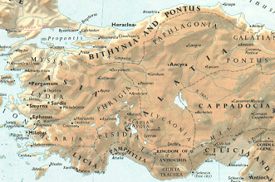

2. “having been forbidden by the Holy Spirit to proclaim the message in Asia.”
a. Paul wanted to go west to the cities of Colossae, Hierapolis, Laodicea, Miletus, Ephesus, Smyrna, Sardis, Philadelphia, Thyatira, and Pergamum. However, Paul was expressly forbidden by God the Holy Spirit to go into the Roman Province of Asia. Therefore, he had to change his plans and pass through the Phrygian-Galatian regions, which means the churches previously established by Paul on his first missionary journey (Derbe, Lystra, Iconium, Pisidian Antioch). “It is much more likely that Luke means here that Paul finished traveling through the region he had been through before including going through Iconium and Pisidian Antioch with the intent to go straight on into Asia, rather than that he now took a visit to north Galatia.” [There is really no support in this passage for the North Galatian theory as put forth by Lightfoot.]
b. The Roman province of Asia would be Paul’s greatest missionary success, but the timing was not yet right for him to go there. He would eventually be permitted by the Holy Spirit to go to the west coast of Asia and have his greatest success there.
c. Instead, Paul’s team was directed north toward Bithynia, which they were also prevented from entering by the Holy Spirit (see the next verse), and then had to turn west and go through the area of Mysia to the city of Troas on the coast.
d. This is one of the great passages of the Bible that proves that God the Holy Spirit is a person. How? Because the preposition HUPO with the ablative of agency is only used for persons with the passive voice in the verb to indicate the person producing the action of the verb in the passive voice.
e. The point being made here by Luke is that God the Holy Spirit was personally directing the travel of the missionary team. He was keeping them out of trouble along the way, and sending them exactly where He wanted them to go. Timing is so important in God’s plan, and the timing had to be perfect for the initial success of the gospel in the province of Asia.
f. What’s the principle? When God the Holy Spirit closes doors before us, we shouldn’t try to force our way through them. Go where the Holy Spirit has opened the door for ministry. If the door is shut now, wait until God opens the door for evangelization of a new territory. Right now the great success would be in Philippi. On his third missionary journey Paul would have great success in Asia about a year or two from now.

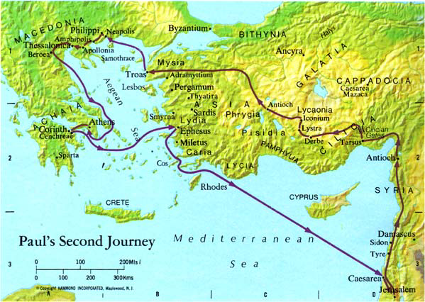

Arndt, W., Danker, F. W., & Bauer, W. (2000). A Greek-English Lexicon of the New Testament and other early Christian literature. (3rd ed.) (p. 244). Chicago: University of Chicago Press.
Arndt, W., Danker, F. W., & Bauer, W. (2000). A Greek-English Lexicon of the New Testament and other early Christian literature. (3rd ed.) (p. 1093). Chicago: University of Chicago Press.
Arndt, W., Danker, F. W., & Bauer, W. (2000). A Greek-English Lexicon of the New Testament and other early Christian literature. (3rd ed.) (p. 580). Chicago: University of Chicago Press.
Arndt, W., Danker, F. W., & Bauer, W. (2000). A Greek-English Lexicon of the New Testament and other early Christian literature. (3rd ed.) (p. 582). Chicago: University of Chicago Press.
Wood, D. R. W., & Marshall, I. H. (1996). New Bible Dictionary (3rd ed.) (p. 391). Leicester, England; Downers Grove, Ill.: InterVarsity Press.
Wood, D. R. W., & Marshall, I. H. (1996). New Bible Dictionary (3rd ed.) (p. 927). Leicester, England; Downers Grove, Ill.: InterVarsity Press.
Witherington, p. 478.

